Homework III
1.
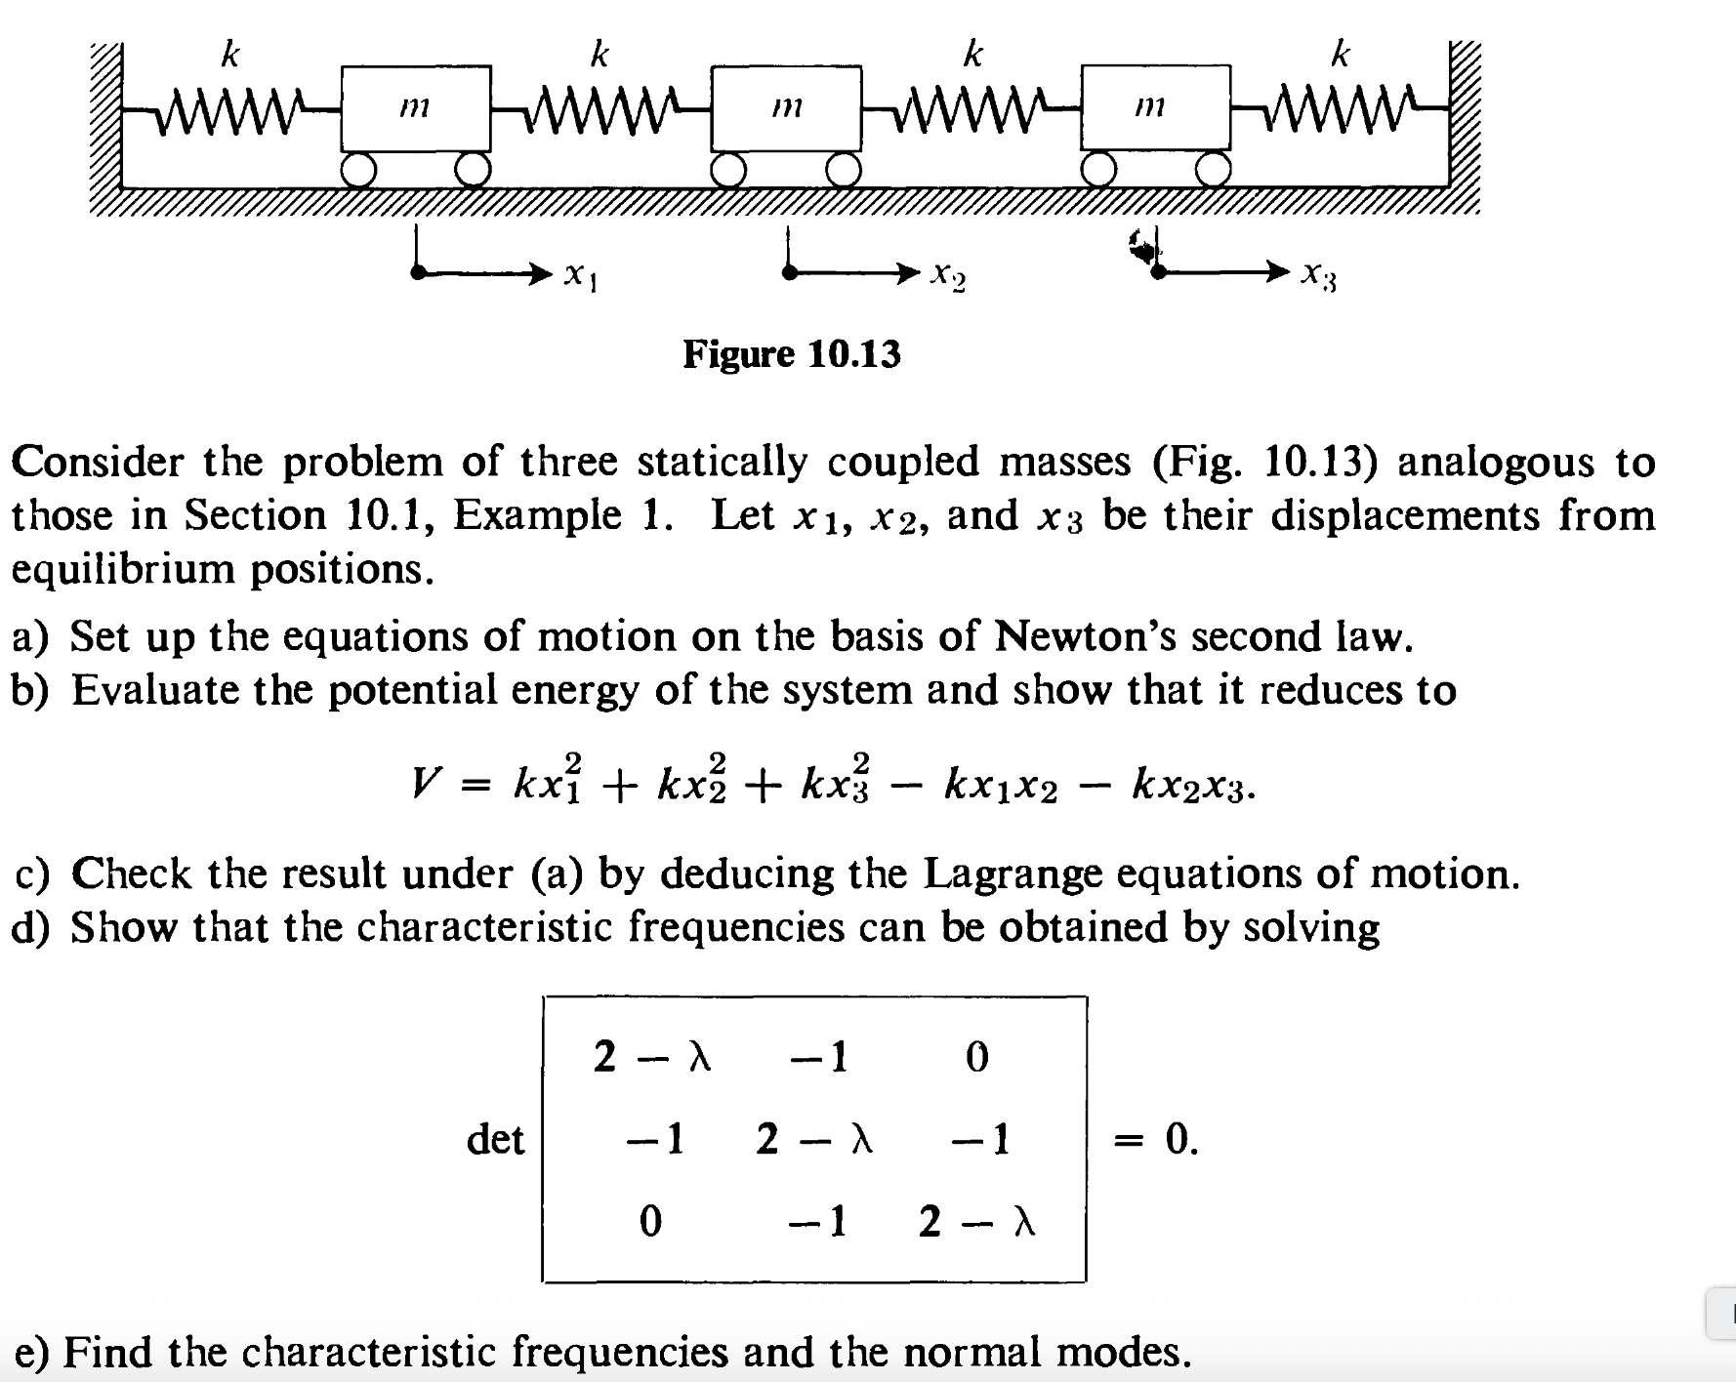
Hint:
$$m\frac{d^{2}x_{1}}{dt^{2}}=k\left(x_{2}-x_{1}\right)-kx_{1}=-2kx_{1}+kx_{2}$$
$$m\frac{d^{2}x_{2}}{dt^{2}}=k\left(x_{3}-x_{2}\right)-k\left(x_{2}-x_{1}\right)=-2kx_{2}+kx_{3}+kx_{1}$$
$$m\frac{d^{2}x_{3}}{dt^{2}}=-k\left(x_{3}-x_{2}\right)-kx_{3}=-2kx_{3}+kx_{2}$$
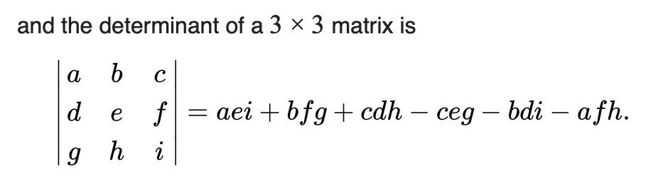
Sol:
- 運動方程式：
$$\frac{d^{2}x_{1}}{dt^{2}}=ω_{0}^{2}\left(x_{2}-x_{1}\right)-ω_{0}^{2}x_{1}=-2ω_{0}^{2}x_{1}+ω_{0}^{2}x_{2}$$
$$\frac{d^{2}x_{2}}{dt^{2}}=ω_{0}^{2}\left(x_{3}-x_{2}\right)-ω_{0}^{2}\left(x_{2}-x_{1}\right)=-2ω_{0}^{2}x_{2}+ω_{0}^{2}x_{3}+ω_{0}^{2}x_{1}$$
$$\frac{d^{2}x_{3}}{dt^{2}}=-ω_{0}^{2}\left(x_{3}-x_{2}\right)-ω_{0}^{2}x_{3}=-2ω_{0}^{2}x_{3}+ω_{0}^{2}x_{2}$$
- 計算彈簧的彈力位能：
$$V=\frac{k}{2}\left[x_{1}^{2}+{\left(x_{2}-x_{1}\right)}^{2}+{\left(x_{3}-x_{2}\right)}^{2}+x_{3}^{2}\right]=k\left(x_{1}^{2}+x_{2}^{2}+x_{3}^{2}-x_{1}x_{2}-x_{2}x_{3}\right)$$
- In matrix notation, the system of ODE’s can be written as:
$$x≡\left(\begin{matrix}x_{1} \\ x_{2} \\ x_{3}\end{matrix}\right),A=ω_{0}^{2}\left(\begin{matrix}2 & -1 & 0 \\ -1 & 2 & -1 \\ 0 & -1 & 2\end{matrix}\right)$$
$$\frac{d^{2}}{dt^{2}}x=-A∙x$$
Take $x≡ae^{iωt}$，Plug into the equation：$A∙a=ω^{2}a≡λω_{0}^{2}a$。
$$\left(A-λω_{0}^{2}I\right)∙a=0$$
The characteristic equation is $\left|A-λω_{0}^{2}I\right|=0$ or
$$\left|\begin{matrix}2-λ & -1 & 0 \\ -1 & 2-λ & -1 \\ 0 & -1 & 2-λ\end{matrix}\right|=0$$
It is simplified to an algebraic equation for $λ$:
$${\left(2-λ\right)}^{3}-2\left(2-λ\right)=\left(2-λ\right)\left(2-4λ+λ^{2}\right)=0$$
Solved as
$λ=2,2±\sqrt{2}$, or $ω^{2}=2ω_{0}^{2},\left(2±\sqrt{2}\right)ω_{0}^{2}$
- Compute the eigenvectors：
For $λ=2, ω=ω_{2}\sim \sqrt{2}ω_{0}$: Solve $\left(A-λω_{0}^{2}\right)∙a=0$
$$ω_{0}^{2}\left(\begin{matrix}0 & -1 & 0 \\ -1 & 0 & -1 \\ 0 & -1 & 0\end{matrix}\right)\left(\begin{matrix}a_{1} \\ a_{2} \\ a_{3}\end{matrix}\right)=0$$
Written explicitly
$$-a_{2}=0$$
$$-a_{1}-a_{3}=0$$
$$-a_{2}=0$$
We find the eigenvector up to a constant:
$$a^{\left(2\right)}=c_{2}\left(\begin{matrix}-1 \\ 0 \\ 1\end{matrix}\right)$$
For $λ=2-\sqrt{2}, ω=ω_{1}\sim \sqrt{2-\sqrt{2}}ω_{0}$:
$$ω_{0}^{2}\left(\begin{matrix}\sqrt{2} & -1 & 0 \\ -1 & \sqrt{2} & -1 \\ 0 & -1 & \sqrt{2}\end{matrix}\right)\left(\begin{matrix}a_{1} \\ a_{2} \\ a_{3}\end{matrix}\right)=0$$
Hence
$$\sqrt{2}a_{1}-a_{2}=0$$
$$-a_{1}+\sqrt{2}a_{2}-a_{3}=0$$
$$-a_{2}+\sqrt{2}a_{3}=0$$
$$a^{\left(1\right)}=c_{1}\left(\begin{matrix}1 \\ \sqrt{2} \\ 1\end{matrix}\right)$$

For $λ=2+\sqrt{2}, ω=ω_{3}\sim \sqrt{2+\sqrt{2}}ω_{0}$:
$$ω_{0}^{2}\left(\begin{matrix}-\sqrt{2} & -1 & 0 \\ -1 & -\sqrt{2} & -1 \\ 0 & -1 & -\sqrt{2}\end{matrix}\right)\left(\begin{matrix}a_{1} \\ a_{2} \\ a_{3}\end{matrix}\right)=0$$
$$\sqrt{2}a_{1}+a_{2}=0$$
$$a_{1}+\sqrt{2}a_{2}+a_{3}=0$$
$$a_{2}+\sqrt{2}a_{3}=0$$
$$a^{\left(3\right)}=c_{3}\left(\begin{matrix}1 \\ -\sqrt{2} \\ 1\end{matrix}\right)$$

2. Consider a coupled oscillation of two particles as shown below:
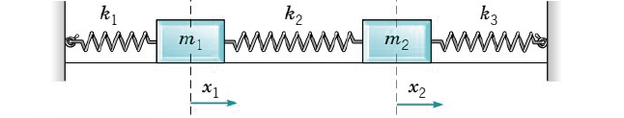
with equations of motion:
$$\frac{d^{2}x_{1}}{dt^{2}}=-\frac{k_{1}+k_{2}}{m_{1}}x_{1}+\frac{k_{2}}{m_{1}}x_{2}, \frac{d^{2}x_{2}}{dt^{2}}=\frac{k_{2}}{m_{2}}x_{1}-{\frac{k_{2}+k_{3}}{m_{2}}x}_{2}$$
which can be written in the notations of matrices:
$$\frac{d^{2}}{dt^{2}}x=-A∙x$$
Assume that the matrix $A$ equals:
$$A≡ω_{0}^{2}\left(\begin{matrix}5 & 4 \\ 4 & 5\end{matrix}\right)$$
The general solutions can be written as:
$$x=\left(\begin{matrix}x_{1} \\ x_{2}\end{matrix}\right)=c_{1}\left(\begin{matrix}a_{11} \\ a_{21}\end{matrix}\right)cos\left(ω_{1}t+ϕ_{1}\right){+}c_{2}\left(\begin{matrix}a_{12} \\ a_{22}\end{matrix}\right)cos\left(ω_{2}t+ϕ_{2}\right)$$
- Find the numbers $ω_{1},\left(\begin{matrix}a_{11} \\ a_{21}\end{matrix}\right)$ and $ω_{2},\left(\begin{matrix}a_{12} \\ a_{22}\end{matrix}\right)$.
- If the initial condition is $x_{1}\left(0\right)=a_{m}$, $x_{2}\left(0\right)=0,$ $x_{1}^{'}\left(0\right)=x_{2}^{'}\left(0\right)=0$, find the solution. Hint: $ϕ_{1}=ϕ_{2}=0.$
Sol:
- Guess the solutions are$X=ae^{iωt}$, $A∙a=ω^{2}a$. This is eigenvalue problem of $A$.
The characteristic equation:
$$\left|A-λI\right|=ω_{0}^{2}\left|\begin{matrix}5-λ & 4 \\ 4 & 5-λ\end{matrix}\right|=0$$
$$λ^{2}-10λ+9=0$$
$$λ=1 or λ_{2}=9$$
$$ω_{1}=ω_{0}, ω_{2}=\sqrt{3}ω_{0}$$
For $ω_{1}=ω_{0},$ $\left(A-λI\right)∙a_{1}=ω_{0}^{2}\left(\begin{matrix}4 & 4 \\ 4 & 4\end{matrix}\right)∙\left(\begin{matrix}a_{11} \\ a_{21}\end{matrix}\right)=0$, $a_{1}=c_{1}\left(\begin{matrix}1 \\ -1\end{matrix}\right)$
For $ω_{2}=\sqrt{3}ω_{0},$ $\left(A-λI\right)∙a_{2}=ω_{0}^{2}\left(\begin{matrix}-4 & 4 \\ 4 & -4\end{matrix}\right)∙\left(\begin{matrix}a_{12} \\ a_{22}\end{matrix}\right)=0$, $a_{2}=c_{1}\left(\begin{matrix}1 \\ 1\end{matrix}\right)$
$$x=\left(\begin{matrix}x_{1} \\ x_{2}\end{matrix}\right)=c_{1}\left(\begin{matrix}1 \\ -1\end{matrix}\right)cos\left(ω_{0}t+ϕ_{1}\right){+}c_{2}\left(\begin{matrix}1 \\ 1\end{matrix}\right)cos\left(\sqrt{3}ω_{0}t+ϕ_{2}\right)$$
- $x_{1}\left(0\right)=c_{1}+c_{2}=a_{m}, x_{2}\left(0\right)=c_{1}-c_{2}=0$
$$\left(\begin{matrix}x_{1} \\ x_{2}\end{matrix}\right)=\frac{a_{m}}{2}\left(\begin{matrix}1 \\ -1\end{matrix}\right)cos ω_{0}t{+}\frac{a_{m}}{2}\left(\begin{matrix}1 \\ 1\end{matrix}\right)\cos{\sqrt{3}ω_{0}t}$$

