Homework III

- Consider a string with fixed ends of length $L$. The initial condition is a Sawtooth wave: $ϕ\left(x,0\right)=u_{0}\left(x\right)$ as we studied in class and initial velocities are zero: $v_{0}\left(x\right)=0$. The following is the Fourier Series expansion of $u_{0}\left(x\right)$.
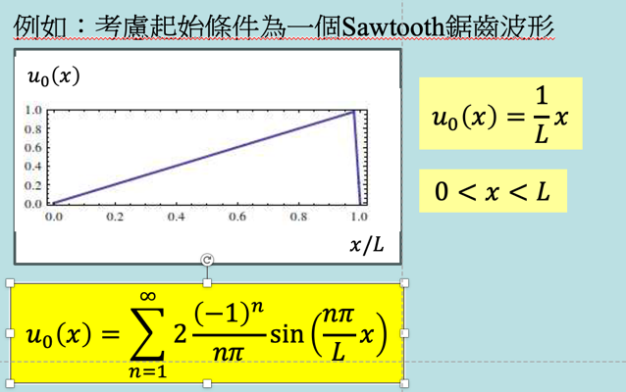
Calculate numerically wavefunction $ϕ\left(x,t\right)$ and its time derivative $\frac{∂ϕ}{∂t}$ at $x=\frac{L}{4}, t=\frac{L}{4v}$, using Fourier series with $n=1,2,⋯8$ as an approximation.

- Consider a periodic function of $x$ of period $2π$: $f\left(x\right)=1, 0<x<π$ and $f\left(x\right)=-1, -π< x<0$.
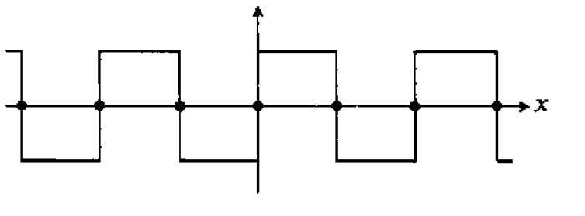
Write down the Fourier series of $f\left(x\right)$: