Homework II
- A field $\vec{E}$ equals :
$$\vec{E}=\left(x^{2}+y^{2}+z^{2}\right)(x\hat{i}+y\hat{j}+z\hat{k})$$
Calculate $\vec{∇}∙\vec{E}$
- A field $\vec{E}$ equals :
$$\vec{E}=\left(x^{2}+yz^{2}\right)\hat{i}+(2x-y^{3})\hat{j}$$
Calculate $\vec{∇}×\vec{E}$.
Along a circle ${\left(x-2\right)}^{2}+{\left(y-3\right)}^{2}=9,z=0$, calculate $\oint{\vec{E}∙d\vec{s}}$ using $\vec{∇}×\vec{E}$.
- Consider the spring system of $N=3$ coupled masses. Assume that the spring constants are all equal to $k$ and the masses are all equal to $m$. $ω_{0}=\sqrt{\frac{k}{m}}$.
If we move the first particle to the right by $a$ and let go as all three particles are at rest, that is, the initial condition is $x_{1}\left(0\right)=a$, $x_{2}\left(0\right)=x_{3}\left(0\right)=0$, $x_{1}^{'}\left(0\right)=x_{2}^{'}\left(0\right)=x_{3}^{'}\left(0\right)=0$, solve the $x_{1}\left(t\right)$. Write the solution in terms of $a,ω_{0}.$
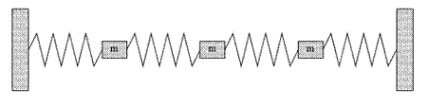

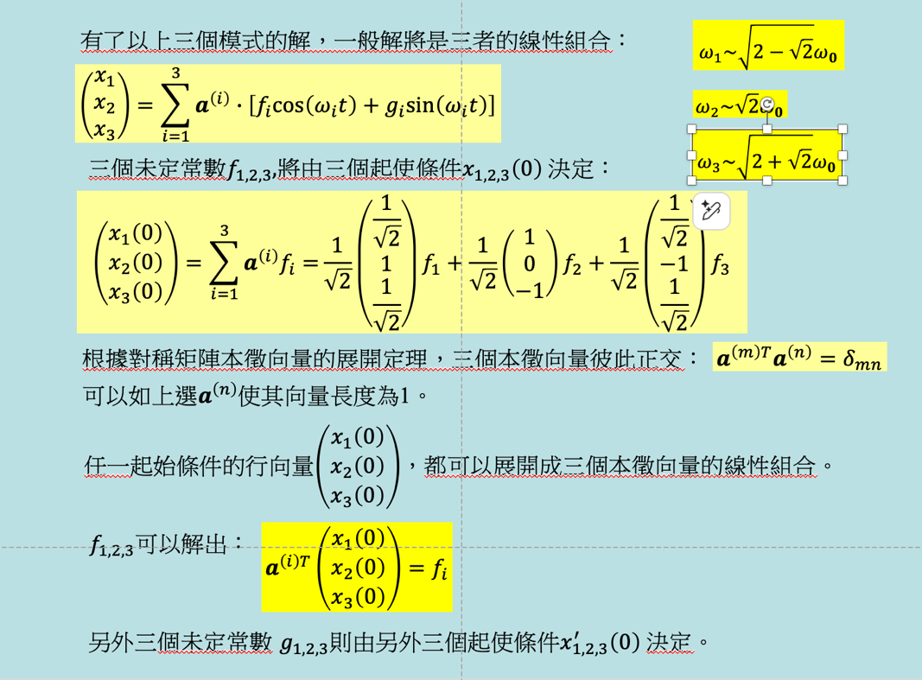

- Consider the following wave equation:
$$\frac{∂^{2}ϕ}{∂t^{2}}=v^{2}\frac{∂^{2}ϕ}{∂x^{2}}-V\left(x\right)ϕ$$
Here we add a term $V\left(x\right)ϕ$ to the right-hand side of the wave function we studied in class. $V\left(x\right)=v^{2}α^{2}x^{2}$ is a known function. This could be done by adding a position dependent restoring force to the particles on the string.

It is reasonable to think that there exists solutions that are separable:
$$ϕ\left(x,t\right)=X\left(x\right)∙T\left(t\right).$$
- Find the Ordinary Differential Equation satisfied by $X\left(x\right)$ and $T\left(t\right)$. Show that $T\left(t\right)$ satisfies the ODE of a simple harmonic oscillator and the solution can be written as:
$$T\left(t\right)=a_{m}\cos\left(ωt+ϕ\right)\sim fcos\left(ωt\right)+gsin\left(ωt\right)$$
- Check that $e^{-α\frac{x^{2}}{2}}$ is a solution for $X\left(x\right)$. Write down the corresponding $T\left(t\right)$. What is the value of $ω$ for this solution?

