Homework II
- A field $\vec{E}$ equals :
$$\vec{E}=\left(x^{2}+y^{2}+z^{2}\right)(x\hat{i}+y\hat{j}+z\hat{k})$$
Calculate $\vec{∇}∙\vec{E}$
Sol: $\frac{∂E_{x}}{∂x}=\frac{∂}{∂x}\left[x\left(x^{2}+y^{2}+z^{2}\right)\right]=\left(x^{2}+y^{2}+z^{2}\right)+2x^{2}$
$$\vec{∇}∙\vec{E}=\frac{∂E_{x}}{∂x}+\frac{∂E_{y}}{∂y}+\frac{∂E_{z}}{∂z}=3\left(x^{2}+y^{2}+z^{2}\right)+2\left(x^{2}+y^{2}+z^{2}\right)=5r^{2}$$
- A field $\vec{E}$ equals :
$$\vec{E}=\left(x^{2}+yz^{2}\right)\hat{i}+(2x-y^{3})\hat{j}$$
Calculate $\vec{∇}×\vec{E}$.
Along a circle ${\left(x-2\right)}^{2}+{\left(y-3\right)}^{2}=9,z=0$, calculate $\oint{\vec{E}∙d\vec{s}}$ using $\vec{∇}×\vec{E}$.
Sol:
$${\left(\vec{∇}×\vec{E}\right)}_{x}=\frac{∂E_{z}}{∂y}-\frac{∂E_{y}}{∂z}=0$$
$${\left(\vec{∇}×\vec{E}\right)}_{y}=\frac{∂E_{x}}{∂z}-\frac{∂E_{z}}{∂x}=2yz$$
$${\left(\vec{∇}×\vec{E}\right)}_{z}=\frac{∂E_{y}}{∂x}-\frac{∂E_{x}}{∂y}=2-z^{2}=2-z^{2}$$
According to Stokes’ Law: $\oint{\vec{E}∙d\vec{s}}=\int{\left(\vec{∇}×\vec{E}\right)∙d\vec{a}}$. The surface is on x-y plane:
$$d\vec{a}=da∙\hat{k}$$
$$\int{\left(\vec{∇}×\vec{E}\right)∙d\vec{a}}=\int{{\left(\vec{∇}×\vec{E}\right)}_{z}da}=\int{2da}=2A$$

- Consider the spring system of $N=3$ coupled masses. Assume that the spring constants are all equal to $k$ and the masses are all equal to $m$. $ω_{0}=\sqrt{\frac{k}{m}}$.
If we move the first particle to the right by $a$ and let go as all three particles are at rest, that is, the initial condition is $x_{1}\left(0\right)=a$, $x_{2}\left(0\right)=x_{3}\left(0\right)=0$, $x_{1}^{'}\left(0\right)=x_{2}^{'}\left(0\right)=x_{3}^{'}\left(0\right)=0$, solve the $x_{1}\left(t\right)$. Write the solution in terms of $a,ω_{0}.$
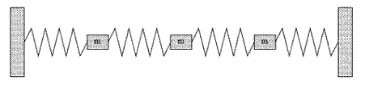

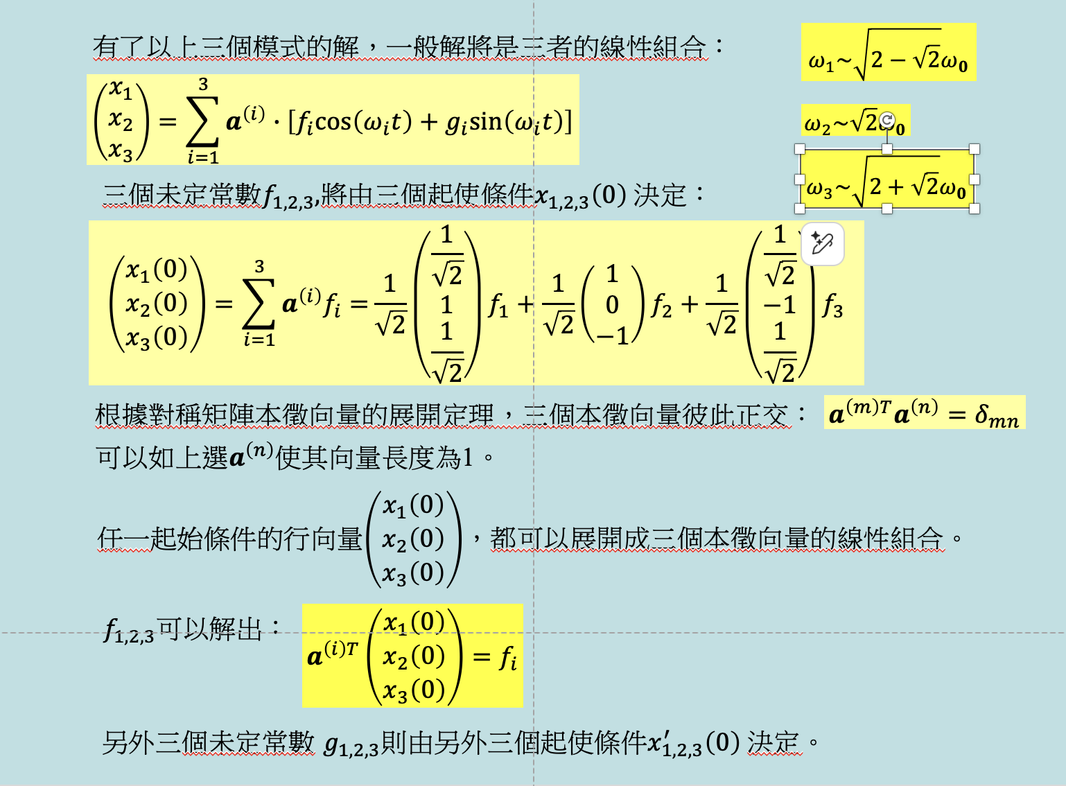

Sol:
$\left(\begin{matrix}x_{1}\left(0\right) \\ x_{2}\left(0\right) \\ x_{3}\left(0\right)\end{matrix}\right)=\left(\begin{matrix}a \\ 0 \\ 0\end{matrix}\right)=\frac{1}{\sqrt{2}}\left(\begin{matrix}\frac{1}{\sqrt{2}} \\ 1 \\ \frac{1}{\sqrt{2}}\end{matrix}\right)f_{1}+\frac{1}{\sqrt{2}}\left(\begin{matrix}1 \\ 0 \\ -1\end{matrix}\right)f_{2}+\frac{1}{\sqrt{2}}\left(\begin{matrix}\frac{1}{\sqrt{2}} \\ -1 \\ \frac{1}{\sqrt{2}}\end{matrix}\right)f_{3}$
$$a^{\left(i\right)T}\left(\begin{matrix}x_{1}\left(0\right) \\ x_{2}\left(0\right) \\ x_{3}\left(0\right)\end{matrix}\right)=f_{i}$$
$$\left(\frac{1}{2},\frac{1}{\sqrt{2}},\frac{1}{2}\right)\left(\begin{matrix}a \\ 0 \\ 0\end{matrix}\right)=f_{1}=\frac{a}{2}$$
$$\frac{1}{\sqrt{2}}\left(1,0,-1\right)\left(\begin{matrix}a \\ 0 \\ 0\end{matrix}\right)=f_{2}=\frac{1}{\sqrt{2}}a$$
$$\left(\frac{1}{2},-\frac{1}{\sqrt{2}},\frac{1}{2}\right)\left(\begin{matrix}a \\ 0 \\ 0\end{matrix}\right)=f_{3}=\frac{a}{2}$$
$$\left(\begin{matrix}x_{1} \\ x_{2} \\ x_{3}\end{matrix}\right)=\sum_{i=1}^{3}{a^{\left(i\right)}∙\left[f_{i}cos\left(ω_{i}t\right)\right]}$$
$$=\frac{a}{2}\frac{1}{\sqrt{2}}\left(\begin{matrix}\frac{1}{\sqrt{2}} \\ 1 \\ \frac{1}{\sqrt{2}}\end{matrix}\right)cos\left(ω_{1}t\right)+a\frac{1}{2}\left(\begin{matrix}1 \\ 0 \\ -1\end{matrix}\right)cos\left(ω_{2}t\right)+\frac{a}{2}\frac{1}{\sqrt{2}}\left(\begin{matrix}\frac{1}{\sqrt{2}} \\ -1 \\ \frac{1}{\sqrt{2}}\end{matrix}\right)cos\left(ω_{3}t\right)$$
$$x_{1}=\frac{a}{2}\left(\frac{1}{2}cos \sqrt{2-\sqrt{2}}ω_{0}t+cos \sqrt{2}ω_{0}t+\frac{1}{2}cos \sqrt{2+\sqrt{2}}ω_{0}t\right)$$
- Consider the following wave equation:
$$\frac{∂^{2}ϕ}{∂t^{2}}=v^{2}\frac{∂^{2}ϕ}{∂x^{2}}-V\left(x\right)ϕ$$
Here we add a term $V\left(x\right)ϕ$ to the right-hand side of the wave function we studied in class. $V\left(x\right)=v^{2}α^{2}x^{2}$ is a known function. This could be done by adding a position dependent restoring force to the particles on the string.

It is reasonable to think that there exists solutions that are separable:
$$ϕ\left(x,t\right)=X\left(x\right)∙T\left(t\right).$$
- Find the Ordinary Differential Equation satisfied by $X\left(x\right)$ and $T\left(t\right)$. Show that $T\left(t\right)$ satisfies the ODE of a simple harmonic oscillator and the solution can be written as:
$$T\left(t\right)=a_{m}\cos\left(ωt+ϕ\right)\sim fcos\left(ωt\right)+gsin\left(ωt\right)$$
- Check that $e^{-α\frac{x^{2}}{2}}$ is a solution for $X\left(x\right)$. Write down the corresponding $T\left(t\right)$. What is the value of $ω$ for this solution?
Sol:
- Plug $ϕ\left(x,t\right)=X\left(x\right)∙T\left(t\right)$into $\frac{∂^{2}ϕ}{∂t^{2}}=v^{2}\frac{∂^{2}ϕ}{∂x^{2}}-V\left(x\right)ϕ:$
$$X\frac{∂^{2}T}{∂t^{2}} =Tv^{2}\frac{∂^{2}X}{∂x^{2}}-VXT$$
Divide the whole equation by $v^{2}XT$:
$$\frac{1}{v^{2}}\frac{1}{T}\frac{d^{2}T}{dt^{2}}=\frac{1}{X}\frac{d^{2}X}{dx^{2}}-\frac{V}{v^{2}}=λ$$
It can be equal to a constant $λ$. Therefore the equation for $T:$
$$\frac{d^{2}T}{dt^{2}}=v^{2}λ∙T≡-ω^{2}T$$
This is the same equation as a SHM for $ω=v\sqrt{-λ}$. The solution is the same as a SHM:
$$T\left(t\right)=a_{m}\cos\left(ωt+ϕ\right)\sim fcos\left(ωt\right)+gsin\left(ωt\right)$$

The equation for $X$:
$$\frac{d^{2}X}{dx^{2}}-\frac{V}{v^{2}}X=\frac{d^{2}X}{dx^{2}}-α^{2}x^{2}X=λ∙X$$
- Plug $e^{-α\frac{x^{2}}{2}}$ into
$$\frac{d^{2}X}{dx^{2}}-α^{2}x^{2}X=λ∙X$$
$${-αe}^{-α\frac{x^{2}}{2}}+{{\left(αx\right)}^{2}e}^{-α\frac{x^{2}}{2}}-α^{2}x^{2}e^{-α\frac{x^{2}}{2}}=λe^{-α\frac{x^{2}}{2}}$$
If $λ=-α,$ $e^{-α\frac{x^{2}}{2}}$is a solution of $X$. The whole solution:
$$ϕ\left(x,t\right)=X\left(x\right)∙T\left(t\right)=e^{-α\frac{x^{2}}{2}}\left[fcos\left(ωt\right)+gsin\left(ωt\right)\right]$$
$$ω=v\sqrt{α}$$

