Homework I
- Calculate $\int_{0}^{∞}{dx∙}e^{-x^{4}}$.
(Hint: Put $x^{4}=y.$)
Use the following Weierstrass Formula to compute a numerical result, by including $n=1⋯5$ in the infinite product:
$$\frac{1}{Γ\left(z\right)}=ze^{γz}\prod_{n=1}^{∞}{\left(1+\frac{z}{n}\right)}e^{-\frac{z}{n}}$$
$γ=0.5772$.
Sol: $x=y^{\frac{1}{4}}$, $dx=\frac{1}{4}y^{-\frac{3}{4}}dy$
$$\int_{0}^{∞}{dx∙}e^{-x^{4}}=\frac{1}{4}\int_{0}^{∞}{dy∙}y^{-\frac{3}{4}}∙e^{-y}=\frac{1}{4}Γ\left(\frac{1}{4}\right)$$
$$\frac{1}{Γ\left(\frac{1}{4}\right)}=\frac{1}{4}e^{0.1443}\left(1+0.25\right)e^{-0.25}\left(1+0.125\right)e^{-0.125}\left(1+0.083\right)e^{-0.083}\left(1+0.26\right)e^{-0.06}$$
$$=\frac{1}{4}e^{0.1443}\left(1.25\right)e^{-0.25}\left(1.125\right)e^{-0.125}\left(1.083\right)e^{-0.083}\left(1.06\right)e^{-0.06}$$
$$=\frac{1}{4}1.1552∙0.9735∙0.9928∙0.997∙0.998\sim 0.2777$$
$$Γ\left(\frac{1}{4}\right)\sim 3.601$$

$$\int_{0}^{∞}{dx∙}e^{-x^{4}}=0.902$$

- Calculate $\int_{0}^{∞}{dy∙}y^{5}e^{-y^{2}}$.
Hint: Put $y^{2}=x.$
Sol: $y^{2}=x, 2ydy=dx$
$$\int_{0}^{∞}{dy∙}y^{5}e^{-y^{2}}=\frac{1}{2}\int_{0}^{∞}{dx∙}x^{2}e^{-x}=\frac{1}{2}Γ\left(3\right)=1$$

- There is also a function called Beta function.
Read the following paragraph in Baos and calculate the following integration:
$$\int_{0}^{∞}{\frac{y^{2}dy}{{\left(1+y\right)}^{6}}}$$
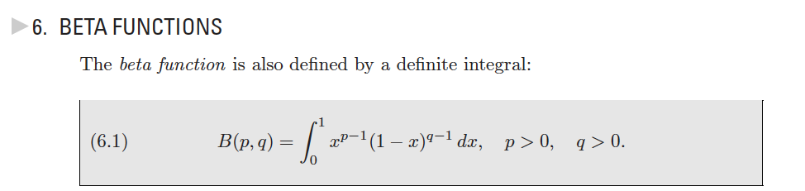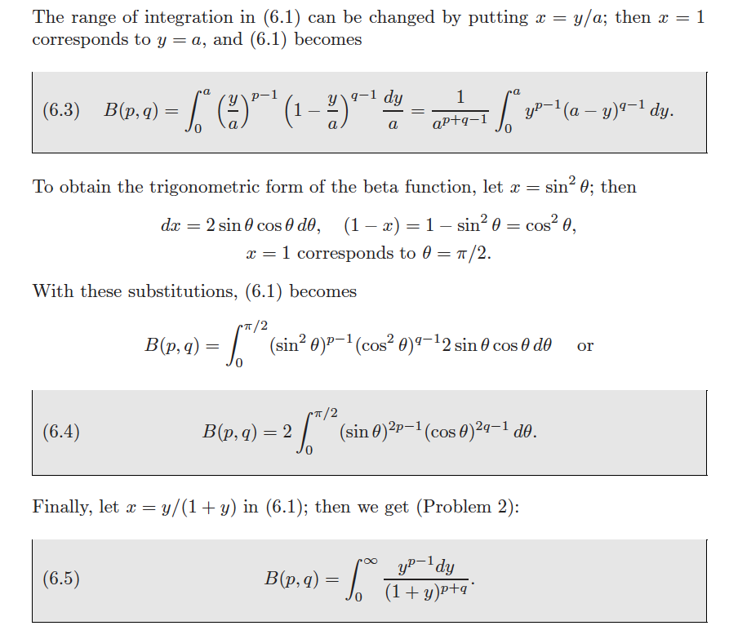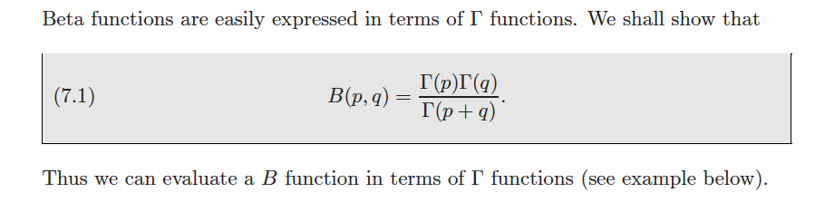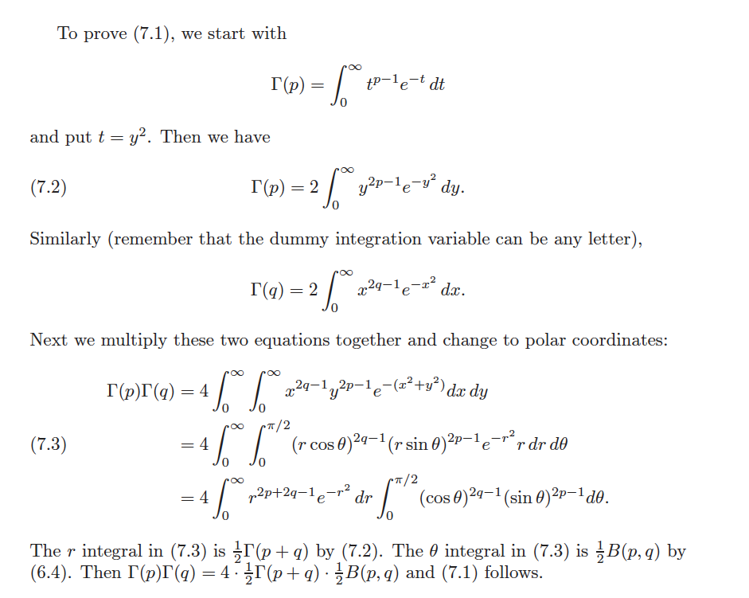
Sol:

