數物期中考
Apr 2026
- The energy levels of the hydrogen atom can be written as $E_{n}=-\frac{13.6}{n^{2}} \text{eV}$.
If some external electrons, with fixed kinetic energy $13.1 \text{eV}$, hit hydrogen atoms at ground state $n=1$ (assume that one electron hit one atom at a time), with all or part of external electron energy absorbed by the atoms, the atoms will emit a photon or photons afterwards. What are the largest and the smallest frequencies of these emitted photons? $h=6.582×{10}^{-16} \text{eV∙s}$.
Solution:
The energy of the first three levels are: $E_{1}=-13.6 \text{eV}$ $E_{2}=-3.4 \text{eV, }E_{3}=-1.5 \text{eV, }E_{4}=-0.85 \text{eV, }E_{5}=-0.54 \text{eV}$. The external electron can only have enough energy for the internal electron to reach $n=2,3,4,5$. Hence the largest and the smallest frequencies of these emitted photons transit: $5→1$, $and 5→4$, respectively. The photon energies are
$$E_{5}-E_{1}=13.06 \text{eV}, E_{5}-E_{4}=0.31 \text{eV}$$
The corresponding frequencies:
$$f_{51}=\frac{E_{5}-E_{1}}{h}=\frac{13.06 \text{eV}}{6.582×{10}^{-16} eV∙s.}=1.98×{10}^{16} \text{Hz}, f_{54}=4.71×{10}^{14} \text{Hz}$$

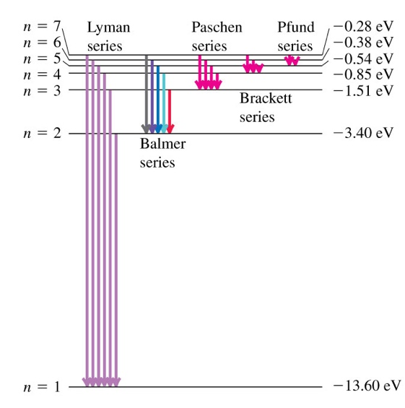
- The Heat Equations is the equation for the temperature distribution in a heat conductivity thin ring. The ring is thin and its temperature depends only on $x (0<x<2πR)$, the location along the circumference of the ring. Denote the temperature difference from a constant temperature $T_{0}$ at $x$ and time $t$ as $u\left(x,t\right)$. $R$ is the radius of the ring. Using the law of conductivity and the first law of thermodynamics, it can be shown that $u\left(x,t\right)$ satisfies the following partial differential equation:
$$\frac{∂^{2}u}{∂x^{2}}=σ\frac{∂u}{∂t}$$
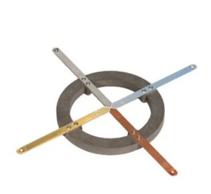
$σ$ is a fixed real positive constant. It is almost identical to the Schrodinger Wave Equation except that the coefficient $σ$ in front of $\frac{∂u}{∂t}$ is real now instead of imaginary.
It is reasonable to think that there exist solutions that are separable just like in the wave equations we discussed in class:
$$u\left(x,t\right)=X\left(x\right)∙T\left(t\right)$$
Since it is a ring, the temperature satisfies a Periodic Boundary condition at all times:
$$u\left(t,0\right)=u\left(t,2πR\right)$$
This condition is widely used in solid state physics.
- Find the Ordinary Differential Equation satisfied by $T\left(t\right)$. Assume that $u\left(x,t\right)$ will not grow indefinitely as $t→∞$. Show that the exponentially decreasing function:
$$T\left(t\right)=e^{-\frac{λ}{σ}t}$$
is a solution for $T\left(t\right)$. $λ$ is a positive constant to be determined.
- Find the Ordinary Differential Equation satisfied by $X\left(x\right)$. This equation is identical to the time independent Schrodinger Equation for free space and hence the solution can be written as:
$$X\left(x\right)=Ae^{i\sqrt{λ}x}+Be^{-i\sqrt{λ}x}=C\cos{\sqrt{λ}x}+D\sin{\sqrt{λ}x}$$
Let’s concentrate on $X\left(x\right)=D\sin{\sqrt{λ}x}$ and ignore the Cosine part for now. The periodic boundary condition would be satisfied if
$$X\left(x\right)=X(x+2πR)$$
The condition for $\sqrt{λ}$ to satisfy the periodic condition is
$$λ_{n}=cn^{2}$$
Calculate the constant $c$. Write down the $u\left(x,t\right)$ for $λ_{n}$. Observe that it will vanish $u\left(x,t\right)→0$ as $t→∞$, meaning the temperature distribution on the ring will eventually become uniform ($=T_{0})$.
Afterword後話: To put $\cos{\sqrt{λ}x}$ back into consideration, we need one more periodic condition: $X'\left(x\right)=X'(x+2πR)$. Apparently, the first derivative is continuous along the whole ring. Then the condition for $\sqrt{λ}$ will be the same.

Sol:
- 將 $u\left(x,t\right)=X\left(x\right)∙T\left(t\right)$代入波方程式：
$$\frac{∂^{2}u}{∂x^{2}}=σ\frac{∂u}{∂t}$$
左右都除以 $X\left(x\right)∙T\left(t\right)∙σ$：
$$\frac{1}{X\left(x\right)}\left[\frac{d^{2}X\left(x\right)}{dx^{2}}\right]=σ\frac{1}{T\left(t\right)}\frac{dT\left(t\right)}{dt}$$
在左邊只與$x$有關，右邊只與$t$有關，兩者是獨立變數，唯一可能是左右兩式與兩個變數都無關，是一常數，設為$-λ$:
$$\frac{1}{X\left(x\right)}\left[\frac{d^{2}X\left(x\right)}{dx^{2}}\right]=σ\frac{1}{T\left(t\right)}\frac{dT\left(t\right)}{dt}≡-λ$$
$$\frac{dT\left(t\right)}{dt}=-\frac{λ}{σ}T\left(t\right)$$
$$T\left(t\right)=e^{-\frac{λ}{σ}t}$$

- 空間部分$ψ\left(x\right)$滿足：
$$\frac{1}{X\left(x\right)}\left[\frac{d^{2}X\left(x\right)}{dx^{2}}\right]=-λ$$
也就是：
$$\frac{d^{2}X\left(x\right)}{dx^{2}}=-λX\left(x\right)$$
$$X\left(x\right)=Ae^{i\sqrt{λ}x}+Be^{-i\sqrt{λ}x}=C\cos{\sqrt{λ}x}+D\sin{\sqrt{λ}x}$$
$$X\left(x\right)=X(x+2πR)$$
$$\sqrt{λ}∙2πR=2nπ, n=1,2,3…$$
The condition is $\sqrt{λ}=\frac{n}{R}$ or $λ={\left(\frac{n}{R}\right)}^{2}$.

- Consider an infinite potential box, with boundaries at $x=0$ and $x=a$:
$V\left(x\right)=∞, x>a, x<0$ and $V\left(x\right)=0, 0< x<a$.
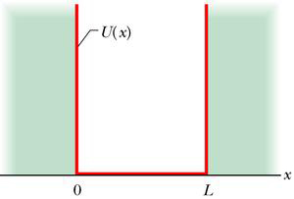
$$a$$
$$V\left(x\right)$$
As we have shown in class, in this potential the stationary states 定態state function can be written as $u_{n}=\sqrt{\frac{2}{a}}\sin{\frac{nπx}{a}}$ with eigenvalues $E_{n}=\left(\frac{ℏ^{2}}{2m}\right)\frac{π^{2}}{a^{2}}n^{2}$.
- Assume the wavefunction of an electron at $t=0$ is (, its total probability already normalized to one):
$$Ψ\left(x,0\right)=\left(\sqrt{\frac{2}{a}}\sin{\frac{5πx}{a}}\right) 0<x<a,$$
$$=0 x<0,x>a$$
For a later time $t>0$, write down the wave function $Ψ\left(x,t\right)$, in terms of $E_{5}$ and $t$. Calculate the Probability of finding the electron between $0< x<\frac{a}{8}$ at time $t$. (15)
Hint: You might need this formula: ${\text{sin}}^{2}θ=\frac{1-\cos{2θ}}{2}$.

- Assume the wavefunction of another electron at $t=0$ is: (, its probability already normalized to one)
$$Ψ\left(x,0\right)=\sqrt{\frac{1}{2}}\left(\sqrt{\frac{2}{a}}\sin{\frac{πx}{a}}\right)+\sqrt{\frac{1}{2}}\left(\sqrt{\frac{2}{a}}\sin{\frac{3πx}{a}}\right) 0<x<a,$$
$$=0 x<0,x>a$$
For a later time $t>0$, at $x=\frac{a}{4}$, write down the wave function $Ψ\left(\frac{a}{4},t\right)$, in terms of $E_{1,3}$ and $t$. It can be shown that its probability density at $x=\frac{a}{4}$ is an oscillating function of time $t$:
$$P\left(\frac{a}{4},t\right)∝1+\cos{ωt}$$
Calculate the angular frequency $ω$ of this oscillation in terms of $ℏ,m,a$.
Hint: ${\left|A+B\right|}^{2}=\left(A^{*}+B^{*}\right)\left(A+B\right)={\left|A\right|}^{2}+{\left|B\right|}^{2}+A^{*}B+B^{*}A$

解答：

$$P=\int_{0}^{\frac{a}{8}}{{\left|\sqrt{\frac{2}{a}}\sin{\frac{5πx}{a}}\right|}^{2}∙dx \text{=}\frac{2}{a}\int_{0}^{\frac{a}{8}}{\left(\frac{1-\cos{\frac{10πx}{a}}}{2}\right)∙dx }}$$
$$\text{=}{\left.\frac{2}{a}\left(\frac{x}{2}-\frac{a}{10π}\frac{\sin{\frac{10πx}{a}}}{2}\right)\right|}_{0}^{\frac{a}{8}}=\frac{1}{12}-\frac{a}{10π}\frac{1}{2\sqrt{2}}$$

$t=0$時此狀態可以視為定態$u_{1,2}$的如上疊加，接著定態隨時間個自演化，位能下薛丁格方程式要求$u_{n}$乘$\text{上}e^{-i\frac{E_{n}}{ℏ}t}$。乘完之後依同樣方式疊加，整個波函數也就滿足薛丁格波方程式。因此
$Ψ\left(x,t\right)=\sqrt{\frac{1}{2}}\left(\sqrt{\frac{2}{a}}\sin{\frac{πx}{a}}\right)e^{-i\frac{E_{1}}{ℏ}t}+\sqrt{\frac{1}{2}}\left(\sqrt{\frac{2}{a}}\sin{\frac{3πx}{a}}\right)e^{-i\frac{E_{3}}{ℏ}t}$。
$$Ψ\left(\frac{a}{4},t\right)=\sqrt{\frac{1}{2}}\left(\sqrt{\frac{2}{a}}\sin{\frac{π}{4}}\right)e^{-i\frac{E_{1}}{ℏ}t}+\sqrt{\frac{1}{2}}\left(\sqrt{\frac{2}{a}}\sin{\frac{3π}{4}}\right)e^{-i\frac{E_{3}}{ℏ}t}$$
$$=\sqrt{\frac{1}{a}}\left(\frac{1}{\sqrt{2}}e^{-i\frac{E_{1}}{ℏ}t}+\frac{1}{\sqrt{2}}e^{-i\frac{E_{3}}{ℏ}t}\right)$$
$$P\left(\frac{a}{4},t\right)={\left|Ψ\left(\frac{a}{4},t\right)\right|}^{2}={\frac{1}{2a}\left|e^{-i\frac{E_{1}}{ℏ}t}+e^{-i\frac{E_{3}}{ℏ}t}\right|}^{2}$$

$$=\frac{1}{2a}\left\{{\left|e^{-i\frac{E_{1}}{ℏ}t}\right|}^{2}+{\left|e^{-i\frac{E_{3}}{ℏ}t}\right|}^{2}+e^{i\frac{E_{1}}{ℏ}t}e^{-i\frac{E_{3}}{ℏ}t}+e^{i\frac{E_{3}}{ℏ}t}e^{-i\frac{E_{1}}{ℏ}t}\right\}$$
$$=\frac{1}{2a}\left\{1+1+e^{-i\frac{\left(E_{3}-E_{1}\right)}{ℏ}t}+e^{i\frac{\left(E_{3}-E_{1}\right)}{ℏ}t}\right\}$$
$$=\frac{1}{2a}\left\{2+\cos{\frac{\left(E_{3}-E_{1}\right)}{ℏ}t-i\sin{\frac{\left(E_{3}-E_{1}\right)}{ℏ}t}}+\cos{\frac{\left(E_{3}-E_{1}\right)}{ℏ}t+i\sin{\frac{\left(E_{3}-E_{1}\right)}{ℏ}t}}\right\}$$
$$=\frac{1}{2a}\left\{2+2\cos{\frac{\left(E_{3}-E_{1}\right)}{ℏ}t}\right\}∝1+\cos{ωt}$$
$$ω=\frac{\left(E_{3}-E_{1}\right)}{ℏ}=\frac{\left(\frac{ℏ^{2}}{2m}\right)\frac{π^{2}}{a^{2}}8}{ℏ}=\frac{{4π}^{2}ℏ}{ma^{2}}$$

