習題九

- We consider String Wave Equation last term: $τ\frac{∂^{2}y}{∂x^{2}}=μ\frac{∂^{2}y}{∂t^{2}}$. It can be generalized to the case with x-dependent $τ\left(x\right),μ(x)$ and an extra restoring force $v(x)$. The equation is now written as:
$$\frac{∂}{∂x}\left[τ\left(x\right)\frac{∂y}{∂x}\right]-v(x)y=μ(x)\frac{∂^{2}y}{∂t^{2}}$$
also known as generalized string wave equation.
It can be solved in ways quite similar to wave equation by separation of variables. Assume the separable mode solutions can be written as
$$y\left(x,t\right)=X\left(x\right)∙T\left(t\right).$$
- Find the Ordinary Differential Equation satisfied by $X\left(x\right)$ and $T\left(t\right)$. Show that $T\left(t\right)$ satisfies the same equation of motion as SHM and solution can be written as
$$T\left(t\right)=a_{m}\cos\left(ωt+ϕ\right)$$
The constant $ω$ (unspecified yet) can be interpreted as the oscillating frequency of the mode solution while $a_{m},ϕ$ can be used to fit the initial conditions. The ODE satisfied by $X\left(x\right)$ is called Sturm-Liouville Eigenfunction Problem. Almost the spatial part of classical wave equations and QM time independent Schrodinger Equations are examples of SL problems.
- Consider the case:
$$v\left(x\right)=ax^{2},τ\left(x\right)=μ\left(x\right)=1$$
Write down the Ordinary Differential Equation, or Sturm-Liouville Eigenfunction Equation, satisfied by $X\left(x\right)$ in terms of $ω,a$. Observe that it is the same as time independent Schrodinger Equations for SHM:
$$\frac{d^{2}u}{dx^{2}}=\frac{m^{2}ω_{0}^{2}}{ℏ^{2}}x^{2}u-\frac{2mE}{ℏ^{2}}u$$
if we replace $\frac{m^{2}ω_{0}^{2}}{ℏ^{2}}$ in QM SHM with $a$ in generalized string equation, and $\frac{2mE}{ℏ^{2}}$ with $ω^{2}$. What are the possible values of oscillating frequencies $ω$ in terms of the parameter $a$ (just $a,$ since it is the only parameter in our generalized string equation, and no $ℏ,m,ω_{0}$, which exist only in analogy QM equation)? What is the wavefunction $y\left(x,t\right)$ for the smallest possible $ω$.

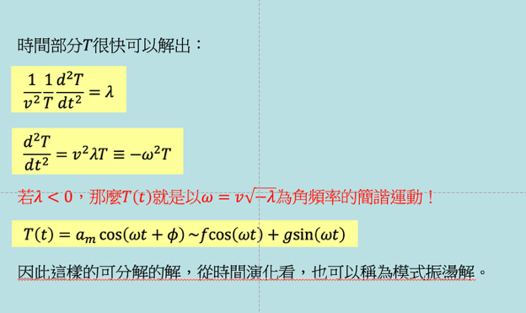
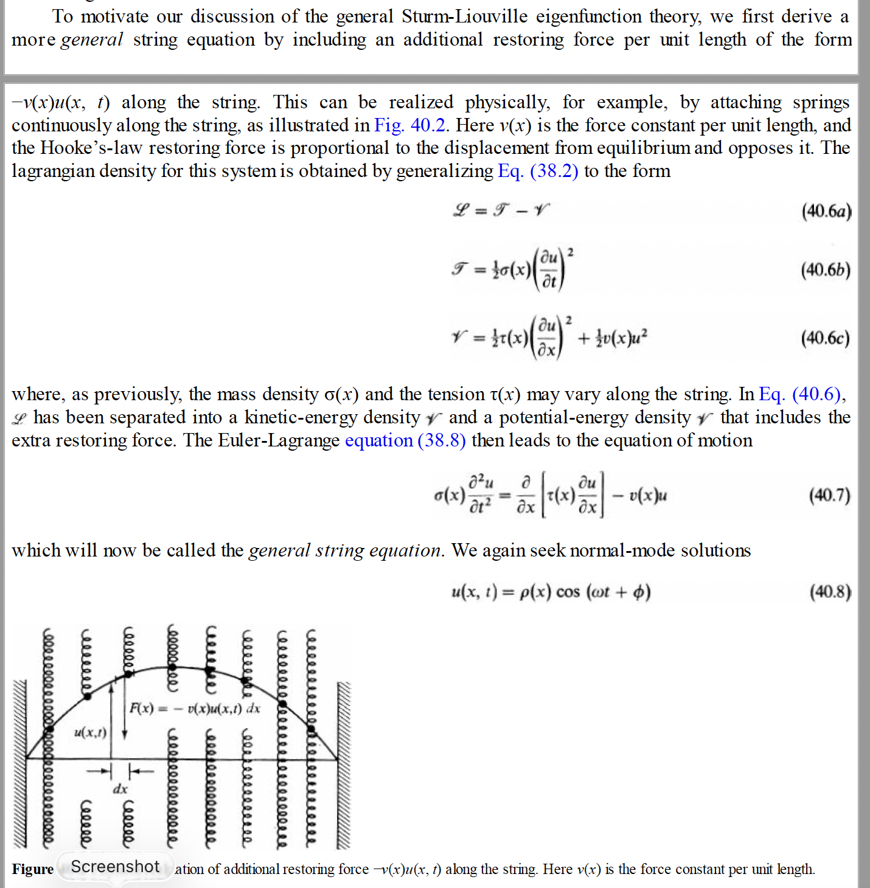
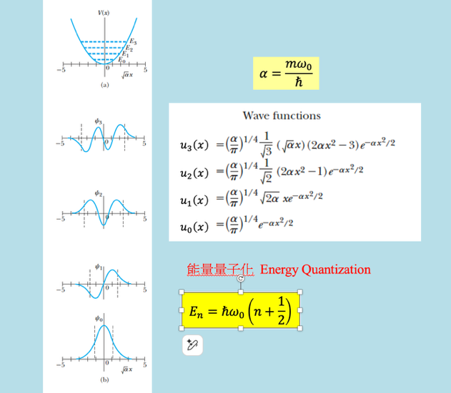

Solution: Sol:
- 將$y\left(x,t\right)=X\left(x\right)∙T\left(t\right)$代入波方程式：
$$\frac{∂}{∂x}\left[τ\left(x\right)\frac{∂y}{∂x}\right]-v(x)y=μ(x)\frac{∂^{2}y}{∂t^{2}}$$
左右都除以 $X\left(x\right)∙T\left(t\right)∙μ(x)$：
$$\frac{1}{μ(x)X\left(x\right)}\left[\frac{∂}{∂x}\left[τ\left(x\right)\frac{∂X}{∂x}\right]-v(x)X\right]=\frac{1}{T\left(t\right)}\frac{d^{2}T}{dt^{2}}$$
在左邊只與$x$有關，右邊只與$t$有關，兩者是獨立變數！唯一可能是左右兩式與兩個變數都無關，是一常數，設為$λ$。
$$\frac{1}{μ(x)X\left(x\right)}\left[\frac{d}{dx}\left[τ\left(x\right)\frac{dX}{dx}\right]-v(x)X\right]=\frac{1}{T\left(t\right)}\frac{d^{2}T}{dt^{2}}≡λ$$

$$\frac{d^{2}T}{dt^{2}}=λT≡-ω^{2}T$$
$λ<0$，
$$T\left(t\right)=a_{m}\cos\left(ωt+ϕ\right)$$
空間部分$X\left(x\right)$滿足
$$\frac{1}{μ\left(x\right)X\left(x\right)}\left[\frac{d}{dx}\left[τ\left(x\right)\frac{dX}{dx}\right]-v\left(x\right)X\right]=-ω^{2}$$
That is:
$$\left[\frac{d}{dx}\left[τ\left(x\right)\frac{dX}{dx}\right]-v\left(x\right)X\right]=-ω^{2}μ\left(x\right)X\left(x\right)$$
This is the so-called Sturm-Liouville Eigenfunction Problem. $ω^{2}$ is the eigenvalue.

- In the case: $v\left(x\right)=ax^{2},τ\left(x\right)=μ\left(x\right)=1$, the SL equation becomes:
$$\left[\frac{d^{2}X}{dx^{2}}-ax^{2}X\right]=-ω^{2}X\left(x\right)$$
Compare it to QM SHM:
$$\frac{d^{2}u}{dx^{2}}-\frac{m^{2}ω_{0}^{2}}{ℏ^{2}}x^{2}u=-\frac{2mE}{ℏ^{2}}u$$
They are identical if we replace $\frac{m^{2}ω_{0}^{2}}{ℏ^{2}}$ with $a$ and $\frac{2mE}{ℏ^{2}}$ with $ω^{2}$.
$$\frac{m^{2}ω_{0}^{2}}{ℏ^{2}}=a$$
$$\frac{2mE}{ℏ^{2}}=ω^{2}$$
We know the possible values of $E$ are $E_{n}=ℏω_{0}\left(n+\frac{1}{2}\right)=ℏ\left(n+\frac{1}{2}\right)\frac{ℏ}{m}\sqrt{a}$. The possible values of $ω$ are: $ω_{n}=\frac{2mE_{n}}{ℏ^{2}}=\left(2n+1\right)\sqrt{a}$.
The smallest possible $ω$ is $n=0, ω=\sqrt{a}$. The corresponding $X\left(x\right)=e^{-α\frac{x^{2}}{2}}=e^{-\frac{mω_{0}}{ℏ}\frac{x^{2}}{2}}=e^{-\sqrt{a}\frac{x^{2}}{2}}$. The wavefunction is
$$y\left(x,t\right)=X\left(x\right)∙T\left(t\right)=e^{-\sqrt{a}\frac{x^{2}}{2}}a_{m}\cos\left(\sqrt{a}t+ϕ\right)$$

- Consider the wavefunction of an electron at a certain moment:
$$ψ\left(x\right)=\sqrt{\frac{2}{a}}\sin{\frac{3πx}{a}},0< x<a,$$
$$ψ\left(x\right)=0, x>a, x<0$$
This is the stationary state wavefunction of an electron located within an infinite potential box, with boundaries at $x=0$ and $x=a$:
(The potential is $V\left(x\right)=∞, x>a, x<0$ and $V\left(x\right)=0, 0< x<a$. We will discuss this wavefunction in details in class later.)
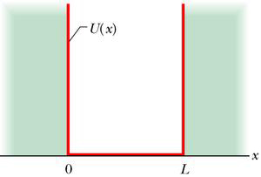
$$a$$
$$V\left(x\right)$$
- Prove that it is normalized: $\int_{0}^{a}{{\left|ψ\left(x\right)\right|}^{2}∙dx }=1$.(15)
- Calculate the Probability of finding the electron between $0< x<\frac{a}{12}.$(15)
Hint: You might need this formula: ${\text{sin}}^{2}θ=\frac{1-\cos{2θ}}{2}$.
解答：

$$\int_{0}^{a}{{\left|\sqrt{\frac{2}{a}}\sin{\frac{3πx}{a}}\right|}^{2}∙dx }=\frac{2}{a}\int_{0}^{a}{{\left(\sin{\frac{3πx}{a}}\right)}^{2}∙dx }=\frac{2}{a}\int_{0}^{a}{\left(\frac{1-\cos{\frac{6πx}{a}}}{2}\right)dx \text{=}}$$
$${\left.\frac{2}{a}\left(\frac{x}{2}-\frac{a}{6π}\frac{\sin{\frac{6πx}{a}}}{2}\right)\right|}_{0}^{a}=\frac{2}{a}\frac{a}{2}-0=1$$

$$P=\int_{0}^{\frac{a}{12}}{{\left|\sqrt{\frac{2}{a}}\sin{\frac{3πx}{a}}\right|}^{2}∙dx \text{=}{\left.\frac{2}{a}\left(\frac{x}{2}-\frac{a}{6π}\frac{\sin{\frac{6πx}{a}}}{2}\right)\right|}_{0}^{\frac{a}{12}}=\frac{1}{12}-\frac{1}{6π}}$$
- Consider an infinite potential box, with boundaries at $x=0$ and $x=a$:
$V\left(x\right)=∞, x>a, x<0$ and $V\left(x\right)=0, 0< x<a$.
$$a$$
$$V\left(x\right)$$
As we have shown in class, in this potential the energy eigenstate can be written as $\sqrt{\frac{2}{a}}\sin{\frac{nπx}{a}}$ with eigenvalues $E_{n}=\left(\frac{ℏ^{2}}{2m}\right)\frac{π^{2}}{a^{2}}n^{2} (you can use$ the notation $E_{n}$to simplify your answers) . Assume the wavefunction of a particle at $t=0$(probability already normalized to one) is:
$$Ψ\left(x,0\right)=\sqrt{\frac{4}{5}}\left(\sqrt{\frac{2}{a}}\sin{\frac{πx}{a}}\right)+\sqrt{\frac{1}{5}}\left(\sqrt{\frac{2}{a}}\sin{\frac{2πx}{a}}\right) 0<x<a,$$
$$=0 x<0,x>a$$
- For a later time $t$, write down the wave function $ψ\left(x,t\right).$ There is no need to simplify the answer. (15)
- At $x=\frac{a}{6}$, calculate the probability density $P\left(\frac{a}{6},t\right)$ as a function of time $t$.
Hint: ${\left|A+B\right|}^{2}=\left(A^{*}+B^{*}\right)\left(A+B\right)={\left|A\right|}^{2}+{\left|B\right|}^{2}+A^{*}B+B^{*}A$

解答：
- $t=0$時此狀態可以視為定態$u_{1,2}$的如上疊加，接著定態隨時間個自演化，位能下薛丁格方程式要求$u_{n}$乘$\text{上}e^{-i\frac{E_{n}}{ℏ}t}$。乘完之後依同樣方式疊加，整個波函數也就滿足薛丁格波方程式。因此
$Ψ\left(x,t\right)=\sqrt{\frac{4}{5}}\left(\sqrt{\frac{2}{a}}\sin{\frac{πx}{a}}\right)e^{-i\frac{E_{1}}{ℏ}t}+\sqrt{\frac{1}{5}}\left(\sqrt{\frac{2}{a}}\sin{\frac{2πx}{a}}\right)e^{-i\frac{E_{2}}{ℏ}t}$。
- $Ψ\left(\frac{a}{6},t\right)=\sqrt{\frac{4}{5}}\left(\sqrt{\frac{2}{a}}\sin{\frac{π}{6}}\right)e^{-i\frac{E_{1}}{ℏ}t}+\sqrt{\frac{1}{5}}\left(\sqrt{\frac{2}{a}}\sin{\frac{π}{3}}\right)e^{-i\frac{E_{2}}{ℏ}t}$
$$=\sqrt{\frac{2}{5a}}\left(2\frac{1}{2}e^{-i\frac{E_{1}}{ℏ}t}+\frac{\sqrt{3}}{2}e^{-i\frac{E_{2}}{ℏ}t}\right)$$
$$P\left(\frac{a}{6},t\right)={\left|Ψ\left(\frac{a}{6},t\right)\right|}^{2}={\frac{2}{5a}\left|e^{-i\frac{E_{1}}{ℏ}t}+\frac{\sqrt{3}}{2}e^{-i\frac{E_{2}}{ℏ}t}\right|}^{2}$$

$$=\frac{2}{5a}\left\{{\left|e^{-i\frac{E_{1}}{ℏ}t}\right|}^{2}+{\left|e^{-i\frac{E_{2}}{ℏ}t}\right|}^{2}+e^{i\frac{E_{1}}{ℏ}t}e^{-i\frac{E_{2}}{ℏ}t}+e^{i\frac{E_{2}}{ℏ}t}e^{-i\frac{E_{1}}{ℏ}t}\right\}$$
$$=\frac{2}{5a}\left\{1+1+e^{-i\frac{\left(E_{2}-E_{1}\right)}{ℏ}t}+e^{i\frac{\left(E_{2}-E_{1}\right)}{ℏ}t}\right\}$$
$$=\frac{2}{5a}\left\{2+\cos{\frac{\left(E_{2}-E_{1}\right)}{ℏ}t-i\sin{\frac{\left(E_{2}-E_{1}\right)}{ℏ}t}}+\cos{\frac{\left(E_{2}-E_{1}\right)}{ℏ}t+i\sin{\frac{\left(E_{2}-E_{1}\right)}{ℏ}t}}\right\}$$
$$=\frac{2}{5a}\left\{2+2\cos{\frac{\left(E_{2}-E_{1}\right)}{ℏ}t}\right\}$$
$$=\frac{2}{5a}\left\{2+2\cos{\frac{\left(\frac{ℏ^{2}}{2m}\right)\frac{π^{2}}{a^{2}}3}{ℏ}t}\right\}=\frac{2}{5a}\left\{2+2\cos{\frac{{3π}^{2}ℏ}{2ma^{2}}t}\right\}$$

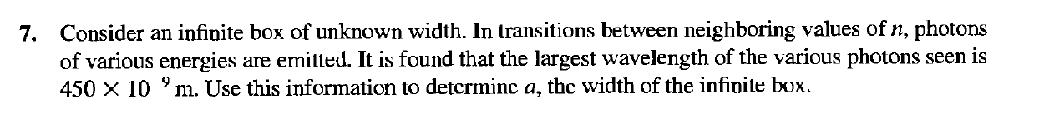

Sol:
