Problem Set 8

- The energy levels of the hydrogen atom can be written as $E_{n}=-\frac{13.6}{n^{2}} \text{eV}$. If some external electrons, with fixed kinetic energy $12.5 \text{eV}$, hit hydrogen atoms at ground state $n=1$ (assume that one electron hit one atom at a time), with all or part of external electron energy absorbed by the atoms, the atoms will emit a photon or photons afterwards. What are the possible energies of these emitted photons?

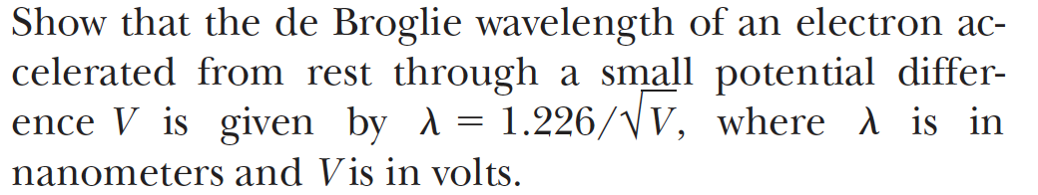

- Consider a wavefunction at $t=0$ written as:
$$ψ_{E}=e^{ikx}+Re^{-ikx}$$
Calculate the probability density as a function of $x$ in terms of constants $R,k$.

