Homework III
- First consider the homogeneous ODE:
$$\frac{d^{2}x}{dt^{2}}+3\frac{dx}{dt}+3x=0$$
- Find the general solutions $x_{h}$ of this ODE.
- Consider the inhomogeneous ODE:
$$\frac{d^{2}x}{dt^{2}}+3\frac{dx}{dt}+3x=12e^{-2t}$$
Find one solution. Hint: $x∝e^{-2t}$ would work.
- Find the general solutions $x_{inh}$ of the inhomogeneous ODE.
- Assume the initial condition $x\left(0\right)=0,\frac{dx}{dt}\left(0\right)=0$, find the solution $x\left(t\right)$.

Sol:
- 取$x=ce^{αt}$，代入微分方程式，得到$α$的代數方程式：$α^{2}+3α+3=0$：
求解：$α=\frac{-3±i\sqrt{3}}{2}$，取$e^{αt}$的實數部與虛數部，就能得到兩個實數解，取線性組合，就得到一般解：
$$x_{h}=c_{1}e^{-3t/2}\cos{\frac{\sqrt{3}}{2}t}+c_{2}e^{-3t/2}\sin{\frac{\sqrt{3}}{2}t}$$
- 取$x=de^{-2t}$，代入微分方程式：$\left(4-6+3\right)de^{-2t}=12e^{-2t}$，$d=12$
得到一個特解：$x=12e^{-2t}$
- 一般解：
$$x_{inh}=c_{1}e^{-3t/2}\cos{\frac{\sqrt{3}}{2}t}+c_{2}e^{-3t/2}\sin{\frac{\sqrt{3}}{2}t}+12e^{-2t}$$
- 代入起始條件$x\left(0\right)=c_{1}+12=0$，$c_{1}=-12$。
$\frac{dx}{dt}\left(0\right)=-\frac{3}{2}c_{1}+\frac{\sqrt{3}}{2}c_{2}-24=0$，$c_{2}=\frac{12}{\sqrt{3}}=4\sqrt{3}$。
$$x_{inh}=-12e^{-3t/2}\cos{\frac{\sqrt{3}}{2}t}+4\sqrt{3}e^{-3t/2}\sin{\frac{\sqrt{3}}{2}t}+12e^{-2t}$$

2.
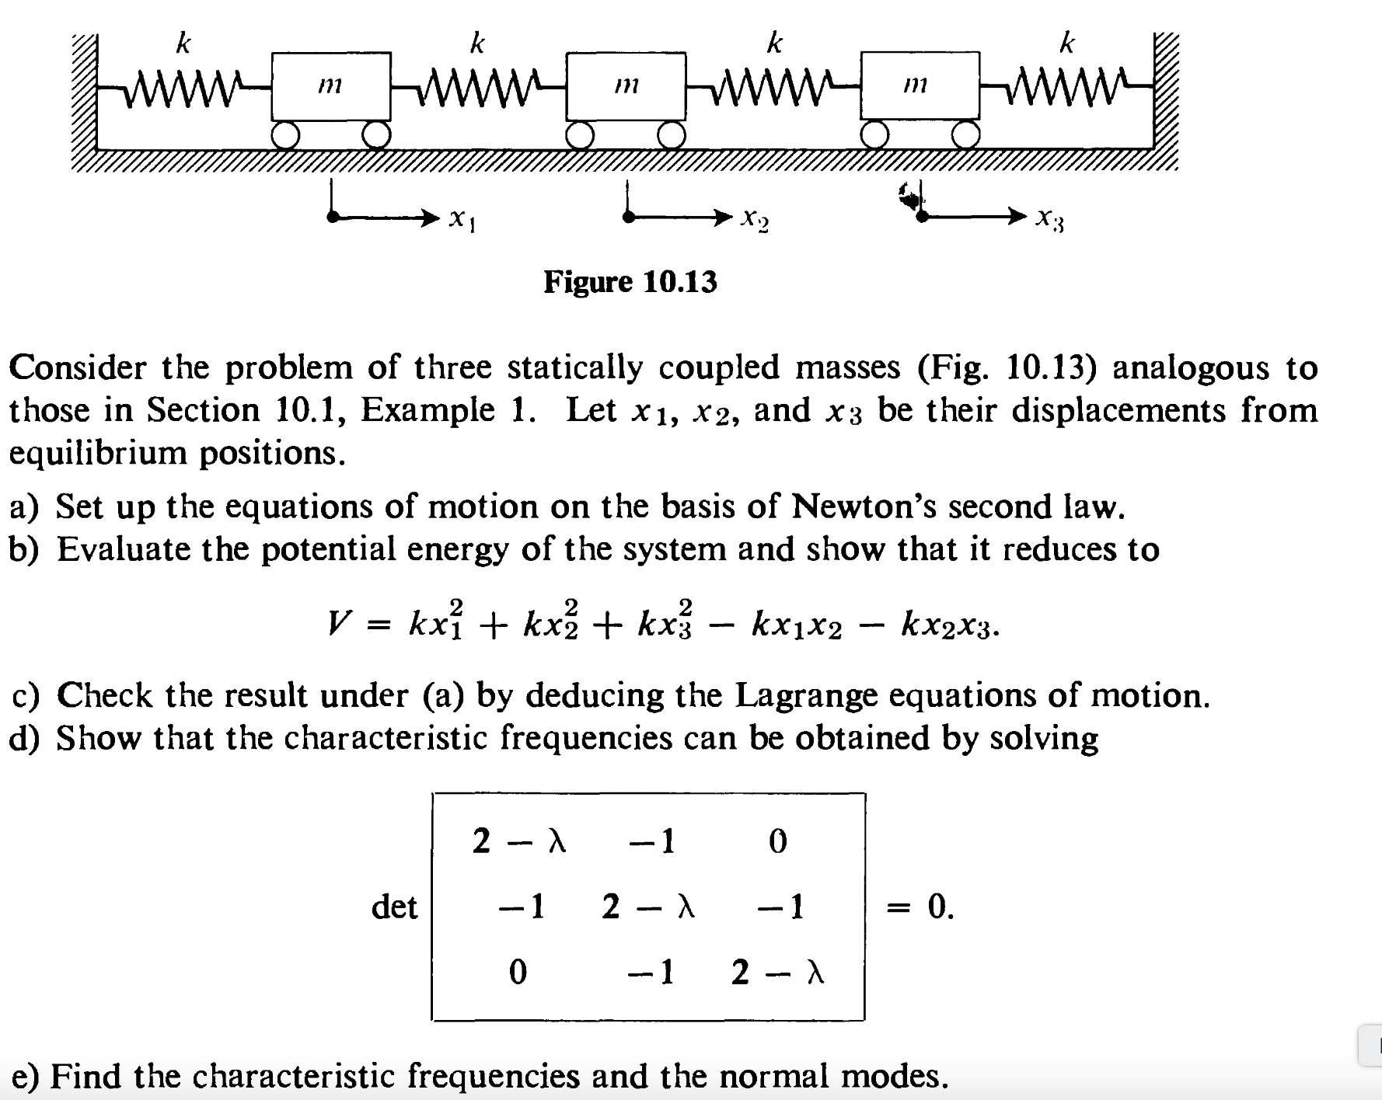
Sol:
- 運動方程式：
$$m\frac{d^{2}x_{1}}{dt^{2}}=k\left(x_{2}-x_{1}\right)-kx_{1}=-2kx_{1}+kx_{2}$$
$$m\frac{d^{2}x_{2}}{dt^{2}}=k\left(x_{3}-x_{2}\right)-k\left(x_{2}-x_{1}\right)=-2kx_{2}+kx_{3}+kx_{1}$$
$$m\frac{d^{2}x_{3}}{dt^{2}}=-k\left(x_{3}-x_{2}\right)-kx_{3}=-2kx_{3}+kx_{2}$$
- 計算彈簧的彈力位能：
$$V=\frac{k}{2}\left[x_{1}^{2}+{\left(x_{2}-x_{1}\right)}^{2}+{\left(x_{3}-x_{2}\right)}^{2}+x_{3}^{2}\right]=k\left(x_{1}^{2}+x_{2}^{2}+x_{3}^{2}-x_{1}x_{2}-x_{2}x_{3}\right)$$
- 若以矩陣語言來書寫：
$$x≡\left(\begin{matrix}x_{1} \\ x_{2} \\ x_{3}\end{matrix}\right),A=ω_{0}^{2}\left(\begin{matrix}2 & -1 & 0 \\ -1 & 2 & -1 \\ 0 & -1 & 2\end{matrix}\right)$$
$$\frac{d^{2}}{dt^{2}}x=-A∙x$$
取$x≡ae^{iωt}$，代入得本徵值方程式：$A∙a=ω^{2}a=λω_{0}^{2}a$。特徵方程式為以下行列式為零：
$$\left|\begin{matrix}2-λ & -1 & 0 \\ -1 & 2-λ & -1 \\ 0 & -1 & 2-λ\end{matrix}\right|=0$$
得代數方程式：
$${\left(2-λ\right)}^{3}-2\left(2-λ\right)=\left(2-λ\right)\left(2-4λ+λ^{2}\right)=0$$
$$解得本徵值：$$
$λ=2,2±\sqrt{2}$, $ω^{2}=2ω_{0}^{2},\left(2±\sqrt{2}\right)ω_{0}^{2}$
- 計算本徵向量：
For $λ=2$: 解聯立方程組：$\left(A-λω_{0}^{2}\right)∙a=0$
可以寫成：
$$-a_{2}=0$$
$$-a_{1}-a_{3}=0$$
$$-a_{2}=0$$
可以得：$a=\left(\begin{matrix}1 \\ 0 \\ -1\end{matrix}\right)$
For $λ=2+\sqrt{2}$:
$$\sqrt{2}a_{1}+a_{2}=0$$
$$a_{1}+\sqrt{2}a_{2}+a_{3}=0$$
$$a_{2}+\sqrt{2}a_{3}=0$$
$a=\frac{1}{2}\left(\begin{matrix}1 \\ -\sqrt{2} \\ 1\end{matrix}\right)$
For $λ=2-\sqrt{2}$:
$$\sqrt{2}a_{1}-a_{2}=0$$
$$-a_{1}+\sqrt{2}a_{2}-a_{3}=0$$
$$-a_{2}+\sqrt{2}a_{3}=0$$

$a=\frac{1}{2}\left(\begin{matrix}1 \\ \sqrt{2} \\ 1\end{matrix}\right)$

