習題十一

- Consider a packet-like state :
$$ψ\left(x\right)=\frac{1}{\sqrt{2N}} -N≤x≤N$$
$=0 x>N,x<N$
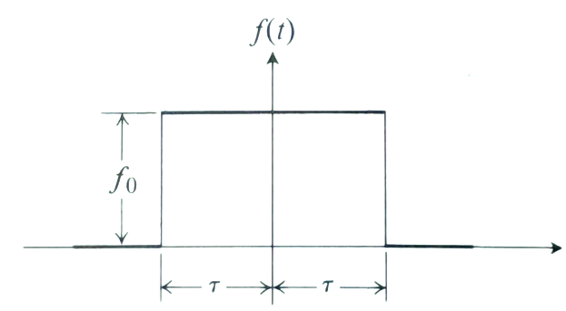

$$\frac{1}{\sqrt{2N}}$$

$$N$$
$$N$$

Calculate the Fourier Transform:
$$ϕ\left(p\right)=\frac{1}{\sqrt{2πℏ}}\int_{-∞}^{∞}{ψ\left(x\right)∙e^{-ipx/ℏ}∙dx}.$$
Prove that
$$ϕ\left(p\right)=\frac{1}{\sqrt{πNℏ}}\frac{\sin{\frac{N}{ℏ}p}}{\frac{p}{ℏ}}$$
$$\frac{\sin{\frac{N}{ℏ}p}}{\frac{p}{ℏ}}$$
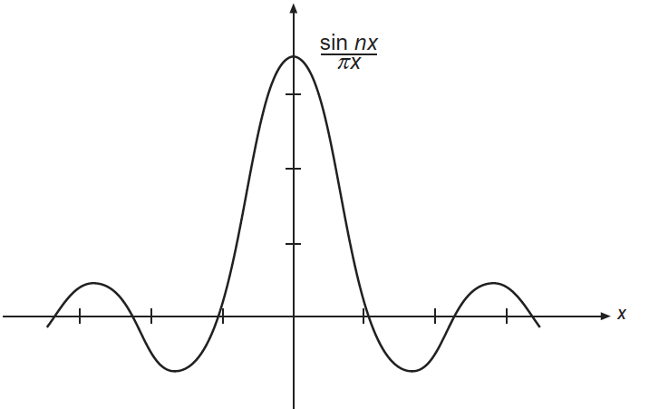
$$p$$

- Consider an infinite potential box, with boundaries at $x=0$ and $x=a$:
$V\left(x\right)=∞, x>a, x<0$ and $V\left(x\right)=0, 0< x<a$.
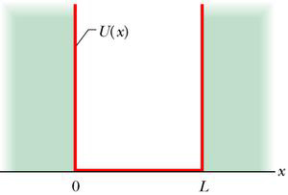
$$a$$
$$V\left(x\right)$$
As we have shown in class, in this potential the energy eigenstate can be written as $\sqrt{\frac{2}{a}}\sin{\frac{nπx}{a}}$ with eigenvalues $E_{n}=\left(\frac{ℏ^{2}}{2m}\right)\frac{π^{2}}{a^{2}}n^{2} (you can use$ the notation $E_{n}$to simplify your answers) . Assume the wavefunction of a particle at $t=0$(probability already normalized to one) is:
$$Ψ\left(x,0\right)=\sqrt{\frac{4}{5}}\left(\sqrt{\frac{2}{a}}\sin{\frac{πx}{a}}\right)+\sqrt{\frac{1}{5}}\left(\sqrt{\frac{2}{a}}\sin{\frac{2πx}{a}}\right) 0<x<a,$$
$$=0 x<0,x>a$$
At $t=0$, make an energy measurement. What are the values it could possibly give? What are the corresponding probabilities? Do they add up to one? What is the expectation value of energy. (20)
Hint: Expectation value is the sum of the measured value times the probability.

