數物期末考
Dec 2025
- We mentioned in class that through the diagonalization of a matrix, we can represent a matrix by its eigenvectors and eigenvalues:
$$A=UΛU^{-1}=U\left(\begin{matrix}λ_{1} & 0 \\ 0 & λ_{2}\end{matrix}\right)U^{-1}$$
$$U≡\left(\begin{matrix}a^{\left(1\right)} & a^{\left(2\right)}\end{matrix}\right)$$
Given any one column vector $a$ and any two numbers $λ_{1},λ_{2}$we can construct a matrix which has $a$ as one of the eigenvectors and $λ_{1},λ_{2}$ as eigenvalues.
Let’s start with $a^{\left(1\right)}=\frac{1}{\sqrt{5}}\left(\begin{matrix}1 \\ -2\end{matrix}\right)$. (25)
- For a symmetric matrix, eigenvectors are orthogonal to each other. Use this property to find a normalized $a^{\left(2\right)}$ such that $a^{T\left(2\right)}a^{\left(1\right)}=0,a^{T\left(2\right)}a^{\left(2\right)}=1$.
- Construct $U$ and calculate $U^{-1}$ using $U^{-1}=\frac{1}{\det{U}}\left(\begin{matrix}U_{22} & -U_{12} \\ -U_{21} & U_{11}\end{matrix}\right)$.
- Choose the two eigenvalues as $λ_{1}=10,λ_{2}=20$. Find the matrix $A$.
- Check indeed $A∙a^{\left(1\right)}=λ_{1}a^{\left(1\right)}.$
Sol:
- Assume that $a^{\left(2\right)}=\left(\begin{matrix}b \\ c\end{matrix}\right)$. Since $a^{T\left(2\right)}a^{\left(1\right)}=0, b-2c=0. Hence a^{\left(2\right)}=c\left(\begin{matrix}2 \\ 1\end{matrix}\right).$ Using $a^{T\left(2\right)}a^{\left(2\right)}=1,$ $a^{\left(2\right)}=\frac{1}{\sqrt{5}}\left(\begin{matrix}2 \\ 1\end{matrix}\right).$
- $U=\frac{1}{\sqrt{5}}\left(\begin{matrix}1 & 2 \\ -2 & 1\end{matrix}\right), U^{-1}=\frac{1}{\sqrt{5}}\left(\begin{matrix}1 & -2 \\ 2 & 1\end{matrix}\right)$
- $A=UΛU^{-1}=U\left(\begin{matrix}λ_{1} & 0 \\ 0 & λ_{2}\end{matrix}\right)U^{-1}=\frac{1}{5}\left(\begin{matrix}1 & 2 \\ -2 & 1\end{matrix}\right)\left(\begin{matrix}10 & 0 \\ 0 & 20\end{matrix}\right)\left(\begin{matrix}1 & -2 \\ 2 & 1\end{matrix}\right)$
$$\frac{1}{5}\left(\begin{matrix}1 & 2 \\ -2 & 1\end{matrix}\right)\left(\begin{matrix}10 & -20 \\ 40 & 20\end{matrix}\right)=\frac{1}{5}\left(\begin{matrix}90 & 20 \\ 20 & 60\end{matrix}\right)=\left(\begin{matrix}18 & 4 \\ 4 & 12\end{matrix}\right)$$
- $\left(\begin{matrix}18 & 4 \\ 4 & 12\end{matrix}\right)\frac{1}{\sqrt{5}}\left(\begin{matrix}1 \\ -2\end{matrix}\right)=\frac{1}{\sqrt{5}}\left(\begin{matrix}10 \\ -20\end{matrix}\right)=10×\frac{1}{\sqrt{5}}\left(\begin{matrix}1 \\ -2\end{matrix}\right)$

- Consider the spring system of $N=3$ coupled masses. Assume that the spring constants are all equal to $k$ and the masses are all equal to $m$. $ω_{0}=\sqrt{\frac{k}{m}}$.
If we move the first particle to the right by $a$ and let go as all three particles are at rest, that is, the initial condition is $x_{1}\left(0\right)=a$, $x_{2}\left(0\right)=x_{3}\left(0\right)=0$, $x_{1}^{'}\left(0\right)=x_{2}^{'}\left(0\right)=x_{3}^{'}\left(0\right)=0$, solve the $x_{1}\left(t\right)$. Write the solution in terms of $a,ω_{0}.$
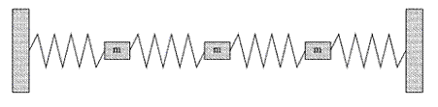

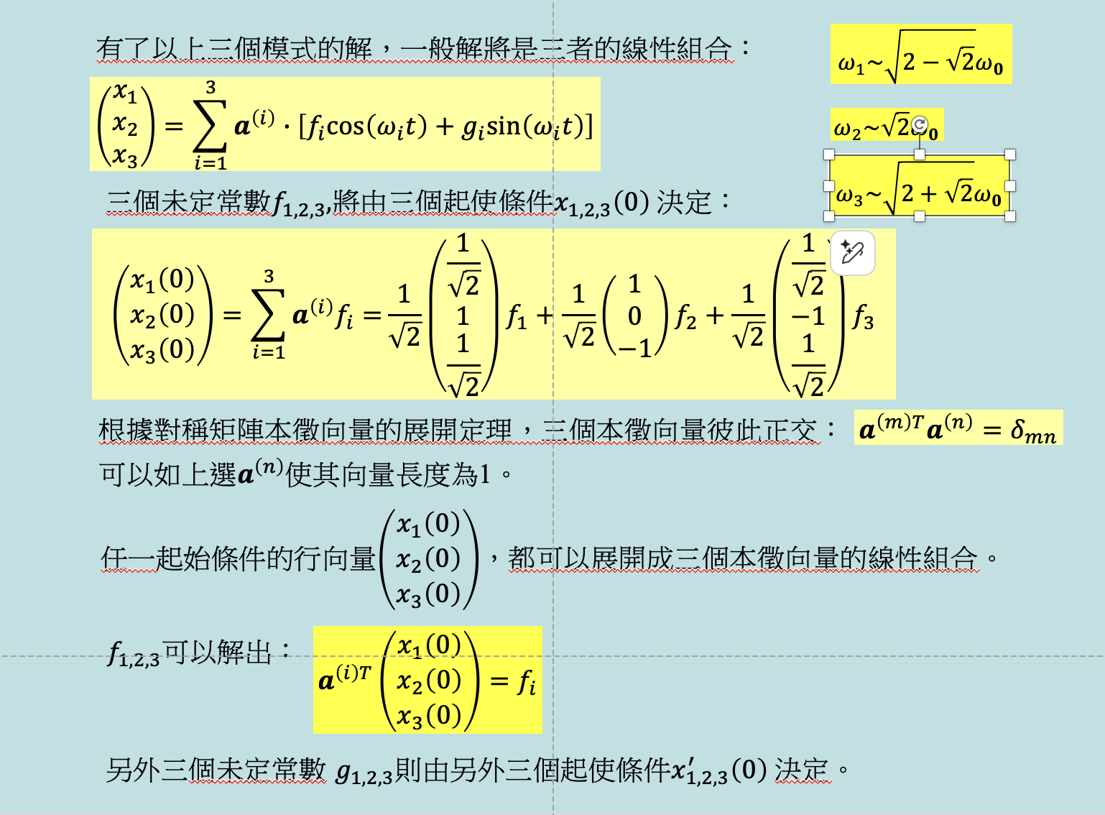

Sol:
$\left(\begin{matrix}x_{1}\left(0\right) \\ x_{2}\left(0\right) \\ x_{3}\left(0\right)\end{matrix}\right)=\left(\begin{matrix}a \\ 0 \\ 0\end{matrix}\right)=\frac{1}{\sqrt{2}}\left(\begin{matrix}\frac{1}{\sqrt{2}} \\ 1 \\ \frac{1}{\sqrt{2}}\end{matrix}\right)f_{1}+\frac{1}{\sqrt{2}}\left(\begin{matrix}1 \\ 0 \\ -1\end{matrix}\right)f_{2}+\frac{1}{\sqrt{2}}\left(\begin{matrix}\frac{1}{\sqrt{2}} \\ -1 \\ \frac{1}{\sqrt{2}}\end{matrix}\right)f_{3}$
$$a^{\left(i\right)T}\left(\begin{matrix}x_{1}\left(0\right) \\ x_{2}\left(0\right) \\ x_{3}\left(0\right)\end{matrix}\right)=f_{i}$$
$$\left(\frac{1}{2},\frac{1}{\sqrt{2}},\frac{1}{2}\right)\left(\begin{matrix}a \\ 0 \\ 0\end{matrix}\right)=f_{1}=\frac{a}{2}$$
$$\frac{1}{\sqrt{2}}\left(1,0,-1\right)\left(\begin{matrix}a \\ 0 \\ 0\end{matrix}\right)=f_{2}=\frac{1}{\sqrt{2}}a$$
$$\left(\frac{1}{2},-\frac{1}{\sqrt{2}},\frac{1}{2}\right)\left(\begin{matrix}a \\ 0 \\ 0\end{matrix}\right)=f_{3}=\frac{a}{2}$$
$$\left(\begin{matrix}x_{1} \\ x_{2} \\ x_{3}\end{matrix}\right)=\sum_{i=1}^{3}{a^{\left(i\right)}∙\left[f_{i}cos\left(ω_{i}t\right)\right]}$$
$$=\frac{a}{2}\frac{1}{\sqrt{2}}\left(\begin{matrix}\frac{1}{\sqrt{2}} \\ 1 \\ \frac{1}{\sqrt{2}}\end{matrix}\right)cos\left(ω_{1}t\right)+a\frac{1}{2}\left(\begin{matrix}1 \\ 0 \\ -1\end{matrix}\right)cos\left(ω_{2}t\right)+\frac{a}{2}\frac{1}{\sqrt{2}}\left(\begin{matrix}\frac{1}{\sqrt{2}} \\ -1 \\ \frac{1}{\sqrt{2}}\end{matrix}\right)cos\left(ω_{3}t\right)$$
$$x_{1}=\frac{a}{2}\left(\frac{1}{2}cos \sqrt{2-\sqrt{2}}ω_{0}t+cos \sqrt{2}ω_{0}t+\frac{1}{2}cos \sqrt{2+\sqrt{2}}ω_{0}t\right)$$

- The Maxwell Equation in vacuum can be written as:
$$\vec{∇}×\vec{E}=-\frac{∂\vec{B}}{∂t}, \vec{∇}×\vec{B}=μ_{0}ε_{0}\frac{∂\vec{E}}{∂t}$$
$$\vec{∇}∙\vec{E}=0, \vec{∇}∙\vec{B}=0$$
Consider a plane wave propagating in the $x$ direction. The electric field of the wave is along the $y$ direction and both the electric field and magnetic field are independent of coordinates $y,z$. The electric field can be written as:
$$\vec{E}=\left(0,E_{y}\left(x,t\right),0\right)=\left(0,E_{0}\cos\left(kx-ωt\right),0\right)$$
- Calculate $\vec{∇}×\vec{E}$ and $\frac{∂\vec{E}}{∂t}$.
- Use Maxwell Equation $\vec{∇}×\vec{E}=-\frac{∂\vec{B}}{∂t}$ to find the magnetic field $\vec{B}(x,t)$ (write it in three component notation).
Hint: Only one component is nonzero.
Comment: If you further plug the result into the other Maxwell Equation $\vec{∇}×\vec{B}=μ_{0}ε_{0}\frac{∂\vec{E}}{∂t}$, you would find that $\frac{ω}{k}=c=\frac{1}{\sqrt{μ_{0}ε_{0}}}$ as expected.
Sol:

$$\vec{∇}×\vec{E}=\left(\frac{∂E_{y}}{∂z}-\frac{∂E_{z}}{∂y},\frac{∂E_{z}}{∂x}-\frac{∂E_{x}}{∂z},\frac{∂E_{x}}{∂y}-\frac{∂E_{y}}{∂x}\right)=\left(\frac{∂E_{y}}{∂z},0,-\frac{∂E_{y}}{∂x}\right)=\left(0,0,-\frac{∂E_{y}}{∂x}\right)=\left(0,0,kE_{0}\sin\left(kx-ωt\right)\right)$$
$$\frac{∂\vec{E}}{∂t}=\left(0,-ωE_{0}\sin\left(kx-ωt\right),0\right)$$
- $\vec{∇}×\vec{E}=-\frac{∂\vec{B}}{∂t}=\left(0,0,kE_{0}\sin\left(kx-ωt\right)\right)$
$$\frac{∂B_{z}}{∂t}=-kE_{0}\sin\left(kx-ωt\right)$$
$$B_{z}\left(x,t\right)=\frac{k}{ω}E_{0}\cos\left(kx-ωt\right)$$

- One of the first Schrodinger Wave Equations to be written down and solved is that of an electron in the simple harmonic potential $V\left(x\right)=\frac{ℏ^{2}}{2m}α^{2}x^{2}$:
$$iℏ\frac{∂Ψ}{∂t}=-\frac{ℏ^{2}}{2m}\frac{∂^{2}Ψ}{∂x^{2}}+V\left(x\right)Ψ$$
$α$ is actually $\frac{mω}{ℏ}=\frac{\sqrt{mk}}{ℏ}.$ But calculation would be easier to keep $α$ as above. $ℏ$ is the Planck Constant $h$ divided by $2π$. Here $Ψ\left(x,t\right)$ is the famous wave function. As you can see from the equation, the left-hand side contains an $i$ and hence the wavefunction must be complex valued. It is reasonable to think that there exist solutions that are separable just like in the classical wave equation we discussed in class:
$$Ψ\left(x,t\right)=ψ\left(x\right)∙ϕ\left(t\right).$$
- Find the Ordinary Differential Equation satisfied by $ψ\left(x\right)$ and $ϕ\left(t\right)$. Show that:
$$ϕ\left(t\right)=e^{-i\frac{E}{ℏ}t}$$
is the solution for $ϕ\left(t\right)$. $E$ is a constant to be determined.
- $ψ\left(x\right)$ would have solutions for a discreet set of infinite number of positive values of $E$. Prove that $e^{-α\frac{x^{2}}{2}}$ is a solution for $ψ\left(x\right)$. Write down the corresponding $E$(this is the smallest $E$ and $E$corresponds to energy. All the other solutions have larger $E$ and $e^{-α\frac{x^{2}}{2}}$ is the ground state) and$ϕ\left(t\right)$ in terms of $α,m,ℏ$.
Sol:
- 將$Ψ\left(x,t\right)=ψ\left(x\right)∙ϕ\left(t\right)$代入波方程式：
$$-\frac{ℏ^{2}}{2m}ϕ\left(t\right)\frac{d^{2}ψ\left(x\right)}{dx^{2}}+V\left(x\right)ψ\left(x\right)ϕ\left(t\right)=iℏψ\left(x\right)\frac{dϕ\left(t\right)}{dt}$$
左右都除以 $ψ\left(x\right)∙ϕ\left(t\right)$：
$$\frac{1}{ψ\left(x\right)}\left[-\frac{ℏ^{2}}{2m}\frac{d^{2}ψ\left(x\right)}{dx^{2}}+V\left(x\right)ψ\left(x\right)\right]=iℏ\frac{1}{ϕ\left(t\right)}\frac{dϕ\left(t\right)}{dt}$$
唯一可能是左右兩式與兩個變數都無關，是一常數。設為$E$。
在左邊只與$x$有關，右邊只與$t$有關，兩者是獨立變數！
$$\frac{1}{ψ\left(x\right)}\left[-\frac{ℏ^{2}}{2m}\frac{d^{2}ψ\left(x\right)}{dx^{2}}+V\left(x\right)ψ\left(x\right)\right]=iℏ\frac{1}{ϕ\left(t\right)}\frac{dϕ\left(t\right)}{dt}≡E$$
$$iℏ\frac{dϕ\left(t\right)}{dt}=Eϕ\left(t\right)$$
$$ϕ\left(t\right)=e^{-i\frac{E}{ℏ}t}$$
- 空間部分$ψ\left(x\right)$滿足：
$$\frac{1}{ψ\left(x\right)}\left[-\frac{ℏ^{2}}{2m}\frac{d^{2}ψ\left(x\right)}{dx^{2}}+V\left(x\right)ψ\left(x\right)\right]=E$$
也就是：
$$-\frac{ℏ^{2}}{2m}\frac{d^{2}ψ\left(x\right)}{dx^{2}}+\frac{ℏ^{2}}{2m}α^{2}x^{2}ψ\left(x\right)=Eψ\left(x\right)$$
代入$ψ\left(x\right)=e^{-α\frac{x^{2}}{2}}$
$$-\frac{d^{2}ψ}{dx^{2}}+α^{2}x^{2}ψ=\frac{2m}{ℏ^{2}}E∙ψ$$
$${αe}^{-α\frac{x^{2}}{2}}-{{\left(αx\right)}^{2}e}^{-α\frac{x^{2}}{2}}+α^{2}x^{2}e^{-α\frac{x^{2}}{2}}={αe}^{-α\frac{x^{2}}{2}}=\frac{2m}{ℏ^{2}}E∙ψ$$
If $E=\frac{ℏ^{2}}{2m}α,$ $e^{-α\frac{x^{2}}{2}}$is a solution. The whole solution:
$$Ψ\left(x,t\right)=ψ\left(x\right)∙ϕ\left(t\right)=e^{-α\frac{x^{2}}{2}}e^{-i\frac{E}{ℏ}t}$$
$$E=\frac{ℏ^{2}}{2m}α$$

