習題四解答
- Consider a Simple Harmonic Oscillator whose Hamiltonian can be written as: $H=\frac{1}{2m}p^{2}+\frac{1}{2}kx^{2}$. The eigenstates can be written as $\left.\left|n\right.\right\rangle$with eigenvalues $E_{n}^{\left(0\right)}=ℏω\left(n+\frac{1}{2}\right)$.
This SHO is perturbed by a small potential: $λH_{1}=λℏω\left(\frac{2mω}{ℏ}\right)x^{2}$. Treating this potential as a perturbation. To the leading order of $λ$, the real ground state can be written as a linear combination of the unperturbed energy eigenstates $\left.\left|n\right.\right\rangle :$
$$\left|\left.0_{real}\right\rangle \right.\sim \left|\left.0\right\rangle \right.+λ\sum_{k≠0}{\frac{\left\langle \left.k\right|\right.H_{1}\left|\left.0\right\rangle \right.}{E_{0}^{\left(0\right)}-E_{k}^{\left(0\right)}}\left|\left.k\right\rangle \right.}$$
Find the possible $\left|\left.k\right\rangle \right.$ or ${\left|\left.k\right\rangle \right.}^{'}s$and calculate the coefficients.
You can use the formula: $a\left.\left|n\right.\right\rangle =\sqrt{n}∙\left.\left|n-1\right.\right\rangle ,$ $a^{†}\left.\left|n\right.\right\rangle =\sqrt{n+1}∙\left.\left|n+1\right.\right\rangle ,\left[a,a^{†}\right]=1$
$$x=\sqrt{\frac{ℏ}{2mω}}\left(a+a^{†}\right)$$

解答：$\left\langle \left.k\right|\right.{\left(a+a^{†}\right)}^{2}\left|\left.0\right\rangle \right.=\left\langle \left.k\right|\right.\left(a+a^{†}\right)\left(a+a^{†}\right)\left|\left.0\right\rangle \right.=\left\langle \left.k\right|\right.\left(a+a^{†}\right)a^{†}\left|\left.0\right\rangle \right.$
$$\left\langle \left.2\right|\right.H_{1}\left|\left.0\right\rangle \right.=\sqrt{2}λℏω$$
$$\left|\left.0_{real}\right\rangle \right.\sim \left|\left.0\right\rangle \right.+λ\sum_{k≠0}{\frac{\left\langle \left.k\right|\right.H_{1}\left|\left.0\right\rangle \right.}{E_{0}^{\left(0\right)}-E_{k}^{\left(0\right)}}\left|\left.k\right\rangle \right.}=\left|\left.0\right\rangle \right.-\frac{\sqrt{2}λℏω}{2ℏω}\left|\left.2\right\rangle \right.=\left|\left.0\right\rangle \right.-\frac{\sqrt{2}λ}{2}\left|\left.2\right\rangle \right.$$

- Consider an infinite potential as discussed in class, with boundaries at $x=0$ and $x=a$, while containing a small step potential:
$$V\left(x\right)=∞, x>a, x<0$$
$=0, a/2< x<a$.
$=-b, 0< x<a/2$.
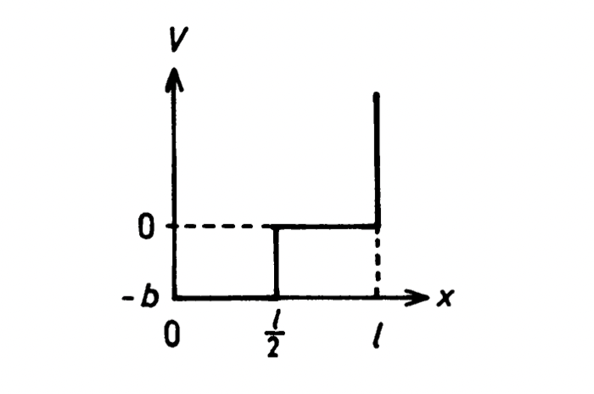
$$a/2$$
$$V\left(x\right)$$
$$a$$
The eigenfunction of an infinite box is known to be:
$$ψ\left(x\right)=\sqrt{\frac{2}{a}}\sin{\frac{nπx}{a}} , 0<x<a$$
$$=0 x<0,x>a$$
with energy eigenvalues: $E_{n}^{(0)}=\frac{n^{2}π^{2}ℏ^{2}}{2ma^{2}}$.
Calculate the correction in first order of $b$ to the ground state energy $E_{1}^{\left(1\right)}.$
解答：
$$E_{1}^{\left(1\right)}=\frac{2}{a}\int_{0}^{a}{dx\sin{\frac{πx}{a}}V\left(x\right)\sin{\frac{πx}{a}}}=\frac{2}{a}\int_{0}^{\frac{a}{2}}{dx\left(-b\right){\left(\sin{\frac{πx}{a}}\right)}^{2}}=-\frac{b}{a}\int_{0}^{\frac{a}{2}}{dx \left(1-\cos{\frac{2πx}{a}}\right)}=-\frac{b}{2}$$

- We will work out here an example of degenerate perturbation theory.
A Simple Harmonic Oscillator has a Hamiltonian as: $H=\frac{1}{2m}p^{2}+\frac{1}{2}kx^{2}$. The eigenstates can be written as $\left.\left|n\right.\right\rangle \sim u_{n}\left(x\right)$with eigenvalues $E_{n}=ℏω\left(n+\frac{1}{2}\right)$. We can extend the idea to 2D and consider a 2D SHO with a Hamiltonian:
$$H=\frac{1}{2}p_{x}^{2}+\frac{1}{2}p_{y}^{2}+\frac{1}{2}x^{2}+\frac{1}{2}y^{2}$$
For convenience, here we choose a unit system where $ℏ=m=ω=1$. Just like 3D electron gas we discussed in class, the motion in $x$ and the motion in $y$ are separable and the 2D SHO can be separated into two 1D SHO, one in $x$ and one in $y$, with no interaction between them. The eigenstates could be written (as in 3D electron gas) as the products of an eigenstate $\left.\left|n_{x}\right.\right\rangle$of 1D SHO in $x$ and an eigenstate $\left.\left|n_{y}\right.\right\rangle$of 1D SHO in $y$:
$$\left.\left|n_{x},\right.n_{y}\right\rangle ≡\left.\left|n_{x}\right.\right\rangle \left.\left|n_{y}\right.\right\rangle \sim u_{n_{x}}\left(x\right)∙u_{n_{y}}\left(y\right)$$
with energy eigenvalues:
$$E_{{n_{x},n}_{y}}={n_{x}+n}_{y}+1$$
The ground state is $\left.\left|0,\right.0\right\rangle \sim u_{0}\left(x\right)∙u_{0}\left(y\right)$. And there are two lowest excited states
$$\left.\left|1,\right.0\right\rangle \sim u_{1}\left(x\right)∙u_{0}\left(y\right),\left.\left|0,\right.1\right\rangle \sim u_{0}\left(x\right)∙u_{1}\left(y\right)$$
with the same energy and hence this is a two-fold degeneracy.
- What is the energy eigenvalue of the lowest excited states?
Now introduce a perturbation potential:
$$H_{1}=\frac{1}{2}εxy\left(x^{2}+y^{2}\right)$$
$ε≪1.$To calculate the energy corrections for the two degenerate states using perturbation, we need the matrix elements of $H_{1}$ between $\left.\left|1,\right.0\right\rangle and \left.\left|0,\right.1\right\rangle$. They turn out to be very simple. We can identify $\left.\left|1,\right.0\right\rangle$ as $\left|\left.ϕ_{1}\right\rangle \right.$ and $\left.\left|0,\right.1\right\rangle$as $\left|\left.ϕ_{2}\right\rangle \right.$in the class discussion.
$$h_{11}=\left\langle \left.1,0\right|\right.H_{1}\left|\left.1,0\right\rangle \right.=h_{22}=\left\langle \left.0,1\right|\right.H_{1}\left|\left.0,1\right\rangle \right.=0$$
$$h_{12}=\left\langle \left.1,0\right|\right.H_{1}\left|\left.0,1\right\rangle \right.=h_{21}=\left\langle \left.0,1\right|\right.H_{1}\left|\left.1,0\right\rangle \right.=\frac{3}{4}ε$$
You don’t need to do it but the detailed calculation is as follow:
$$\left\langle \left.1,0\right|\right.H_{1}\left|\left.0,1\right\rangle \right.=\iint_{-∞}^{∞}{dxdy∙u_{1}\left(x\right)u_{0}\left(y\right)\left[\frac{1}{2}εxy\left(x^{2}+y^{2}\right)\right]}u_{0}\left(x\right)u_{1}\left(y\right)$$
$$=\frac{ε}{2}\frac{2}{π}\iint_{-∞}^{∞}{dxdy∙xye^{-\left(x^{2}+y^{2}\right)}\left[xy\left(x^{2}+y^{2}\right)\right]}=$$
$$=\frac{ε}{π}\iint_{-∞}^{∞}{rdrdθ∙e^{-r^{2}}r^{2}∙r^{2}{\text{cos}}^{2}θ∙r^{2}{\text{sin}}^{2}θ}=\frac{3}{4}ε$$
- Use the above matrix elements to form the key matrix $\left(\begin{matrix}h_{11} & h_{12} \\ h_{21} & h_{22}\end{matrix}\right)$. Calculate the 1st order energy corrections $E^{\left(1\right)}$.
Hint:
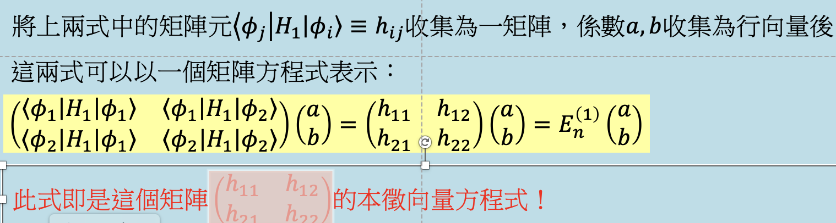
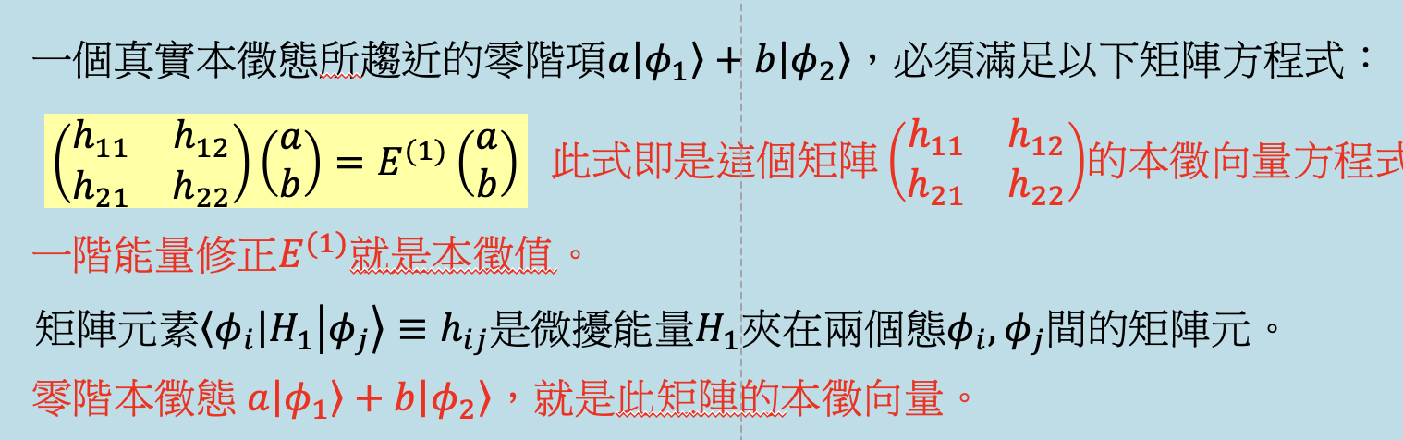
Solution: For the lowest excited states, $E^{\left(0\right)}=2.$
For the degenerate perturbation calculation:
$\left(\begin{matrix}h_{11} & h_{12} \\ h_{21} & h_{22}\end{matrix}\right)=\left(\begin{matrix}0 & \frac{3}{4}ε \\ \frac{3}{4}ε & 0\end{matrix}\right)$. Assume that eigenvalue is $λ$. $\left|\begin{matrix}-λ & \frac{3}{4}ε \\ \frac{3}{4}ε & -λ\end{matrix}\right|=0$
Eigenvalues, which are the energy corrections, are $±\frac{3}{4}ε=E^{\left(1\right)}$

