習題四

- Textbook Chapter 2 8
Solution:
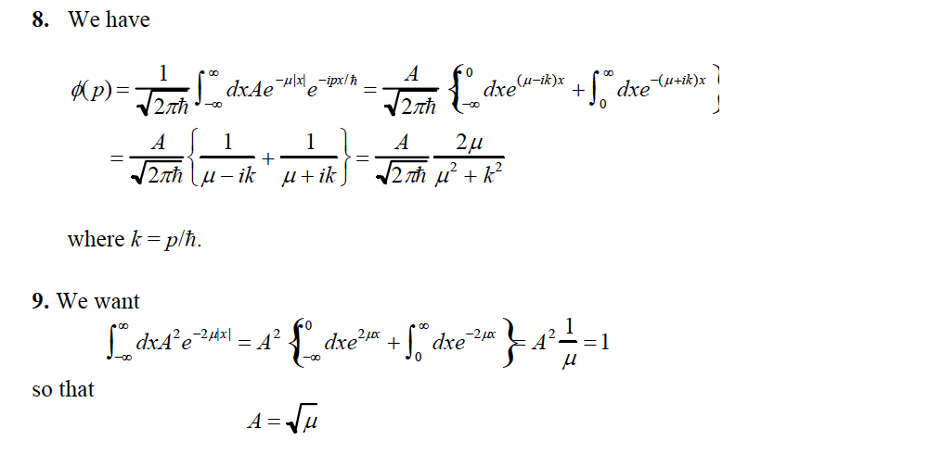
- The instant wavefunction of a wave packet is $Ψ\left(x,0\right)=Ce^{ik_{0}x}e^{-\frac{{ax}^{2}}{2}}$. Determine the constant $C$ using normalization condition.
Solution:
$$1=\int_{-∞}^{∞}{{dx∙ψ}^{*}\left(x\right)}ψ\left(x\right)=C^{2}\int_{-∞}^{∞}{dx∙e^{-ik_{0}x}e^{ik_{0}x}e^{-ax^{2}}}=C^{2}\sqrt{\frac{π}{a}}$$
$$C=\sqrt[4]{\frac{a}{π}}$$

- Textbook Chapter 2 16,17,18
Solution:

