習題三
- Solution:
- $R_{nn-1}\left(r\right)\sim e^{-\frac{r}{{na}_{0}}}∙r^{n-1}$ since $H$ is a polynomials of $n-l-1=0$ order, a constant.
- The maximum occurs at $0=R_{nn-1}^{'}\left(r_{0}\right)\sim \left(n-1\right)r_{0}^{n-2}e^{-\frac{r_{0}}{{na}_{0}}}-r_{0}^{n-1}\frac{1}{{na}_{0}}e^{-\frac{r_{0}}{{na}_{0}}}$. Therefore $r_{0}=n\left(n-1\right)a_{0}$.
- $Y_{n-1n-1}\left(θ,ϕ\right)\sim {\text{sin}}^{n-1}θ$, since $the multiplying polynomial in\cos{θ}is of l-m=0\text{ order}$, again a constant. It peaks at the peak of $\sin{θ}$, ie $θ=\frac{π}{2}.$ That is on the $x-y$ plane.

- Ch. 10 10-1. For the eigenstate with the higher eigenvalue, measure $S_{z}$.what are (or is) the possible values? What are (or is) the corresponding probabilities?
Solution:
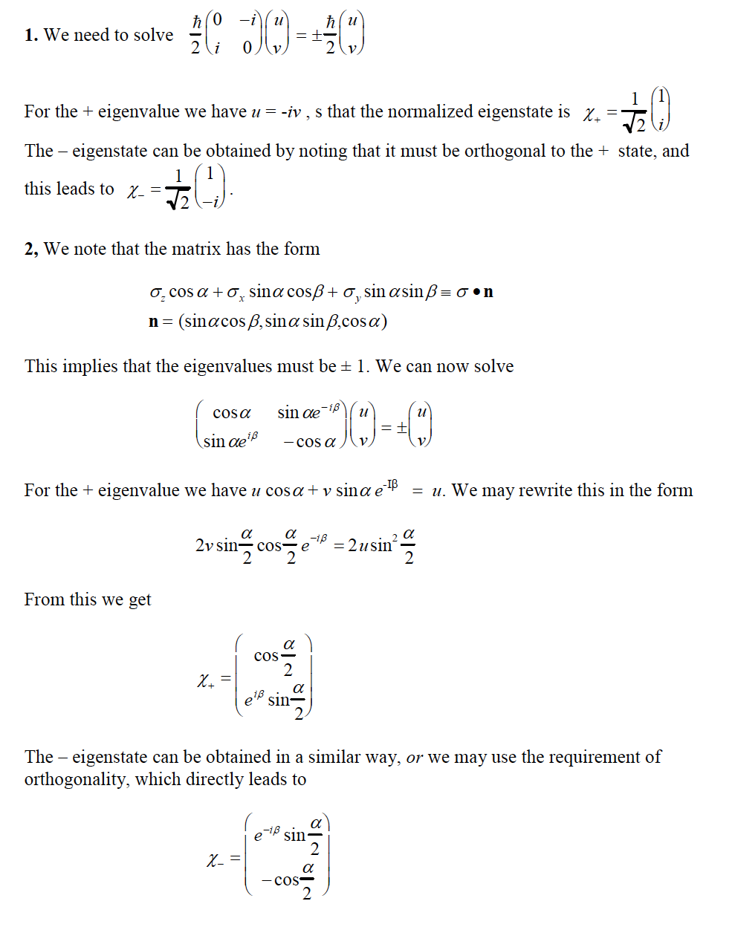
The possible values: $±\frac{1}{2}$. The corresponding probabilities are respectively: ${\left|\frac{1}{\sqrt{2}}\right|}^{2}=\frac{1}{2}$ and ${\left|\frac{i}{\sqrt{2}}\right|}^{2}=\frac{1}{2}$

- Ch. 10 $\left|\left.α\right\rangle \right.=\frac{1}{\sqrt{65}}\left(\begin{matrix}4 \\ 7\end{matrix}\right)$，calculate the expectation value of $S_{x}^{4}:\left\langle α | S_{x}^{4} | α\right\rangle$.
Measure $S_{x}$, what are (or is) the possible values? What are (or is) the corresponding probabilities?
Hint: The expansion components 分量 of $\left|\left.α\right\rangle \right.$ along $\left|\left.x,↑\right\rangle \right.$ equals $\left\langle x,↑ | α\right\rangle$.
Solutions:
$$\left\langle α | S_{x}^{4} | α\right\rangle ={\left(\frac{1}{\sqrt{65}}\right)}^{2}{\left(\frac{ℏ}{2}\right)}^{4}\left(\begin{matrix}4 & 7\end{matrix}\right)\left(\begin{matrix}0 & 1 \\ 1 & 0\end{matrix}\right)\left(\begin{matrix}0 & 1 \\ 1 & 0\end{matrix}\right)\left(\begin{matrix}0 & 1 \\ 1 & 0\end{matrix}\right)\left(\begin{matrix}0 & 1 \\ 1 & 0\end{matrix}\right)\left(\begin{matrix}4 \\ 7\end{matrix}\right)={\left(\frac{ℏ}{2}\right)}^{4}$$
The possible values are again: $±\frac{1}{2}$. The corresponding probabilities are respectively: ${\left|\left\langle x,↑ | α\right\rangle \right|}^{2}={\left|\frac{1}{\sqrt{65}}\frac{1}{\sqrt{2}}\left(\begin{matrix}1 & 1\end{matrix}\right)\left(\begin{matrix}4 \\ 7\end{matrix}\right)\right|}^{2}=\frac{121}{130}$
and ${\left|\left\langle x,↓ | α\right\rangle \right|}^{2}={\left|\frac{1}{\sqrt{65}}\frac{1}{\sqrt{2}}\left(\begin{matrix}1 & -1\end{matrix}\right)\left(\begin{matrix}4 \\ 7\end{matrix}\right)\right|}^{2}=\frac{9}{130}$.
- As in class, use the eigenstates $\left|z,\left.↑\right\rangle \right., \left|z,\left.↓\right\rangle \right.$ of the spin operator in $z$direction $S_{z}$as the basis of the electron spin States. Consider the spin operator $S_{n}$ pointing in the direction of $\hat{n}=\left(\sin{θ}\cos{ϕ},\sin{θ}\sin{ϕ},\cos{θ}\right)$ with $ϕ=0$. This spin operator can be studied in the following setup. We assign the direction of electron beam as $y$ axis. Rotate the magnet in a SG experiment around $y$ axis by an angle $θ$. The magnetic field of this second SG is along $\hat{n}$.
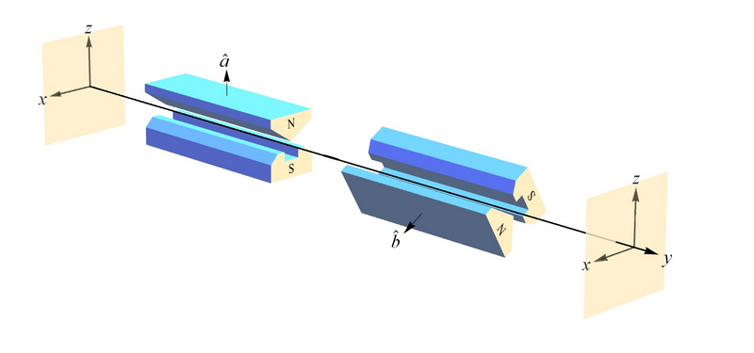
- Derive from $S_{n}=\vec{S}∙\hat{n}$ that $S_{n}=\frac{ℏ}{2}\left(\begin{matrix}\cos{θ} & \sin{θ} \\ \sin{θ} & -\cos{θ}\end{matrix}\right)$ .
- Find the eigenvectors of $S_{n}$, expressed as column vectors in the basis of $\left|z,\left.↑\right\rangle \right., \left|z,\left.↓\right\rangle \right.$: $\left|n,\left.↑\right\rangle \right.=\left(\begin{matrix}c_{1} \\ c_{2}\end{matrix}\right), \left|n,\left.↓\right\rangle \right.=\left(\begin{matrix}d_{1} \\ d_{2}\end{matrix}\right)$. You can choose the coefficient $c_{1,2},d_{1,2}$to be all real. Calculate the coefficients $c_{1,2}$. Please normalize the coefficients so that $c_{1}^{2}+c_{2}^{2}=1$.
- As in the setup above, place a typical SG with $z$ magnetic field and then a second SG with $\hat{n}$ magnetic field. In the first SG only spin-up electron is allowed to pass, ie: $\left|\left.z,↑\right\rangle =\right.\left(\begin{matrix}1 \\ 0\end{matrix}\right)$. Calculate the probability for it to pass the second SG as $\left|n,\left.↑\right\rangle \right.,$ie with $σ_{n}=\frac{ℏ}{2}$ measured? It is a function of $θ$. Think a little bit when the probability would be the largest and the smallest and whether it makes sense. (25)
Solution:
- $S_{n}=\vec{S}∙\hat{n}=\frac{ℏ}{2}\left[\left(\begin{matrix}0 & 1 \\ 1 & 0\end{matrix}\right)\sin{θ}\cos{ϕ}+\left(\begin{matrix}0 & -i \\ i & 0\end{matrix}\right)\sin{θ}\sin{ϕ}+\left(\begin{matrix}1 & 0 \\ 0 & -1\end{matrix}\right)\cos{θ}\right]=\frac{ℏ}{2}\left[\left(\begin{matrix}0 & 1 \\ 1 & 0\end{matrix}\right)\sin{θ}+\left(\begin{matrix}1 & 0 \\ 0 & -1\end{matrix}\right)\cos{θ}\right]=\frac{ℏ}{2}\left(\begin{matrix}\cos{θ} & \sin{θ} \\ \sin{θ} & -\cos{θ}\end{matrix}\right)$.
- $\left(\begin{matrix}\cos{θ} & \sin{θ} \\ \sin{θ} & -\cos{θ}\end{matrix}\right)\left(\begin{matrix}u \\ v\end{matrix}\right)=λ\left(\begin{matrix}u \\ v\end{matrix}\right)$, 此式只有在行列式為零時有非零解：$\left|\begin{matrix}\cos{θ}-λ & \sin{θ} \\ \sin{θ} & -\cos{θ}-λ\end{matrix}\right|=0$, $λ^{2}-{\left(\cos{θ}\right)}^{2}-{\left(\sin{θ}\right)}^{2}=0$,
如預期$λ=±1$。
若$λ=1$，$\left(\cos{θ}-1\right)u+\sin{θ}v=0$
$$\left(\begin{matrix}c_{1} \\ c_{2}\end{matrix}\right)=\left(\begin{matrix}\sin{θ} \\ 1-\cos{θ}\end{matrix}\right)\frac{1}{\sqrt{2-2\cos{θ}}}=\left(\begin{matrix}2sin\frac{θ}{2}{\cos{\frac{θ}{2}}} \\ 2sin\frac{θ}{2}sin\frac{θ}{2}\end{matrix}\right)\frac{1}{2sin\frac{θ}{2}}=\left(\begin{matrix}\cos{\frac{θ}{2}} \\ sin\frac{θ}{2}\end{matrix}\right)$$
若$λ=-1$，$\left(\cos{θ}+1\right)u+\sin{θ}v=0$
$$\left(\begin{matrix}d_{1} \\ d_{2}\end{matrix}\right)=\left(\begin{matrix}-\sin{θ} \\ 1+\cos{θ}\end{matrix}\right)\frac{1}{\sqrt{2+2\cos{θ}}}=\left(\begin{matrix}-2sin\frac{θ}{2}{\cos{\frac{θ}{2}}} \\ 2\cos{\frac{θ}{2}}\cos{\frac{θ}{2}}\end{matrix}\right)\frac{1}{2\cos{\frac{θ}{2}}}=\left(\begin{matrix}-sin\frac{θ}{2} \\ \cos{\frac{θ}{2}}\end{matrix}\right)$$
- The probability for $\left|\left.z,↑\right\rangle =\right.\left(\begin{matrix}1 \\ 0\end{matrix}\right)$ to pass as $\left|n,\left.↑\right\rangle \right.,$ equals:
$${\left|\left\langle n,↑ | z,↑\right\rangle \right|}^{2}={\left|\left(\cos{\frac{θ}{2}}, sin\frac{θ}{2} \right)\left(\begin{matrix}1 \\ 0\end{matrix}\right)\right|}^{2}={\left(\cos{\frac{θ}{2}}\right)}^{2}=\frac{1+\cos{θ}}{2}$$
check$θ=0$，$\hat{n}$ is the same as $\hat{z}$, the probability is 1, correct.

