習題二

- Textbook Ch. 1 4,5,6,13
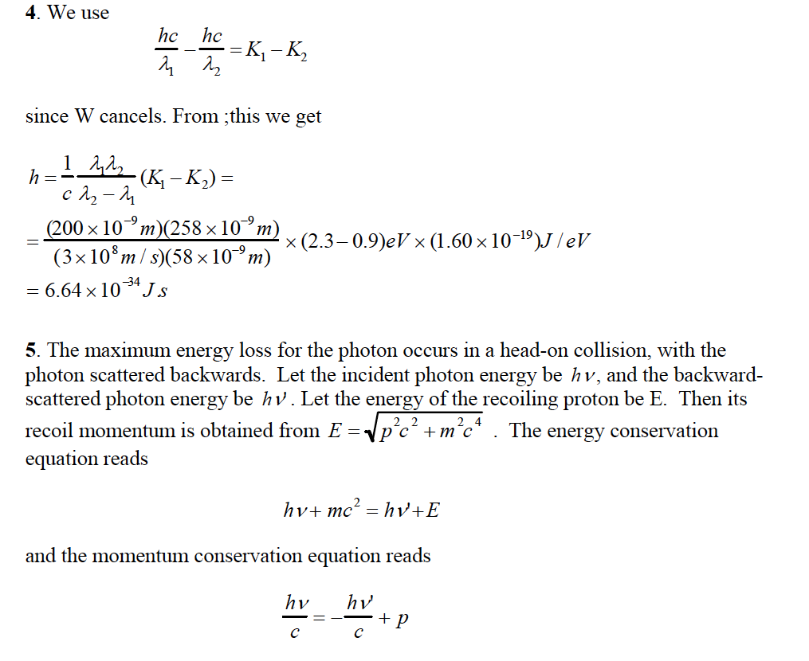
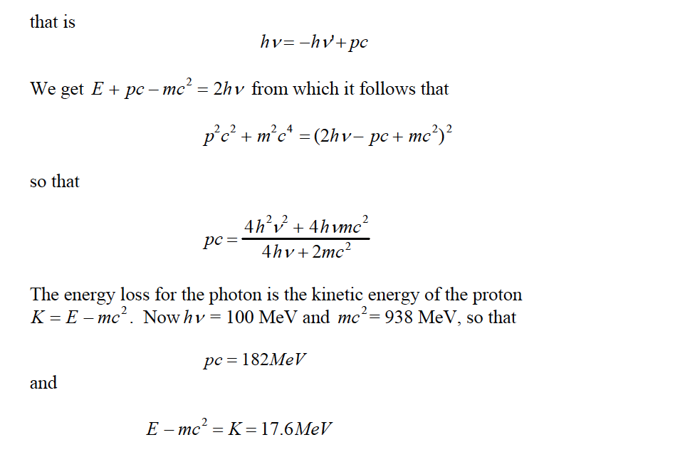
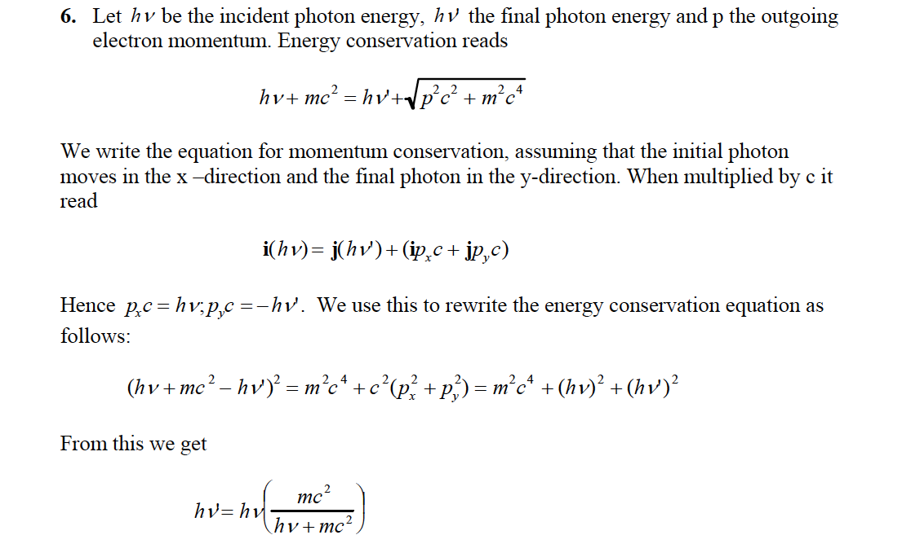
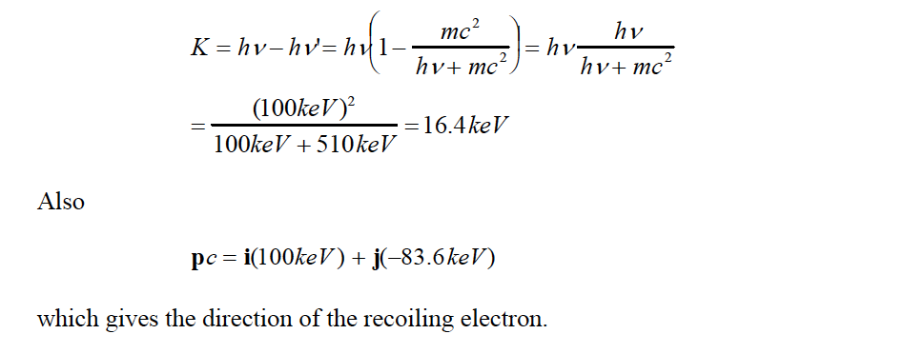
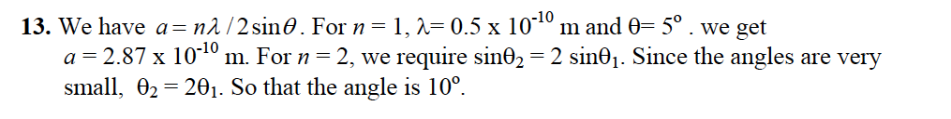
- Consider the decay of a $π^{-}$particle at rest of mass $m_{π}$into a $μ^{-}$ particle of mass $m_{μ}$and a massless neutrino${ ν}^{0}$, $π^{-}→μ^{-}+ν^{0}$. Due to momentum conservation, the magnitude of the $μ^{-}$ momentum $\vec{p}$equals that of ${ ν}^{0}.$Denote their momentum magnitude as $p.$ Write down the energies $E_{μ}, E_{ν}$of $μ^{-}$ and ${ ν}^{0}$ in terms of $p$. Use energy conservation to solve $p$ in terms of $m_{π},m_{μ},c$. (20)
提示：Use the formula we solve in the homework,
$$\frac{E^{2}}{c^{2}}-{\left|\vec{p}\right|}^{2}=m^{2}c^{2}$$
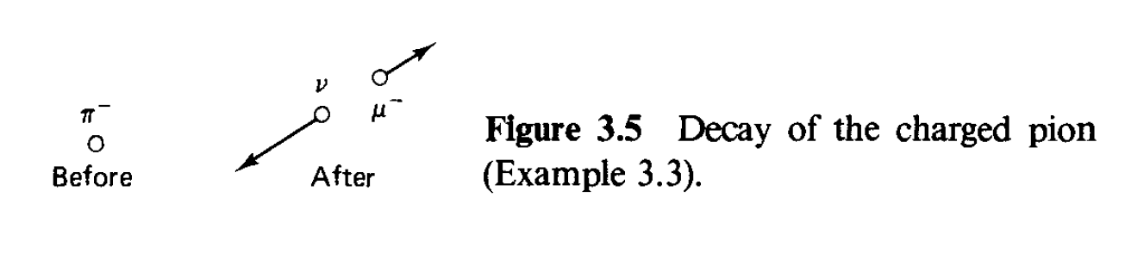
解答：$E=c\sqrt{{\left|\vec{p}\right|}^{2}+m^{2}c^{2}}$. $E_{μ}=c\sqrt{p^{2}+m_{μ}^{2}c^{2}}$, $E_{ν}=cp$.
Energy conservation: $E_{π}=E_{μ}+E_{ν}. \text{We know} E_{π}=m_{π}c^{2}.$
$$m_{π}c^{2}=c\sqrt{p^{2}+m_{μ}^{2}c^{2}}+cp$$
Move $cp$ to the left and square both sides and $p$ can solved
$$p=\frac{m_{π}^{2}-m_{μ}^{2}}{2m_{μ}}c$$

