習題一

1.

2.

3.

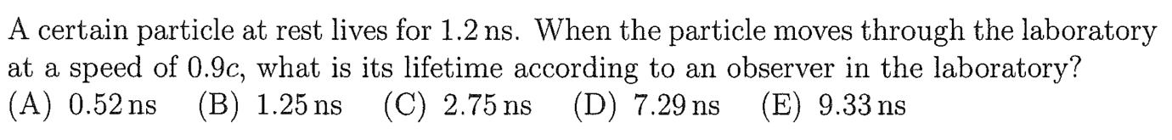

4.

提示：

5.

Hint: problem (b) is bit challenging. You can try it but there is no need to hand it in. I’ll give you the solution later.

For Problem (a), you can treat Rocket A as the moving observer S’, and Rocket B as the particle the observers S and S’ are observing. Then $v=0.6c, u=-0.8c$ while the answer will be $u'$, using the standard notation we used in class.

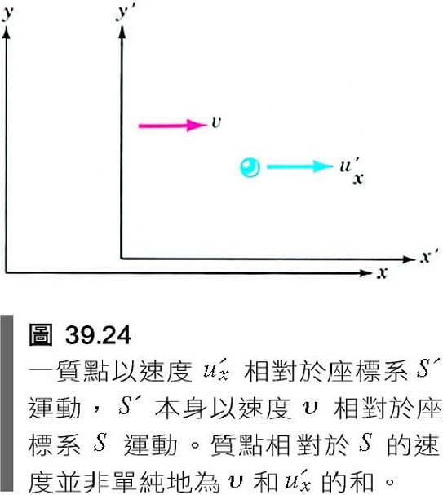

6.

7.

