Modern Physics Final

June 2025

1. Consider a one-dimensional box with boundaries at $x=0$ and $x=a$ with the following potential: $V\left(x\right)=∞, x>a, x<0$ and $V\left(x\right)=0, 0< x<a$.

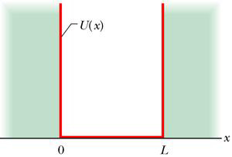 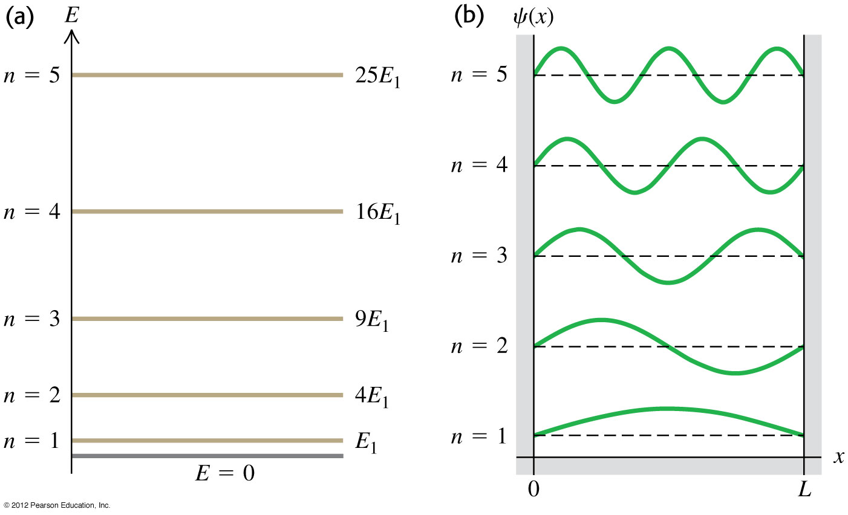

$$V\left(x\right)$$

$$a$$

The energy eigenfunctions are known to be:

$$u_{n}\left(x\right)=\sqrt{\frac{2}{a}}\sin{\frac{nπx}{a}} , 0<x<a. =0 x<0,x>a$$

with eigenvalues: $E_{n}^{(0)}=\frac{n^{2}π^{2}ℏ^{2}}{2ma^{2}}$.

Add a small perturbation to the potential:

$V_{I}\left(x\right)=V_{0}\cos{\frac{πx}{2a}}, 0< x<a$.

Calculate the first order correction $E_{n}^{\left(1\right)}$ to the energy eigenvalue $E_{n}$ (of the eigenstate $u_{n}).$ (20)

Hint: You can use: $\cos{α}\cos{β}=\frac{1}{2}\cos\left(α-β\right)+\frac{1}{2}\cos\left(α+β\right)$. ${\text{sin}}^{2}α=\frac{1}{2}\left(1-\cos{2α}\right)$.

解答：

$$E_{n}^{\left(1\right)}=\frac{2}{a}\int_{0}^{a}{dx\sin{\frac{nπx}{a}}V_{I}\left(x\right)\sin{\frac{nπx}{a}}}=\frac{2}{a}\int_{0}^{a}{dx∙V_{0}\cos{\frac{πx}{2a}}{\left(\sin{\frac{nπx}{a}}\right)}^{2}}=\frac{V_{0}}{a}\int_{0}^{a}{dx∙\cos{\frac{πx}{2a}}\left(1-\cos{\frac{2nπx}{a}}\right)}=\frac{V_{0}}{π}\int_{0}^{π}{dy \cos{\frac{y}{2}}\left(1-\cos{2ny}\right)}$$

$$=\frac{V_{0}}{π}\int_{0}^{π}{dy \left(\cos{\frac{y}{2}}-\cos{\frac{y}{2}}\cos{2ny}\right)}$$

$$=\frac{V_{0}}{π}\int_{0}^{π}{dy\left[\cos{\frac{y}{2}}-\frac{1}{2}\cos\left(2n+\frac{1}{2}\right)y-\frac{1}{2}\cos\left(2n-\frac{1}{2}\right)y\right] }$$

$$=\frac{V_{0}}{π}\left(2-\frac{1}{4n+1}+\frac{1}{4n-1}\right)=\frac{2V_{0}}{π}\left(1+\frac{1}{16n^{2}-1}\right)$$

1. As in class, use the eigenstates $\left|z,\left.↑\right\rangle \right.=\left(\begin{matrix}1 \\ 0\end{matrix}\right), \left|z,\left.↓\right\rangle \right.=\left(\begin{matrix}0 \\ 1\end{matrix}\right)$ of the electron spin operator in $S_{z}$ to form a basis of the electron state vector space. Assume that in this vector space the Hamiltonian can be written as $H=\left(\begin{matrix}E_{0} & 0 \\ 0 & E_{0}\end{matrix}\right)+λ\left(\begin{matrix}0 & -i \\ i & 0\end{matrix}\right).$ The parameter $λ$ is small and the second term can be treated as a perturbation $H_{1}$. The apparent unperturbed eigenstates $\left(\begin{matrix}1 \\ 0\end{matrix}\right), \left(\begin{matrix}0 \\ 1\end{matrix}\right)$ are degenerate in unperturbed energy and may not be the good zeroth order eigenstates in the perturbation calculation. Assume the correct zeroth order eigenstates to be $\left(\begin{matrix}u \\ v\end{matrix}\right)$. (20)
2. Find the two options of $\left(\begin{matrix}u \\ v\end{matrix}\right).$ Please normalize its vector length to $1$.
3. Find the first order correction $E^{(1)}$ to the energy eigenvalues for the two $\left(\begin{matrix}u \\ v\end{matrix}\right)$.

Solution:

1. The good zeroth order eigenstates in the perturbation calculation need to be the eigenvectors of the perturbation matrix: $\left(\begin{matrix}0 & -i \\ i & 0\end{matrix}\right)$.

$\left(\begin{matrix}0 & -i \\ i & 0\end{matrix}\right)\left(\begin{matrix}u \\ v\end{matrix}\right)=a\left(\begin{matrix}u \\ v\end{matrix}\right)$*,* It only have solutions when $\left|\begin{matrix}-a & -i \\ i & -a\end{matrix}\right|=0$, $a^{2}-1=0$,

$a=±1$。

If eigenvalue $a=1$: $-u-iv=0, eigenvector is\left(\begin{matrix}u \\ v\end{matrix}\right)∝\left(\begin{matrix}1 \\ i\end{matrix}\right)→\frac{1}{\sqrt{2}}\left(\begin{matrix}1 \\ i\end{matrix}\right)$.

Energy correction $E^{(1)}$ is $aλ=λ$.

If eigenvalue $a=-1, u-iv=0, eigenvector is\left(\begin{matrix}u \\ v\end{matrix}\right)∝\left(\begin{matrix}1 \\ -i\end{matrix}\right)→\frac{1}{\sqrt{2}}\left(\begin{matrix}1 \\ -i\end{matrix}\right)$.

Energy correction $E^{(1)}$ is .

1. 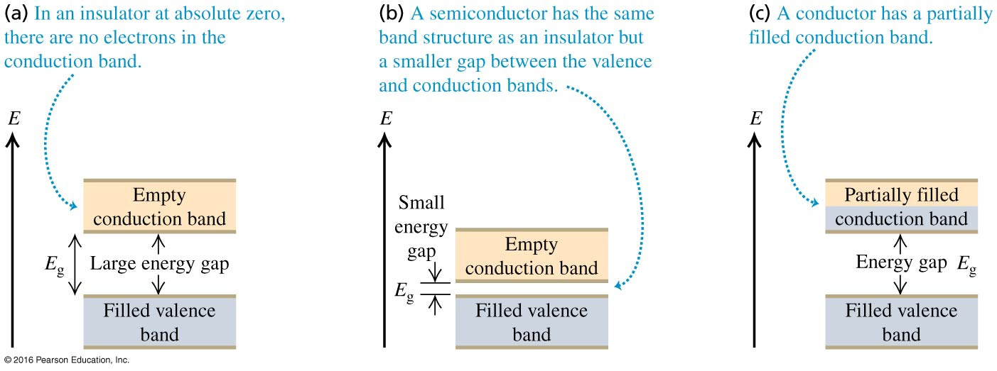The followings are the energy band diagrams of solids: (15)
$$2$$

$$3$$

$$1$$

2. Which of the above diagrams (1 or 2 or 3) is for a conductor? Why is it conducting?
3. Which of the above diagrams is for an insulator? Why is it not conducting?
4. Which of the above diagrams is for a semiconductor? When temperature increases, does its resistivity increase or decrease? Why?

Sol: A. 3. Electrons in the partially filled conduction band can change states easily.

B. 1. Electrons in the filled valance band can’t change their states without absorbing large energy.

C. 2 When temperature increases, more electrons in the filled valance band can jum over the small gap and reach the conduction band. The resistivity will decrease.

1. The energy eigenvalues of a simple harmonic oscillator are $\left(n+\frac{1}{2}\right)ℏω$. Let’s denote the eigenfunctions as $u_{n}\left(x\right)$. Consider two electrons (mass $m$) in the simple harmonic oscillator potential. Denote the coordinates of the two electrons as $x_{1},x_{2}$. Ignore the interaction between the two electrons. The Hamiltonian can hence be written as:

$$H=\frac{p_{1}^{2}}{2m}+\frac{1}{2}mω^{2}x_{1}^{2}+\frac{p_{2}^{2}}{2m}+\frac{1}{2}mω^{2}x_{2}^{2}$$

Use up and down arrows to denote the $S_{z}$ eigenvalues of the two electrons: for example, $\left|\left.↑↓\right\rangle \right.$ is the state with $S_{z}$ up for electron 1, $S_{z}$ down for electron 2. Also use the notation $u_{n}\left(x_{1}\right),u_{n}\left(x_{2}\right)$ in your answer.

1. What is the energy of the ground state of the two-electron system? Write down the ground state wavefunction (both the space part and the spin part). (7)
2. What is the energy of the first excited states of the two-electron system? Write down the wavefunctions for the four first excited states (both the space part and the spin part). (8)

Sol:

1. The energy of eigenstates dependent on only the space part. The ground state would be for both electrons to be in $n=0$, ie (0,0): $E=\left(0+\frac{1}{2}\right)ℏω+\left(0+\frac{1}{2}\right)ℏω=ℏω$.

The space part of the wavefunction is:

$$u_{0}\left(x_{1}\right)∙u_{0}\left(x_{2}\right)$$

This space part wavefunction can only be symmetric. Hence to get a overall antisymmetric wavefunction, the spin part has to be antisymmetric. That could only be:

$$\frac{1}{\sqrt{2}}\left(\left|\left.↑↓\right\rangle \right.-\left|\left.↓↑\right\rangle \right.\right)$$

The whole wavefunction is hence:

$$u_{0}\left(x_{1}\right)∙u_{0}\left(x_{2}\right)∙\frac{1}{\sqrt{2}}\left(\left|\left.↑↓\right\rangle \right.-\left|\left.↓↑\right\rangle \right.\right)$$

1. The space part of the first excited state could be

$\left(0,1\right):u_{0}\left(x_{1}\right)∙u_{1}\left(x_{2}\right)$ or $\left(1,0\right):u_{1}\left(x_{1}\right)∙u_{0}\left(x_{2}\right)$

$$E=\left(0+\frac{1}{2}\right)ℏω+\left(1+\frac{1}{2}\right)ℏω=2ℏω$$

Hence They could be symmetrized S or anti-symmetrized A.

Spin-A is antisymmetric in spin, and hence space part needs to be symmetric:

$$\frac{1}{\sqrt{2}}\left(u_{0}\left(x_{1}\right)∙u_{1}\left(x_{2}\right)+u_{1}\left(x_{1}\right)∙u_{0}\left(x_{2}\right)\right)∙\frac{1}{\sqrt{2}}\left(\left|\left.↑↓\right\rangle \right.-\left|\left.↓↑\right\rangle \right.\right)$$

Spin-S is symmetric in spin and there are 3 of them. The space part needs to be anti-symmetric:

$$\frac{1}{\sqrt{2}}\left(u_{0}\left(x_{1}\right)∙u_{1}\left(x_{2}\right)-u_{1}\left(x_{1}\right)∙u_{0}\left(x_{2}\right)\right)∙\frac{1}{\sqrt{2}}\left(\left|\left.↑↓\right\rangle \right.+\left|\left.↓↑\right\rangle \right.\right)$$

$$\frac{1}{\sqrt{2}}\left(u_{0}\left(x_{1}\right)∙u_{1}\left(x_{2}\right)-u_{1}\left(x_{1}\right)∙u_{0}\left(x_{2}\right)\right)∙\left|\left.↑↑\right\rangle \right.$$

$$\frac{1}{\sqrt{2}}\left(u_{0}\left(x_{1}\right)∙u_{1}\left(x_{2}\right)-u_{1}\left(x_{1}\right)∙u_{0}\left(x_{2}\right)\right)∙\left|\left.↓↓\right\rangle \right.$$

1. Consider a two-dimensional box of size $a×2a$. It is described by a potential with boundaries at $x=0$, $x=a and y=0,y=2a$： $V\left(\vec{r}\right)=0, 0< x<a, 0<y<2a$， $V\left(\vec{r}\right)=∞, everywhere else$. As we have shown in class for the 3D case, here the single electron eigenfunctions (electron mass $m$) for quantum numbers $\left(n_{x},n_{y}\right)$ can be written as: $\frac{1}{a}\sin\left(\frac{n_{x}π}{a}x\right)\sin\left(\frac{n_{y}π}{2a}y\right)$ inside the box, with eigenvalues $E=\frac{{ℏ^{2}π}^{2}}{2ma^{2}}\left(n_{x}^{2}+\frac{n_{y}^{2}}{4}\right)$.
2. Find the energies of the six lowest energy eigenfunctions $\left(n_{x},n_{y}\right)=\left(1,1\right), \left(1,2\right), \left(1,3\right),\left(2,1\right),\left(1,4\right),\left(2,2\right).$ Check that this list is in the order from low to high energy. Is there any degeneracy? (10)

Put **7** electrons into the box and assume there is no interaction between electrons.

1. Find the ground state of the seven-electron system (by listing the $\left(n_{x},n_{y}\right)$ states with electrons and the number of electrons). What is its total energy? (5)
2. For the seven-electron system, find the first excited states and second excited states. What are their total energies and degeneracy (the number of eigenstates with same energy eigenvalues) (5)
3. For the ground state of the seven-electron system, we start to increase the area of the box while keeping its shape, ie. increase $a$ by a small $∆a>0$. Assume we do it slowly so that the electron system stays in the 7-electron ground state (of box size $a+∆a×2\left(a+∆a\right)$). Do we need to add energy (like surface tension 表面張力 when we increase liquid surface) or extract energy (like ideal gas when we enlarge its volumn)? The energy difference can be written as $∆E=f\left(a\right)∆a$. Find the function $f\left(a\right)$. (10)

Sol:

1. $E=\frac{{ℏ^{2}π}^{2}}{2ma^{2}}\left(n_{x}^{2}+\frac{n_{y}^{2}}{4}\right)$，

$$\left(n_{x},n_{y}\right)=\left(1,1\right)→E=\frac{{ℏ^{2}π}^{2}}{2ma^{2}}\frac{5}{4},$$

$$\left(1,2\right)→E=\frac{{ℏ^{2}π}^{2}}{2ma^{2}}2, \left(1,3\right)→E=\frac{{ℏ^{2}π}^{2}}{2ma^{2}}\frac{13}{4}, \left(2,1\right)→E=\frac{{ℏ^{2}π}^{2}}{2ma^{2}}\frac{17}{4},$$

$$\left(1,4\right)→E=\frac{{ℏ^{2}π}^{2}}{2ma^{2}}5, \left(2,2\right)→E=\frac{{ℏ^{2}π}^{2}}{2ma^{2}}5.$$

$\left(1,4\right)$ and $\left(2,2\right)$ are degenerate in energy.

$$\left(2,3\right)$$

$$E$$

$$\left(1,4\right),\left(2,2\right)$$

$$\left(2,1\right)$$

$$\left(1,3\right)$$

$$\left(1,2\right)$$

$$\left(1,1\right)$$

1. Ground state: 2 electrons in $\left(1,1\right), \left(1,2\right), \left(1,3\right)$ and 1 electron in $\left(2,1\right)$:
$$E=\frac{{ℏ^{2}π}^{2}}{2ma^{2}}2×\left(\frac{5}{4}+2+\frac{13}{4}\right)+\frac{17}{4}=\frac{{ℏ^{2}π}^{2}}{2ma^{2}}\frac{69}{4}$$

2. To excite the system, we can:.

take 1 electron from $\left(1,3\right)$ to $\left(2,1\right)$: $E=\frac{{ℏ^{2}π}^{2}}{2ma^{2}}\frac{69+4}{4}=\frac{{ℏ^{2}π}^{2}}{2ma^{2}}\frac{73}{4}$

or take 1 electron from $\left(2,1\right)$ to $\left(1,4\right)$ or $\left(2,2\right)$: $E=\frac{{ℏ^{2}π}^{2}}{2ma^{2}}\frac{69+3}{4}=\frac{{ℏ^{2}π}^{2}}{2ma^{2}}\frac{72}{4}$*.*

It turns out the 2nd has lower energy: 2 $e$ in $\left(1,1\right), \left(1,2\right), \left(1,3\right)$ and 1 $e$ in $\left(1,4\right)$ or $\left(2,2\right).$ This is 1st excited state with twofold degeneracy.

2 $e$ in $\left(1,1\right), \left(1,2\right), \left(2,1\right)$ and 1 $e$ in $\left(1,3\right)$ is the 2nd excited state.

$$\left(2,3\right)$$

$$E$$

$$\left(1,4\right),\left(2,2\right)$$

$$\left(2,1\right)$$

$$\left(1,3\right)$$

$$\left(1,2\right)$$

$$\left(1,1\right)$$

$$\left(2,3\right)$$

$$E$$

$$\left(1,4\right),\left(2,2\right)$$

$$\left(2,1\right)$$

$$\left(1,3\right)$$

$$\left(1,2\right)$$

$$\left(1,1\right)$$

1. The total energy of the ground state is $$E=\frac{{ℏ^{2}π}^{2}}{2ma^{2}}\frac{69}{4}$$

As $a$ increase, the energy decreases and hence we can extract energy like ideal gas with positive pressure. $$∆E=\frac{dE}{da}∆a=-\frac{{ℏ^{2}π}^{2}}{ma^{3}}\frac{69}{4}∆a$$