近物期末考

Dec 2024

1. Consider an instantaneous wavefunction at $t=0$:

$$ψ\left(x\right)=2α\sqrt{α}xe^{-αx}, x>0$$

$$=0, x<0$$

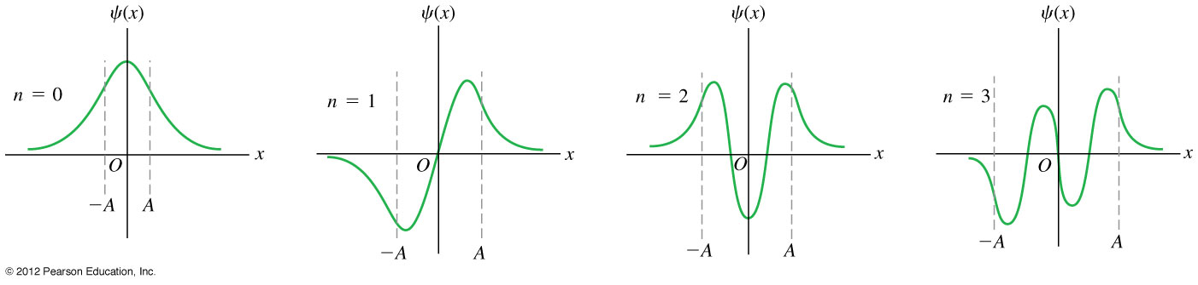

It has been normalized to one. $1=\int_{-∞}^{∞}{{dx∙\left|ψ\left(x\right)\right|}^{2}}$. This state function is an energy eigenfunction of (and hence stationary state in) the potential $V\left(x\right)∝\frac{1}{x}$. Therefore, it satisfies the Time-Independent Schrodinger Equation $\left[-\frac{ℏ^{2}}{2m}\frac{d^{2}}{dx^{2}}+\frac{ρ}{x}\right]ψ\left(x\right)=Eψ\left(x\right)$

(You don’t need this when solving the problem and you can check it at home after exam).

1. What is the ratio of the probability density at $x=\frac{1}{α}$ over the probability density at $x=\frac{4}{α}$? 不用數值結果No need for numerical value.
2. Calculate the expectation value $〈p^{2}〉$. (25)

Hint: You can use the following integration formula.

$$\int_{0}^{∞}{dx}∙x^{n}e^{-ax}={\left(-1\right)}^{n}\frac{∂^{n}}{∂a^{n}}\int_{0}^{∞}{dx}∙e^{-ax}={\left(-1\right)}^{n}\frac{∂^{n}}{∂a^{n}}\frac{1}{a}=n!\frac{1}{a^{n+1}}$$

Sol: The probability density at $x=\frac{1}{α}$ and at $x=\frac{4}{α}$ are respectively ${\left|ψ\left(\frac{1}{α}\right)\right|}^{2}=4αe^{-2}$ and ${\left|ψ\left(\frac{4}{α}\right)\right|}^{2}=64αe^{-8}$ and the ratio is $\frac{1}{16}e^{6}.$

$$〈p^{2}〉=\int_{-∞}^{∞}{dx∙ψ^{*}\left(x\right)}∙\left(-ℏ^{2}\frac{∂^{2}}{∂x^{2}}\right)ψ\left(x\right)=-4α^{3}ℏ^{2}\int_{0}^{∞}{dx∙xe^{-αx}}∙\frac{∂^{2}}{∂x^{2}}\left(xe^{-αx}\right)$$

$$=-4α^{3}ℏ^{2}\int_{0}^{∞}{dx∙xe^{-αx}}∙\frac{∂}{∂x}\left(e^{-αx}-αxe^{-αx}\right)$$

$$=-4α^{3}ℏ^{2}\int_{0}^{∞}{dx∙xe^{-αx}}∙\left(-2αe^{-αx}+α^{2}xe^{-αx}\right)$$

$$=-4α^{3}ℏ^{2}\int_{0}^{∞}{dx}∙\left(-2αxe^{-2αx}+α^{2}x^{2}e^{-2αx}\right)$$

$$=-4α^{3}ℏ^{2}\left(-2α\frac{1}{{\left(2α\right)}^{2}}+2α^{2}\frac{1}{{\left(2α\right)}^{3}}\right)=4ℏ^{2}α^{3}\left(\frac{1}{2α}-\frac{1}{4α}\right)=ℏ^{2}α^{2}$$

1. We studied the potential of infinite well in class. It is easier to consider properties of odd or even functions if we put the origin of the x-axis at the center of the well, instead of the left boundary. Since the potential is an even function, the stationary state function can only be either even or odd functions. Consider an infinite well, with the boundaries set at $x=-\frac{a}{2}$ and $x=\frac{a}{2}$: $V\left(x\right)=∞, x>\frac{a}{2}, x<-\frac{a}{2}$ and $V\left(x\right)=0, -\frac{a}{2}< x<\frac{a}{2}$.

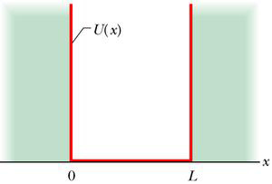

$$-\frac{a}{2}$$

$$\frac{a}{2}$$

$$V\left(x\right)$$

Denote the stationary state functions, ie. energy eigenstates of this infinite well, as $u_{n}$ with eigenvalues $E_{n}=\left(\frac{ℏ^{2}}{2m}\right)\frac{π^{2}}{a^{2}}n^{2} (you can use$ the notation $E_{n}$ later to simplify your answers). We know

$$u_{1}=\sqrt{\frac{2}{a}}\cos{\frac{π}{a}x} u_{2}=\sqrt{\frac{2}{a}}\sin{\frac{2π}{a}x}$$

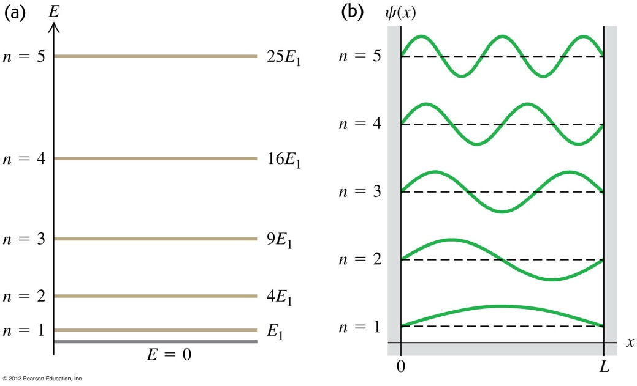

$$-\frac{a}{2}$$

$$\frac{a}{2}$$

A. 問答題無需計算What is the value of ${\int_{-∞}^{∞}{dx∙}u_{1}{\left(x\right)}^{*}∙u}_{2}\left(x\right)$? (5)

Now a particle is known to be inside the box, with an instantaneous 瞬間 wavefunction at as:

This state function $Ψ\left(x,0\right)$ can be expressed as a linear combination of $u_{n}$:

$$Ψ\left(x,0\right)=\sum_{n=1}^{∞}{c_{n}u_{n}\left(x\right)}$$

B. What is $c_{2}$? Argue using the properties of odd and even functions.(10)

C. The coefficient $c_{1}$ equals an integral. It can be simplified to the form: $$c_{1}=κ+λ\int_{-\frac{π}{2}}^{\frac{π}{2}}{dθ∙}\cos{θ}∙θ^{2}$$

$κ,λ$ are numerical constants. What are $κ,λ$?(10)

Hint: Use $θ≡\frac{π}{a}x$.

The above integral over $θ$ can be further calculated by:

$$\int_{-\frac{π}{2}}^{\frac{π}{2}}{dθ∙θ^{2}\cos{αθ}}=-\frac{d^{2}}{dα^{2}}\int_{-\frac{π}{2}}^{\frac{π}{2}}{dθ \cos{αθ}=2\frac{d^{2}}{dα^{2}}\frac{\sin{α\frac{π}{2}}}{α}}$$

And then take $α=1.$ No need to do this part. I’ll give you the full answer in the solution after exam.

Sol:

1. $u_{1,2}$ are orthogonal: ${\int_{-∞}^{∞}{dx∙}u_{1}{\left(x\right)}^{*}∙u}_{2}\left(x\right)=0$.
2. Since $Ψ\left(x,0\right)=\sqrt{\frac{30}{a^{5}}}\left(\frac{a^{2}}{4}-x^{2}\right)$ is a even function, it is the expansion of only even functions. $u_{2}\left(x\right)$ is a odd function and hence $c_{2}=0.$
3. The coefficient:

$$c_{1}=\int_{-∞}^{∞}{dx∙}u_{1}{\left(x\right)}^{*}∙Ψ\left(x,0\right)=\sqrt{\frac{30}{a^{5}}}\int_{-\frac{a}{2}}^{\frac{a}{2}}{dx∙}u_{1}{\left(x\right)}^{*}∙\left(\frac{a^{2}}{4}-x^{2}\right)$$

$$=\sqrt{\frac{60}{a^{6}}}\frac{a^{2}}{4}\int_{-\frac{a}{2}}^{\frac{a}{2}}{dx∙}\cos{\frac{π}{a}x}-\sqrt{\frac{60}{a^{6}}}\int_{-\frac{a}{2}}^{\frac{a}{2}}{dx∙}\cos{\frac{π}{a}x}∙x^{2}$$

$$=\sqrt{\frac{60}{a^{6}}}\frac{a^{2}}{4}\frac{a}{π}2-\sqrt{\frac{60}{a^{6}}}\int_{-\frac{a}{2}}^{\frac{a}{2}}{dx∙}\cos{\frac{π}{a}x}∙x^{2}$$

Using $θ≡\frac{π}{a}x$:

$$c_{1}=\frac{\sqrt{15}}{π}-\sqrt{\frac{60}{a^{6}}}\frac{a^{3}}{π^{3}}\int_{-\frac{π}{2}}^{\frac{π}{2}}{dθ∙}\cos{θ}∙θ^{2}=\frac{\sqrt{15}}{π}-\frac{\sqrt{60}}{π^{3}}\int_{-\frac{π}{2}}^{\frac{π}{2}}{dθ∙}\cos{θ}∙θ^{2}$$

Hence

$$κ=\frac{\sqrt{15}}{π},λ=-\frac{\sqrt{60}}{π^{3}}$$

We can calculate further:

$$\int_{-\frac{π}{2}}^{\frac{π}{2}}{dθ∙θ^{2}\cos{αθ}}=-\frac{d^{2}}{dα^{2}}\int_{-\frac{π}{2}}^{\frac{π}{2}}{dθ \cos{αθ}=2\frac{d^{2}}{dα^{2}}\frac{\sin{α\frac{π}{2}}}{α}}$$

$$=\frac{d}{dα}\left(-\frac{\sin{α\frac{π}{2}}}{α^{2}}+\frac{\frac{π}{2}\cos{α\frac{π}{2}}}{α}\right)\overset{→}{α=1}2sin{\frac{π}{2}-{\left(\frac{π}{2}\right)}^{2}\sin{\frac{π}{2}}}=2-{\left(\frac{π}{2}\right)}^{2}$$

$$c_{1}=\frac{\sqrt{15}}{π}-\frac{\sqrt{60}}{π^{3}}\left(2-\frac{π^{2}}{4}\right)=\frac{2\sqrt{15}}{π}-\frac{2\sqrt{60}}{π^{3}}$$

1. Consider an electron in a simple harmonic potential $V\left(x\right)=\frac{1}{2}kx^{2}$. The stationary states $u_{n}\left(x\right)$ are the eigenfunctions corresponding to the eigenvalues $E_{n}=ℏω\left(n+\frac{1}{2}\right)$. For example:

$$u_{0}\left(x\right)={\left(\frac{mω}{πℏ}\right)}^{\frac{1}{4}}e^{-\frac{mωx^{2}}{2ℏ}}≡ce^{-\frac{mωx^{2}}{2ℏ}}, u_{2}\left(x\right)=c\frac{1}{\sqrt{2}}\left(\frac{2mω}{ℏ}x^{2}-1\right)e^{-\frac{mωx^{2}}{2ℏ}}$$

Here we use the notation $c=\sqrt[4]{\frac{mω}{πℏ}}$ to simplify the expression. Assume the wavefunction of the electron at $t=0$ is:

$$Ψ\left(x,0\right)=\frac{1}{\sqrt{3}}u_{0}\left(x\right)+\frac{\sqrt{2}}{\sqrt{3}}u_{2}\left(x\right)$$

Its total probability has been normalized to one (You can check this after exam).

1. How many node points 節點does $u_{2}\left(x\right)$ have? (5)
2. At $t=0$, make an energy measurement. What are the values it could possibly give? What are the corresponding probabilities? Do the probabilities add up to one? (10)
3. For a later time $t=t_{0}>0$, write down the wave function $ψ\left(x,t_{0}\right).$ There is no need to simplify the answer. Calculate the probability density at the origin $x=0$ when $t=t_{0}$, in terms of $ℏ,ω,c$. (10)

Hint: ${\left|A+B\right|}^{2}=\left(A^{*}+B^{*}\right)\left(A+B\right)={\left|A\right|}^{2}+{\left|B\right|}^{2}+A^{*}B+B^{*}A$

解答：

1. The polynomial $\frac{2mω}{ℏ}x^{2}-1$ in $u_{2}\left(x\right)$ has two solutions and hence $u_{2}\left(x\right)$ has 2 node points 節點.
2. The wave function is a superposition of the eigenfunction $u_{0},u_{2}$ of eigenvalues $E_{0},E_{2}$, with amplitudes $c_{0}=\frac{1}{\sqrt{3}}c_{2}=\frac{\sqrt{2}}{\sqrt{3}}$*,* , $c_{n}=0, n≠0,2$. The energy could only be $E_{0}=\frac{1}{2}ℏω or E_{2}=\frac{5}{2}ℏω$. The corresponding probabilities are the square of the magnitudes ${ c}_{0}$ and $c_{2}$: $\frac{1}{3}$ and $\frac{2}{3}$。They add up to one. The expectation value of energy is $〈E〉=\frac{1}{3}E_{0}+\frac{2}{3}E_{2}=\frac{11}{6}ℏω$.
3. $t=0$ 時此狀態可以視為定態 $u_{0,2}\left(x\right)$ 的如上疊加，接著定態隨時間個自演化，位能下薛丁格方程式要求 $u_{n}$ 乘 $\text{上}e^{-i\frac{E_{n}}{ℏ}t}$。乘完之後依同樣方式疊加，整個波函數也就滿足薛丁格波方程式。因此

$Ψ\left(x,t\right)=\frac{1}{\sqrt{3}}u_{0}\left(x\right)e^{-i\frac{E_{0}}{ℏ}t}+\frac{\sqrt{2}}{\sqrt{3}}u_{2}\left(x\right)e^{-i\frac{E_{2}}{ℏ}t}$。

$$注意\text{兩個定態的}能量E_{0},E_{2}是不一樣的。$$

The wavefunction at the origin $x=0$ equals

$ψ\left(0,t_{0}\right)=\frac{1}{\sqrt{3}}ce^{-i\frac{E_{0}}{ℏ}t_{0}}-\frac{\sqrt{2}}{\sqrt{3}}\frac{c}{\sqrt{2}}e^{-i\frac{E_{2}}{ℏ}t_{0}}=\frac{c}{\sqrt{3}}\left(e^{-i\frac{E_{0}}{ℏ}t_{0}}-e^{-i\frac{E_{2}}{ℏ}t_{0}}\right)$

The probability density:

$${\left|ψ\left(0,t_{0}\right)\right|}^{2}=\frac{c^{2}}{3}{\left|e^{-i\frac{E_{0}}{ℏ}t_{0}}-e^{-i\frac{E_{2}}{ℏ}t_{0}}\right|}^{2}$$

$$=\frac{c^{2}}{3}\left\{{\left|e^{-i\frac{E_{0}}{ℏ}t_{0}}\right|}^{2}+{\left|e^{-i\frac{E_{2}}{ℏ}t_{0}}\right|}^{2}-e^{-i\frac{E_{0}}{ℏ}t_{0}}e^{i\frac{E_{2}}{ℏ}t_{0}}-e^{i\frac{E_{0}}{ℏ}t_{0}}e^{-i\frac{E_{2}}{ℏ}t_{0}}\right\}$$

$$=\frac{c^{2}}{3}\left\{1+1-e^{-i\frac{E_{0}-E_{2}}{ℏ}t_{0}}-e^{i\frac{E_{0}-E_{2}}{ℏ}t_{0}}\right\}=\frac{c^{2}}{3}\left\{2-2\cos{\frac{E_{0}-E_{2}}{ℏ}t_{0}}\right\}=\frac{c^{2}}{3}\left\{2-2\cos{2ωt_{0}}\right\}$$

1. Consider an electron moving from left $x=-∞$ to right $x=∞$ and is scattered by a step potential at $x=0$. The step potential is: and .

Consider the case $E=0.5V_{0}$. The stationary state of this potential, and hence a solution of Time-Independent Schrodinger Equation, is:

$$ψ_{E}=e^{ikx}+Re^{-ikx} x<0 k≡\sqrt{\frac{2mE}{ℏ^{2}}}$$

$$ψ_{E}=Te^{-κx} x>0 κ≡\sqrt{\frac{2m}{ℏ^{2}}\left(V_{0}-E\right)}$$

Note that $κ=k$.

1. Use the continuous conditions to determine $T$ and $R$. (15)
2. Show that $R$ can be written as a pure phase factor:

$$R=e^{-2iδ}$$

What is the angle $δ$? (10)

Solution: The continuous conditions are:

$$1+R=T$$

$$k-kR=iκT$$

They can be solved as:

$$R=\frac{k-iκ}{k+iκ}=\frac{1-i}{1+i}$$

$$T=\frac{2}{1+i}$$

$1-i=\sqrt{2}e^{-i\frac{π}{4}}$

$$R=\frac{\sqrt{2}e^{-i\frac{π}{4}}}{\sqrt{2}e^{i\frac{π}{4}}}=e^{-2i\frac{π}{4}}$$

The angle $δ=\frac{π}{4}$