近代物理期中考
Oct 2023
- Consider the decay of a $π^{-}$particle at rest of mass $m_{π}$into a $μ^{-}$ particle of mass $m_{μ}$and a massless neutrino${ ν}^{0}$, $π^{-}→μ^{-}+ν^{0}$. Due to momentum conservation, the magnitude of the $μ^{-}$ momentum $\vec{p}$equals that of ${ ν}^{0}.$Denote their momentum magnitude as $p.$ Write down the energies $E_{μ}, E_{ν}$of $μ^{-}$ and ${ ν}^{0}$ in terms of $p$. Use energy conservation to solve $p$ in terms of $m_{π},m_{μ},c$. (20)
提示：Use the formula we solve in the homework,
$$\frac{E^{2}}{c^{2}}-{\left|\vec{p}\right|}^{2}=m^{2}c^{2}$$
解答：$E=c\sqrt{{\left|\vec{p}\right|}^{2}+m^{2}c^{2}}$. $E_{μ}=c\sqrt{p^{2}+m_{μ}^{2}c^{2}}$, $E_{ν}=cp$.
Energy conservation: $E_{π}=E_{μ}+E_{ν}. \text{We know} E_{π}=m_{π}c^{2}.$
$$m_{π}c^{2}=c\sqrt{p^{2}+m_{μ}^{2}c^{2}}+cp$$
Move $cp$ to the left and square both sides and $p$ can solved
$$p=\frac{m_{π}^{2}-m_{μ}^{2}}{2m_{μ}}c$$
- In a photoelectric effect experiment, we can measure the stopping voltage $V_{s}$ of the photoelectrons versus the frequencies of the light applied. Assume that at frequency $f_{1}$, the measured stopping voltage is $V_{1}$. Calculate the stopping voltage $V$ corresponding to the frequency 2$f_{1}$. The answer can be expressed in terms of $V_{1}, f_{1},h$. (15)
解答：$eV_{1}=hf_{1}-ϕ$, $eV=h2f_{1}-ϕ$，兩式相減：$V=V_{1}+\frac{h}{e}f_{1}$。
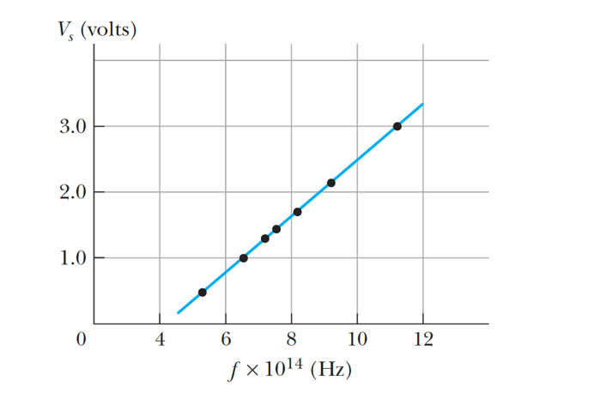
- Consider a quantum system with only three stable energy states：
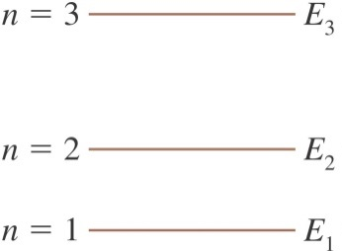

The emitting spectrum of this system consists of 3 lines corresponding to the frequencies: $f\sim 4.8×{10}^{14} \text{Hz, }1.2×{10}^{15}\text{Hz}, 1.7×{10}^{15}\text{Hz}$. Assume the energy $E_{1}$of the ground state is zero. Calculate the energies $E_{3}$ of the highest stable states。$h=6.63×{10}^{-34}\text{J}\text{∙}\text{s}=4.14×{10}^{-15}\text{eV}\text{∙}\text{s}$。(15)
解答：
$1.7×{10}^{15}\text{Hz}\text{是最大發光頻率，} 對應 n=3→n=1,$ 而$E_{1}=0,$
$$E_{3}=E_{3}-E_{1}=∆E=hf=4.14×{10}^{-15} \text{eV∙s∙}1.7×{10}^{15} \text{Hz=}7.0 eV$$

- Consider an infinite potential, with boundaries at $x=0$ and $x=a$: $V\left(x\right)=∞, x>a, x<0$ and $V\left(x\right)=0, 0< x<a$.
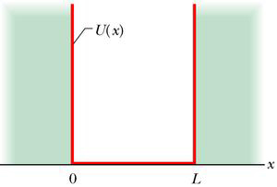
$$a$$
$$V\left(x\right)$$
A particle is known to be localized inside the box, with an instantaneous 瞬間 wavefunction at $t=0$as:
$$Ψ\left(x,0\right)=Cx\left(a-x\right) 0<x<a,$$
$$=0 x<0,x>a$$
Calculate the constant $C$. Use your result to write down the probability density $P$at $x=\frac{a}{2}$ at $t=0$. (25)

解答：$P={\left|ψ\left(x,t\right)\right|}^{2}={\left[Cx\left(a-x\right)\right]}^{2}={\left[Cx\left(a-x\right)\right]}^{2}$
$$=C^{2}\left(a^{2}x^{2}-2ax^{3}+x^{4}\right)$$
$$1=\int_{-∞}^{∞}{dx∙{\left|ψ\left(x,t\right)\right|}^{2}}=\int_{0}^{a}{dx∙P(x,t)}$$
$$=C^{2}\int_{0}^{a}{dx∙\left(a^{2}x^{2}-2ax^{3}+x^{4}\right)}=C^{2}\frac{a^{5}}{30}$$
$C=\sqrt{\frac{30}{a^{5}}}$，
$$P=C^{2}\left(a^{2}x^{2}-2ax^{3}+x^{4}\right)=\frac{30}{a^{5}}\left(a^{2}x^{2}-2ax^{3}+x^{4}\right)$$
$$P\left(\frac{a}{2}\right)=\frac{15}{8a}$$
- Consider an electron moving from left $x=-∞$ to right $x=∞$ and is scattered by a step potential at $x=0$. The step potential is: $V=0, x<0$ and $V=V_{0}, x>0$.
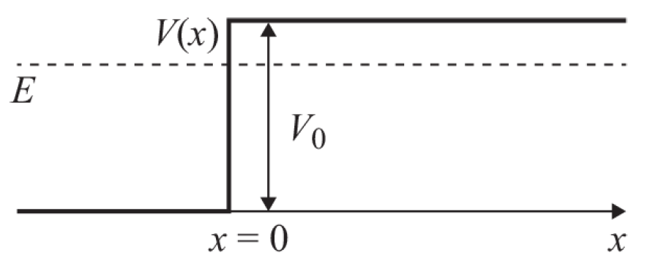
A solution of the Schrodinger Eq in this potential can be written as:
$$Ψ\left(x,t\right)=\left(e^{ikx}+e^{2iδ}e^{-ikx}\right) e^{-iωt} x<0 k≡\sqrt{\frac{2mE}{ℏ^{2}}}$$
$$Ψ\left(x,t\right)=Te^{-κx}e^{-iωt} x>0 κ≡\sqrt{\frac{2m}{ℏ^{2}}\left(E-V_{0}\right)}$$
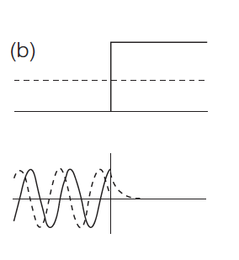
$T(complex)$ and $δ(Real)$ are calculatable constants. Calculate the probability density at $x<0 and x>0$as a function of $x$ in terms of $κ,k,δ,T$. (25)
提示：$\left|e^{iθ}\right|=1$, $\left|e^{a+iθ}\right|=e^{a}$, $\left|mn\right|=\left|m\right|∙\left|n\right|$
${\left|A+B\right|}^{2}=\left(A^{*}+B^{*}\right)\left(A+B\right)={\left|A\right|}^{2}+{\left|B\right|}^{2}+A^{*}B+B^{*}A$

解答：at $x<0, P={\left|\left(e^{ikx}+e^{2iδ}e^{-ikx}\right) e^{-iωt}\right|}^{2}={\left|e^{ikx}+e^{2iδ}e^{-ikx} \right|}^{2}{\left| e^{-iωt}\right|}^{2}$
$$={\left|e^{ikx}+e^{-ikx+2iδ} \right|}^{2}$$
$$=\left(e^{-ikx}+e^{ikx-2iδ}\right)∙\left(e^{ikx}+e^{-ikx+2iδ}\right)=1+1+Re\left(e^{i2kx-4iδ}\right)$$
$=2+2\cos\left(2kx-4δ\right)$。
at $x>0, P={\left|Te^{-κx}e^{-iωt}\right|}^{2}=e^{-2κx}{\left|T\right|}^{2}{\left|e^{-iωt}\right|}^{2}=e^{-2κx}{\left|T\right|}^{2}$

