習題四

- Ch. 10 10-1 For the eigenstate with higher eigenvalue, measure $S_{z}$. What are (or is) the possible values? What are (or is) the corresponding probabilities?
Solution:
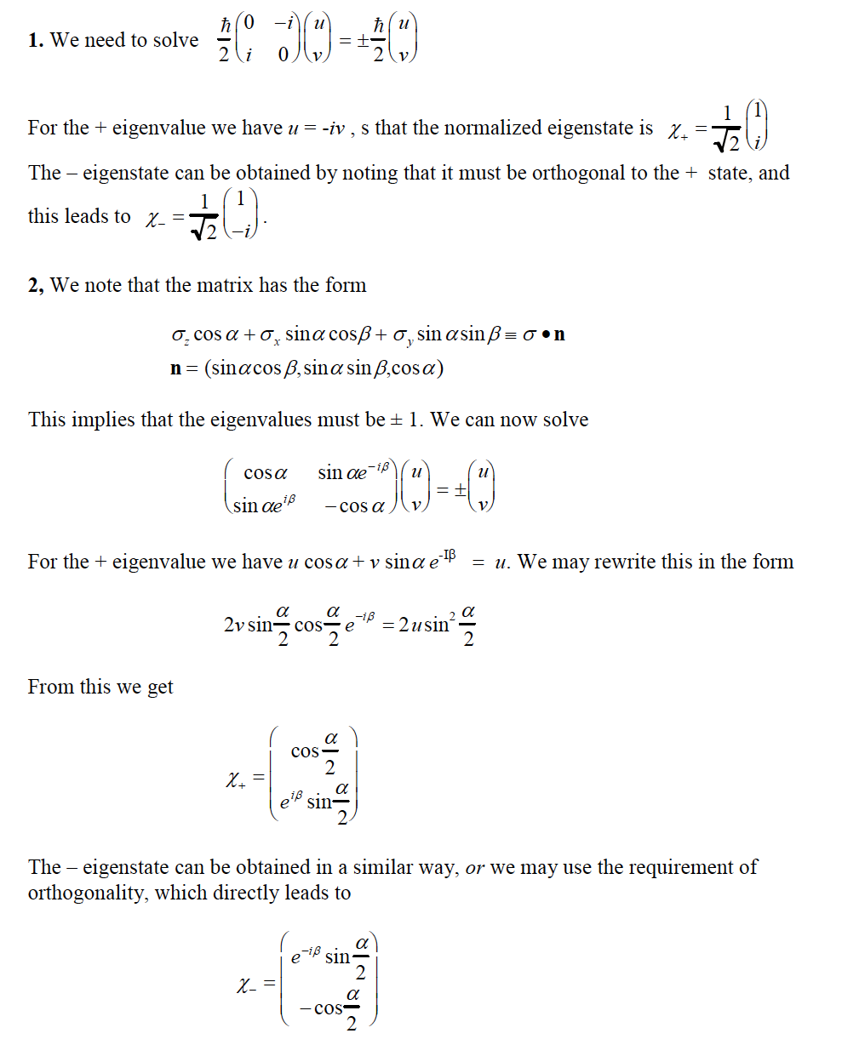
The possible values: $±\frac{1}{2}$. The corresponding probabilities are respectively: ${\left|\frac{1}{\sqrt{2}}\right|}^{2}=\frac{1}{2}$ and ${\left|\frac{i}{\sqrt{2}}\right|}^{2}=\frac{1}{2}$

- Ch. 10 $\left|\left.α\right\rangle \right.=\frac{1}{\sqrt{65}}\left(\begin{matrix}4 \\ 7\end{matrix}\right)$，calculate the expectation value of $S_{x}^{4}:\left\langle α | S_{x}^{4} | α\right\rangle$.

Measure $S_{x}$, what are (or is) the possible values? What are (or is) the corresponding probabilities?
Hint: The expansion components 分量 of $\left|\left.α\right\rangle \right.$ along $\left|\left.x,↑\right\rangle \right.$ equals $\left\langle x,↑ | α\right\rangle$.
Solutions:
$$\left\langle α | S_{x}^{4} | α\right\rangle ={\left(\frac{1}{\sqrt{65}}\right)}^{2}{\left(\frac{ℏ}{2}\right)}^{4}\left(\begin{matrix}4 & 7\end{matrix}\right)\left(\begin{matrix}0 & 1 \\ 1 & 0\end{matrix}\right)\left(\begin{matrix}0 & 1 \\ 1 & 0\end{matrix}\right)\left(\begin{matrix}0 & 1 \\ 1 & 0\end{matrix}\right)\left(\begin{matrix}0 & 1 \\ 1 & 0\end{matrix}\right)\left(\begin{matrix}4 \\ 7\end{matrix}\right)={\left(\frac{ℏ}{2}\right)}^{4}$$
The possible values are again: $±\frac{1}{2}$. The corresponding probabilities are respectively: ${\left|\left\langle x,↑ | α\right\rangle \right|}^{2}={\left|\frac{1}{\sqrt{65}}\frac{1}{\sqrt{2}}\left(\begin{matrix}1 & 1\end{matrix}\right)\left(\begin{matrix}4 \\ 7\end{matrix}\right)\right|}^{2}=\frac{121}{130}$
and ${\left|\left\langle x,↓ | α\right\rangle \right|}^{2}={\left|\frac{1}{\sqrt{65}}\frac{1}{\sqrt{2}}\left(\begin{matrix}1 & -1\end{matrix}\right)\left(\begin{matrix}4 \\ 7\end{matrix}\right)\right|}^{2}=\frac{9}{130}$.

