習題五

- 課本 Ch. 3 3.4
提示：

- 課本 Ch. 3 3.5

- Consider the wave packet-like state as described in Example 2-1 of P27, for which the wave function in momentum space is:
$$ϕ\left(p\right)=N, -a≤p≤a$$
$$=0. \text{elsewhere}$$
It wavefunction in position space $ψ\left(x,0\right)$ is equal to $ψ\left(x,0\right)=\sqrt{\frac{2ℏ}{π}}N\frac{\sin{\frac{a}{ℏ}x}}{x}$
- The constant $N$ can be determined by the condition $\int_{-∞}^{∞}{dp{\left|ϕ\left(p\right)\right|}^{2}}=1$. Calculate $N$.
- Calculate the expectation values: $〈p^{2}〉$.
Hint: Use wave function in momentum space。

- Consider an infinite potential as discussed in class, with boundaries at $x=0$ and $x=a$: $V\left(x\right)=∞, x>a, x<0$ and $V\left(x\right)=0, 0< x<a$.
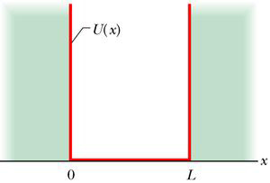
$$a$$
$$V\left(x\right)$$
A particle is known to be localized in middle of the box, with the instant wavefunction as:
$$ψ\left(x\right)=\sqrt{\frac{3}{a}} \frac{a}{3}<x<\frac{2a}{3},$$
$$=0 x<\frac{a}{3},x>\frac{2a}{3}$$
Calculate the probabilities that at the instance the energy measurement yields the ground state energy $E_{1}$, the energy of the first excited state $E_{2}$and the second excited state $E_{3}$.

