Problem Set 2

1.
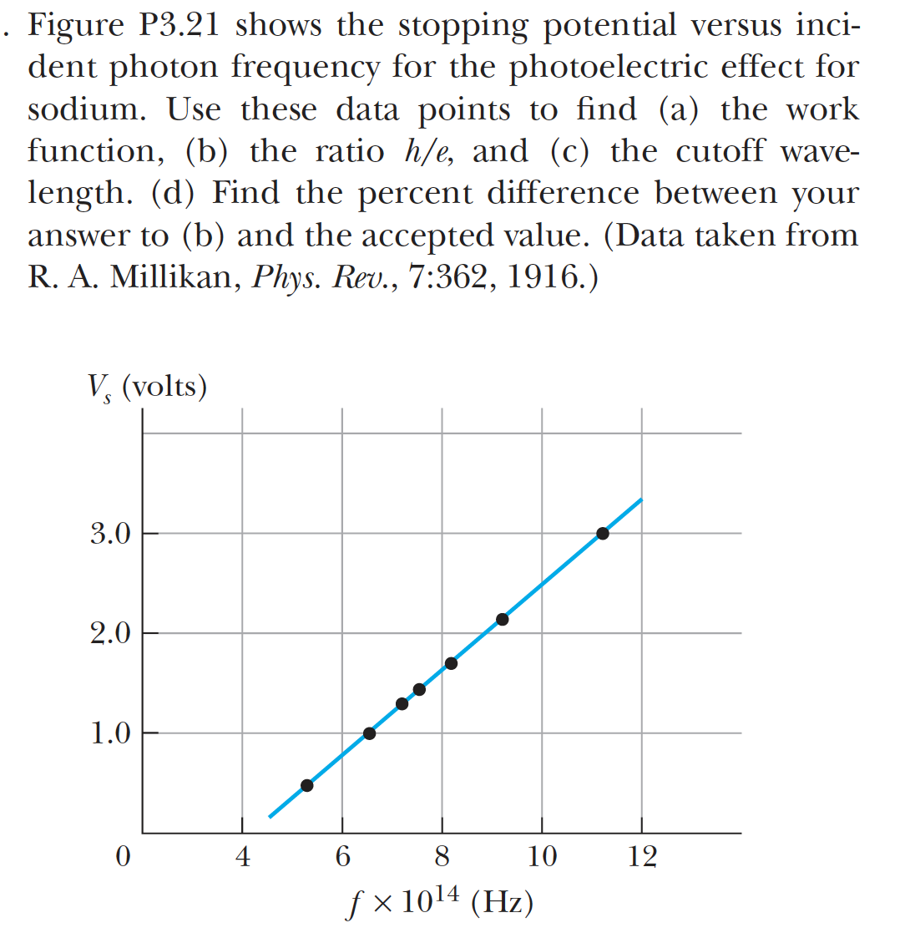

2. Gasiorowicz 1-15

3.
