近代物理期末考 June 2024
考卷領取時間：June 7 (Friday) 14:00 A213
- Assume that $\hat{n}$ is the unit vector pointing in the direction $θ=60°$. The spin operator of an electron along the direction $n(θ=60°)$ can be written as $S_{n}=\frac{ℏ}{2}\left(\begin{matrix}\frac{1}{2} & \frac{\sqrt{3}}{2} \\ \frac{\sqrt{3}}{2} & -\frac{1}{2}\end{matrix}\right).$
- Find the eigenvector $\left|\left.n,↑\right\rangle \right.=\left(\begin{matrix}c_{1} \\ c_{2}\end{matrix}\right)$ with the positive eigenvalue. Please normalize it to $\left\langle n,↑ | n,↑\right\rangle =1$.
Hint: Since you know $S_{n}$ is the spin operator, its eigenvalues must be $±\frac{ℏ}{2}$. You can use this fact to save time in finding eigenvectors.
- When the electron is in the state $\left|\left.n,↑\right\rangle \right.=\left(\begin{matrix}c_{1} \\ c_{2}\end{matrix}\right)$, measure the $z$ component spin $S_{z}$. What are the possible results you would get? Find the corresponding probabilities.
- Given the $y$ component spin $S_{y}=\frac{ℏ}{2}\left(\begin{matrix}0 & -i \\ i & 0\end{matrix}\right)$, calculate the expectation value of $S_{y}^{4}$ in the state $\left|\left.n,↑\right\rangle \right.$: $\left\langle n,↑ | S_{y}^{4} | n,↑\right\rangle$.
Solution:
For the eigenvector of eigenvalue $\frac{ℏ}{2}$: $S_{n}\left(\begin{matrix}c_{1} \\ c_{2}\end{matrix}\right)=\frac{ℏ}{2}\left(\begin{matrix}c_{1} \\ c_{2}\end{matrix}\right)$
$$\left(\begin{matrix}\frac{1}{2} & \frac{\sqrt{3}}{2} \\ \frac{\sqrt{3}}{2} & -\frac{1}{2}\end{matrix}\right)\left(\begin{matrix}c_{1} \\ c_{2}\end{matrix}\right)=\left(\begin{matrix}c_{1} \\ c_{2}\end{matrix}\right), \left(\begin{matrix}-\frac{1}{2} & \frac{\sqrt{3}}{2} \\ \frac{\sqrt{3}}{2} & -\frac{3}{2}\end{matrix}\right)\left(\begin{matrix}c_{1} \\ c_{2}\end{matrix}\right)=0$$
$$c_{1}=\sqrt{3}c_{2}$$
$$\left\langle n,↑ | n,↑\right\rangle =\left(\begin{matrix}\sqrt{3}c_{2} & c_{2}\end{matrix}\right)\left(\begin{matrix}\sqrt{3}c_{2} \\ c_{2}\end{matrix}\right)=1,$$
We find $c_{2}=\frac{1}{2}$, hence $\left|\left.n,↑\right\rangle \right.=\left(\begin{matrix}\frac{\sqrt{3}}{2} \\ \frac{1}{2}\end{matrix}\right)$.
Measuring $S_{z}$, we will get the eigenvalues of $S_{z}$: $±\frac{ℏ}{2}$. $\left|\left.n,↑\right\rangle \right.=\left(\begin{matrix}\frac{\sqrt{3}}{2} \\ \frac{1}{2}\end{matrix}\right)$ can be written in terms of the two eigenvectors of $S_{z}: \left|\left.n,↑\right\rangle \right.=\frac{\sqrt{3}}{2}\left(\begin{matrix}1 \\ 0\end{matrix}\right)+\frac{1}{2}\left(\begin{matrix}0 \\ 1\end{matrix}\right)=\frac{\sqrt{3}}{2}\left|\left.z,↑\right\rangle \right.+\frac{1}{2}\left|\left.z,↓\right\rangle \right.$. The probabilities are: ${\left|\frac{\sqrt{3}}{2}\right|}^{2}=\frac{3}{4}$ and ${\left|\frac{1}{2}\right|}^{2}=\frac{1}{4}$.
The expectation value of $S_{y}^{4}$ in the state of $\left|\left.n,↑\right\rangle \right.$ cab be calculated using matrix multiplication:
$\left\langle n,↑ | S_{y}^{4} | n,↑\right\rangle ={\left(\frac{ℏ}{2}\right)}^{4}\left(\begin{matrix}\frac{\sqrt{3}}{2} & \frac{1}{2}\end{matrix}\right){\left(\begin{matrix}0 & -i \\ i & 0\end{matrix}\right)}^{4}\left(\begin{matrix}\frac{\sqrt{3}}{2} \\ \frac{1}{2}\end{matrix}\right)={\left(\frac{ℏ}{2}\right)}^{4}\left(\begin{matrix}\frac{\sqrt{3}}{2} & \frac{1}{2}\end{matrix}\right)I\left(\begin{matrix}\frac{\sqrt{3}}{2} \\ \frac{1}{2}\end{matrix}\right)=\frac{ℏ^{4}}{16}$.

- An infinite box consists of a potential as follows:
$$V_{0}\left(x\right)=∞, x>a, x<0$$
The energy eigenfunction in this infinite box is known to be:
$$u_{n}\left(x\right)=\sqrt{\frac{2}{a}}\sin{\frac{nπx}{a}} , 0<x<a$$
$$=0 x<0,x>a$$
with energy eigenvalues: $E_{n}^{(0)}=\frac{n^{2}π^{2}ℏ^{2}}{2ma^{2}}$.
Now add a perturbation of a small step potential:
$V_{I}\left(x\right)=0, a/2< x<a$.
$=-b, 0< x<a/2$.
The full potential $V\left(x\right)$now is shown in the following diagram:
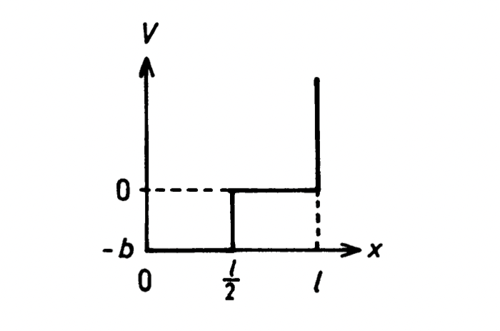
$$a/2$$
$$V\left(x\right)$$
$$a$$
Calculate the correction in the first order of $b$ to the energy eigenvalue of the $n’$th eigenstate $u_{n}:$ $E_{n}^{\left(1\right)}.$
解答：
$$E_{n}^{\left(1\right)}=\frac{2}{a}\int_{0}^{a}{dx\sin{\frac{nπx}{a}}V_{I}\left(x\right)\sin{\frac{nπx}{a}}}=\frac{2}{a}\int_{0}^{\frac{a}{2}}{dx\left(-b\right){\left(\sin{\frac{nπx}{a}}\right)}^{2}}=-\frac{b}{a}\int_{0}^{\frac{a}{2}}{dx \left(1-\cos{\frac{2nπx}{a}}\right)}=-\frac{b}{2}$$

- We will work out here an example of degenerate perturbation theory.
A Simple Harmonic Oscillator has a Hamiltonian as: $H=\frac{1}{2m}p^{2}+\frac{1}{2}kx^{2}$. The eigenstates can be written as $\left.\left|n\right.\right\rangle \sim u_{n}\left(x\right)$with eigenvalues $E_{n}=ℏω\left(n+\frac{1}{2}\right)$. We can extend the idea to 2D and consider a 2D SHO with a Hamiltonian:
$$H=\frac{1}{2}p_{x}^{2}+\frac{1}{2}p_{y}^{2}+\frac{1}{2}x^{2}+\frac{1}{2}y^{2}$$
For convenience, here we choose a unit system where $ℏ=m=ω=1$. Just like 3D electron gas we discussed in class, the motion in $x$ and the motion in $y$ are separable and the 2D SHO can be separated into two 1D SHO, one in $x$ and one in $y$, with no interaction between them. The eigenstates could be written (as in 3D electron gas) as the products of an eigenstate $\left.\left|n_{x}\right.\right\rangle$of 1D SHO in $x$ and an eigenstate $\left.\left|n_{y}\right.\right\rangle$of 1D SHO in $y$:
$$\left.\left|n_{x},\right.n_{y}\right\rangle ≡\left.\left|n_{x}\right.\right\rangle \left.\left|n_{y}\right.\right\rangle \sim u_{n_{x}}\left(x\right)∙u_{n_{y}}\left(y\right)$$
with energy eigenvalues:
$$E_{{n_{x},n}_{y}}={n_{x}+n}_{y}+1$$
The ground state is $\left.\left|0,\right.0\right\rangle \sim u_{0}\left(x\right)∙u_{0}\left(y\right)$. And there are two lowest excited states
$$\left.\left|1,\right.0\right\rangle \sim u_{1}\left(x\right)∙u_{0}\left(y\right),\left.\left|0,\right.1\right\rangle \sim u_{0}\left(x\right)∙u_{1}\left(y\right)$$
with the same energy and hence this is a two-fold degeneracy.
- What is the energy eigenvalue of the lowest excited states?
Now introduce a perturbation potential:
$$H_{1}=\frac{1}{2}εxy\left(x^{2}+y^{2}\right)$$
$ε≪1.$To calculate the energy corrections for the two degenerate states using perturbation, we need the matrix elements of $H_{1}$ between $\left.\left|1,\right.0\right\rangle and \left.\left|0,\right.1\right\rangle$. They turn out to be very simple. We can identify $\left.\left|1,\right.0\right\rangle$ as $\left|\left.ϕ_{1}\right\rangle \right.$ and $\left.\left|0,\right.1\right\rangle$as $\left|\left.ϕ_{2}\right\rangle \right.$in the class discussion.
$$h_{11}=\left\langle \left.1,0\right|\right.H_{1}\left|\left.1,0\right\rangle \right.=h_{22}=\left\langle \left.0,1\right|\right.H_{1}\left|\left.0,1\right\rangle \right.=0$$
$$h_{12}=\left\langle \left.1,0\right|\right.H_{1}\left|\left.0,1\right\rangle \right.=h_{21}=\left\langle \left.0,1\right|\right.H_{1}\left|\left.1,0\right\rangle \right.=\frac{3}{4}ε$$
You don’t need to do it but the detailed calculation is as follow:
$$\left\langle \left.1,0\right|\right.H_{1}\left|\left.0,1\right\rangle \right.=\iint_{-∞}^{∞}{dxdy∙u_{1}\left(x\right)u_{0}\left(y\right)\left[\frac{1}{2}εxy\left(x^{2}+y^{2}\right)\right]}u_{0}\left(x\right)u_{1}\left(y\right)$$
$$=\frac{ε}{2}\frac{2}{π}\iint_{-∞}^{∞}{dxdy∙xye^{-\left(x^{2}+y^{2}\right)}\left[xy\left(x^{2}+y^{2}\right)\right]}=$$
$$=\frac{ε}{π}\iint_{-∞}^{∞}{rdrdθ∙e^{-r^{2}}r^{2}∙r^{2}{\text{cos}}^{2}θ∙r^{2}{\text{sin}}^{2}θ}=\frac{3}{4}ε$$
- Use the above matrix elements to form the key matrix $\left(\begin{matrix}h_{11} & h_{12} \\ h_{21} & h_{22}\end{matrix}\right)$. Calculate the 1st order energy corrections $E^{\left(1\right)}$.
Hint:
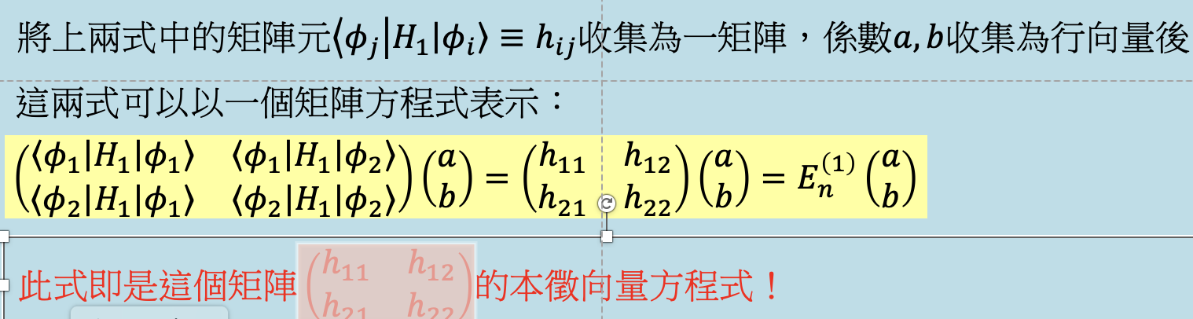
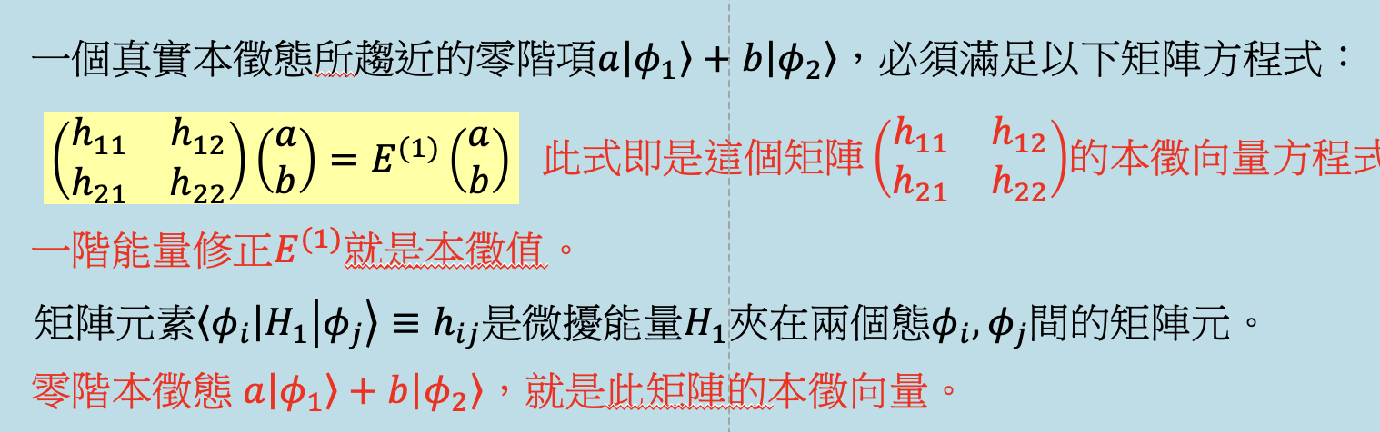
Solution: For the lowest excited states, $E^{\left(0\right)}=2.$
For the degenerate perturbation calculation:
$\left(\begin{matrix}h_{11} & h_{12} \\ h_{21} & h_{22}\end{matrix}\right)=\left(\begin{matrix}0 & \frac{3}{4}ε \\ \frac{3}{4}ε & 0\end{matrix}\right)$. Assume that eigenvalue is $λ$. $\left|\begin{matrix}-λ & \frac{3}{4}ε \\ \frac{3}{4}ε & -λ\end{matrix}\right|=0$
Eigenvalues, which are the energy corrections, are $±\frac{3}{4}ε=E^{\left(1\right)}$

- Which of the following statements are true? (5 points for each correct answer)
- When the energy bands are all totally occupied, the solid is a conductor.
- The conductivity of semiconductors grows as temperature becomes larger.
- When a semiconductor is added impurities of atoms with 5 valance electrons, it becomes an n-type semiconductor, and the current carriers are electric holes.
- In 3D electron gas, the electron energy has an upper limit, $E_{F}$. The thermal and conductivity properties of the electron gas are dominated by electron with energy near $E_{F}$.
Solution: B,D
- Consider an infinite box with boundaries at $x=0$ and $x=a$. The energy eigenstates and eigenvalues are described in problem 2. Put two electrons in the box. The wavefunction of the ground state of the two-electron system, denoted by the two quantum number $\left(n_{1}=1,n_{2}=1\right),$can be written as:
$$\frac{1}{\sqrt{2}}\left[\sin\left(\frac{π}{a}x_{1}\right)\sin\left(\frac{π}{a}x_{2}\right)\right]∙\frac{1}{\sqrt{2}}\left(\left|\left.↑↓\right\rangle \right.-\left|\left.↓↑\right\rangle \right.\right)$$
This overall antisymmetric wavefunction consists of a symmetric space part (of two identical wavefunction) and an antisymmetric spin part.
- Consider the first excited state. What is the energy eigenvalue?
- Write down the wavefunction of the four first excited state, using the above notation.
- What is the energy eigenvalue of the second excited states?
Solution:
- The first excited state has one electron in $n=1$ and one in $n=2$. The energy is the sum: $\frac{5π^{2}ℏ^{2}}{2ma^{2}}.$
- The overall wavefunctions need to be antisymmetric. Therefore, it could consist of a symmetric space part and an antisymmetric spin part,
$$\frac{1}{\sqrt{2}}\left[\sin\left(\frac{π}{a}x_{1}\right)\sin\left(\frac{2π}{a}x_{2}\right)+\sin\left(\frac{π}{a}x_{2}\right)\sin\left(\frac{2π}{a}x_{1}\right)\right]∙\frac{1}{\sqrt{2}}\left(\left|\left.↑↓\right\rangle \right.-\left|\left.↓↑\right\rangle \right.\right)$$
or a antisymmetric space part and a symmetric spin part,
$$\frac{1}{\sqrt{2}}\left[\sin\left(\frac{π}{a}x_{1}\right)\sin\left(\frac{2π}{a}x_{2}\right)-\sin\left(\frac{π}{a}x_{2}\right)\sin\left(\frac{2π}{a}x_{1}\right)\right]∙\left|\left.↑↑\right\rangle \right.$$
$$\frac{1}{\sqrt{2}}\left[\sin\left(\frac{π}{a}x_{1}\right)\sin\left(\frac{2π}{a}x_{2}\right)-\sin\left(\frac{π}{a}x_{2}\right)\sin\left(\frac{2π}{a}x_{1}\right)\right]∙\frac{1}{\sqrt{2}}\left(\left|\left.↑↓\right\rangle \right.+\left|\left.↓↑\right\rangle \right.\right)$$
$$\frac{1}{\sqrt{2}}\left[\sin\left(\frac{π}{a}x_{1}\right)\sin\left(\frac{2π}{a}x_{2}\right)-\sin\left(\frac{π}{a}x_{2}\right)\sin\left(\frac{2π}{a}x_{1}\right)\right]∙\left|\left.↓↓\right\rangle \right.$$
- The second excited state has both electron in $n=2$ ($n=3,1 or 1,3 has higher energy)$. The energy is the sum: $\frac{8π^{2}ℏ^{2}}{2ma^{2}}.$

