額外題

Ch. 6

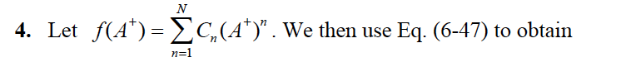

12.

Ch. 7

Ch. 8

