近代物理期末考
Dec 2023
- An electron $\left(\text{charge} e\right)$is moving inside a parallel capacitor of constant electric field with separation $L$ and fixed voltage difference $V_{0}.$ Write down the time independent Schrodinger equation for the stationary states $ψ_{E}\left(x\right)$ of energy $E$ in $0<x<L$. Can you guess if its energy is quantized? Why? No need to solve it. (15)
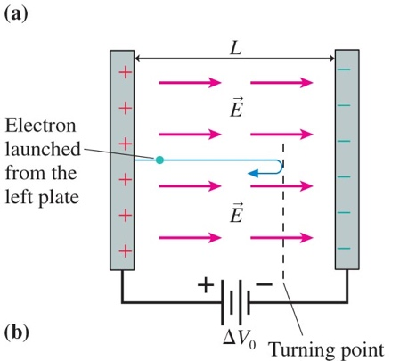
解答：The potential energy of the electron is $V\left(x\right)=\frac{eV_{0}}{L}x$. Therefore the time independent Schrodinger equation is
$$-\frac{ℏ^{2}}{2m}\frac{d^{2}ψ_{E}\left(x\right)}{dx^{2}}+V\left(x\right)∙ψ_{E}\left(x\right)=-\frac{ℏ^{2}}{2m}\frac{d^{2}ψ_{E}\left(x\right)}{dx^{2}}+\frac{eV_{0}}{L}x∙ψ_{E}\left(x\right)=E∙ψ_{E}\left(x\right)$$
This is a complicated differential equation. The solution we have for step potential: $ψ_{E}=Ae^{ikx}+Re^{-ikx}$ totally cannot apply here. Some of you still copy here the formula $k≡\sqrt{\frac{2m(E-V\left(x\right))}{ℏ^{2}}}$. But it does not make sense. The lefthand side is a constant but the righthand side is x-dependent.
I’ll talk about this case next semester.

- A particle’s wavefunction at $t=0$is:
$$Ψ\left(x,0\right)=\sqrt{\frac{30}{a^{5}}}x\left(a-x\right) 0<x<a,$$
$$=0 x<0,x>a$$
Calculate the expectation values: $\left\langle x^{2}\right\rangle ,\left\langle p^{2}\right\rangle$. (25) 提示：$p=-iℏ\frac{∂}{∂x}$
解答：
$$\left\langle x^{2}\right\rangle =\int_{-∞}^{∞}{dx∙x^{2}{\left|ψ\left(x,t\right)\right|}^{2}}$$
$$=\frac{30}{a^{5}}\int_{0}^{a}{dx∙x^{2}\left(a^{2}x^{2}-2ax^{3}+x^{4}\right)}=\frac{30}{a^{5}}\int_{0}^{a}{dx∙\left(a^{2}x^{4}-2ax^{5}+x^{6}\right)}$$
$$\frac{30}{a^{5}}\left(\frac{1}{5}a^{7}-\frac{1}{3}a^{7}+\frac{1}{7}a^{7}\right)=\frac{30}{a^{5}}\frac{1}{105}a^{7}=\frac{2}{7}a^{2}$$

$$\left\langle p^{2}\right\rangle =\int_{-∞}^{∞}{{dx∙Ψ}^{*}\left(x\right)}∙\frac{1}{2m}{\left(-iℏ\frac{∂}{∂x}\right)}^{2}Ψ\left(x\right)=-\frac{30}{a^{5}}ℏ^{2}\int_{0}^{a}{dx∙x\left(a-x\right)\frac{∂^{2}x\left(a-x\right)}{∂x^{2}}}$$
$$=\frac{30}{a^{5}}ℏ^{2}\int_{0}^{a}{dx∙x\left(a-x\right)∙2}=\frac{60}{a^{5}}ℏ^{2}\left(\frac{a^{3}}{2}-\frac{a^{3}}{3}\right)=\frac{10}{a^{2}}ℏ^{2}$$
In $\left\langle p^{2}\right\rangle ,$you must keep the two derivatives in the middle to get the right answer. To see why, check out my careful discussion in the PowerPoint file. You cannot move derivative operators around in your formula. That is a key difference between classical and quantum physics!

- Consider an infinite potential box, with boundaries at $x=0$ and $x=a$:
$V\left(x\right)=∞, x>a, x<0$ and $V\left(x\right)=0, 0< x<a$.
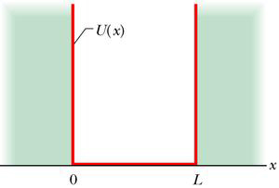
$$a$$
$$V\left(x\right)$$
As we have shown in class, in this potential the energy eigenstate can be written as $\sqrt{\frac{2}{a}}\sin{\frac{nπx}{a}}$ with eigenvalues $E_{n}=\left(\frac{ℏ^{2}}{2m}\right)\frac{π^{2}}{a^{2}}n^{2} (you can use$ the notation $E_{n}$to simplify your answers) . Assume the wavefunction of a particle at $t=0$(probability already normalized to one) is:
$$Ψ\left(x,0\right)=\sqrt{\frac{4}{5}}\left(\sqrt{\frac{2}{a}}\sin{\frac{πx}{a}}\right)+\sqrt{\frac{1}{5}}\left(\sqrt{\frac{2}{a}}\sin{\frac{2πx}{a}}\right) 0<x<a,$$
$$=0 x<0,x>a$$
- At $t=0$, make an energy measurement. What are the values it could possibly give? What are the corresponding probabilities? Do they add up to one? What is the expectation value of energy. (20)
Hint: Expectation value is the sum of the measured value times the probability.
- For a later time $t=t_{0}$, write down the wave function $ψ\left(x,t_{0}\right).$ There is no need to simplify the answer. (15)

解答：
- $Ψ\left(x,0\right)=\sqrt{\frac{4}{5}}\left(\sqrt{\frac{2}{a}}\sin{\frac{πx}{a}}\right)+\sqrt{\frac{1}{5}}\left(\sqrt{\frac{2}{a}}\sin{\frac{2πx}{a}}\right)=\sqrt{\frac{4}{5}}u_{1}(x)+\sqrt{\frac{1}{5}}u_{2}(x).$The wave function is a superposition of the eigenfunction $u_{1},u_{2}$of eigenvalues $E_{1},E_{2}$, with amplitudes$c_{1}=\sqrt{\frac{4}{5}}$, $c_{2}=\sqrt{\frac{1}{5}}$, , $c_{n}=0, n>2$ . You can simply see it from the formula or use the formula $c_{n}=\int_{-∞}^{∞}{dx∙}u_{n}{\left(x\right)}^{*}∙ψ\left(x\right)$and orthogonality theorem ${\int_{-∞}^{∞}{dx∙}u_{m}{\left(x\right)}^{*}∙u}_{n}(x) =δ_{mn}$to get it. The energy could only be $E_{1} or E_{2}$. The corresponding probabilities are the square of the magnitudes${ c}_{1}$ and $c_{2}$: $\frac{4}{5}$ and $\frac{1}{5}$。They add up to one. The expectation value of energy is $〈E〉=\frac{4}{5}E_{1}+\frac{1}{5}E_{2}$.
- $t=0$時此狀態可以視為定態$u_{1,2}$的如上疊加，接著定態隨時間個自演化，位能下薛丁格方程式要求$u_{n}$乘$\text{上}e^{-i\frac{E_{n}}{ℏ}t}$。乘完之後依同樣方式疊加，整個波函數也就滿足薛丁格波方程式。因此
$Ψ\left(x,t\right)=\sqrt{\frac{4}{5}}\left(\sqrt{\frac{2}{a}}\sin{\frac{πx}{a}}\right)e^{-i\frac{E_{1}}{ℏ}t}+\sqrt{\frac{1}{5}}\left(\sqrt{\frac{2}{a}}\sin{\frac{2πx}{a}}\right)e^{-i\frac{E_{2}}{ℏ}t}$。
$注意\text{兩個定態的}能量E_{1},E_{2}是不一樣的。$。

- An electron moving from left $x=-∞$ to right $x=∞$ is scattered by a step potential at $x=0$. The step potential is: $V=0, x<0$ and $V=V_{0}, x>0$. But we do not know the value of $V_{0}$ but are sure about $E \text{and}$that $E<V_{0}$.
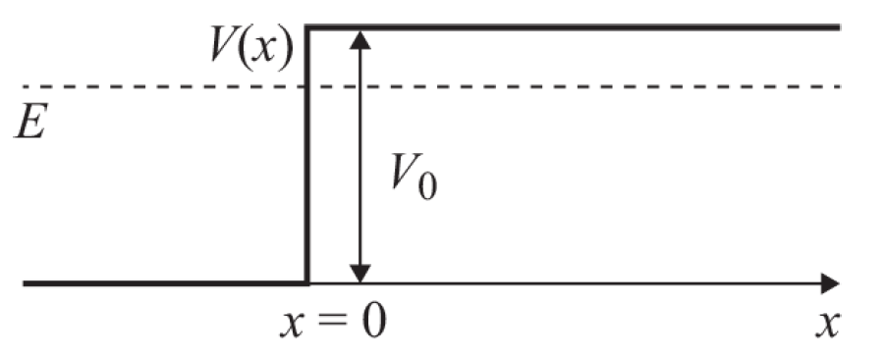
As we have shown in class, the wave function of the stationary state (incoming from left, scattering by the potential) of this potential for $E<V_{0}$can be written as:
$$ψ_{E}\left(x\right)=e^{ikx}+e^{-2iδ}e^{-ikx} x<0 k≡\sqrt{\frac{2mE}{ℏ^{2}}}$$
$$ψ_{E}\left(x\right)=Te^{-κx} x>0 κ≡\sqrt{\frac{2m}{ℏ^{2}}\left(V_{0}-E\right)}$$
$T(complex)$ and $δ(Real)$ are constants. $δ$ can be measured in experiment. Assume that the measured value is $δ=\frac{π}{6}$. From this data we can calculate the value of $V_{0}$.
- Write the two continuity conditions for the wavefunction and its derivative. They could relate $T$,$δ$ in terms of $k,κ$. (5)
- Calculate the value of $\frac{k}{κ}$ and then $V_{0}$ in terms of $E$. (20)
提示：Write down the two continuity conditions, cancel $T$ and then plug in the angle $δ=\frac{π}{6}$ to calculate $\frac{k}{κ}$.

解答：在此情況，已給出：$R=e^{-2iδ}$.
Continuity conditions: for the wavefunction and its derivative to be equal at $x=0.$
$$1+e^{-2iδ}=T$$
$$k-ke^{-2iδ}=iκT$$
將第一式代入第二式：
$$k\left(1-e^{-i\frac{π}{3}}\right)=iκ\left(1+e^{-i\frac{π}{3}}\right)$$
代入具體數值$e^{-i\frac{π}{3}}=\frac{1}{2}-i\frac{\sqrt{3}}{2}$：

$$k\left(\frac{1}{2}+\frac{\sqrt{3}}{2}i\right)=iκ\left(\frac{3}{2}-\frac{\sqrt{3}}{2}i\right)$$
得到：
$$\frac{k}{κ}=\frac{\sqrt{3}+3i}{1+\sqrt{3}i}=\sqrt{3}$$

此值是由$E,V_{0}$決定：
$$\frac{k}{κ}=\sqrt{3}=\sqrt{\frac{E}{E-V_{0}}}$$
兩邊平方：
$$E=3\left(V_{0}-E\right)$$
$$E=\frac{3}{4}V_{0}$$

