解答八

29.8. Identify:   Apply Faraday’s law.

Set Up:   Let  be upward in Figure E29.8 in the textbook.

Execute:   (a) 



(b)    and 

(c) is in the direction ofsois positive. *B* is getting weaker, so the magnitude of the flux is decreasing and  Faraday’s law therefore saysSincethe induced current must flow *counterclockwise* as viewed from above.

29.18 . Identify:   By Lenz’s law, the induced current flows to oppose the flux change that caused it.

Set Up and Execute:   The magnetic field is outward through the round coil and is decreasing, so the magnetic field due to the induced current must also point outward to oppose this decrease. Therefore the induced current is counterclockwise.

Evaluate:   Careful! Lenz’s law does not say that the induced current flows to oppose the magnetic flux. Instead it says that the current flows to oppose the *change* in flux.

29.**22**

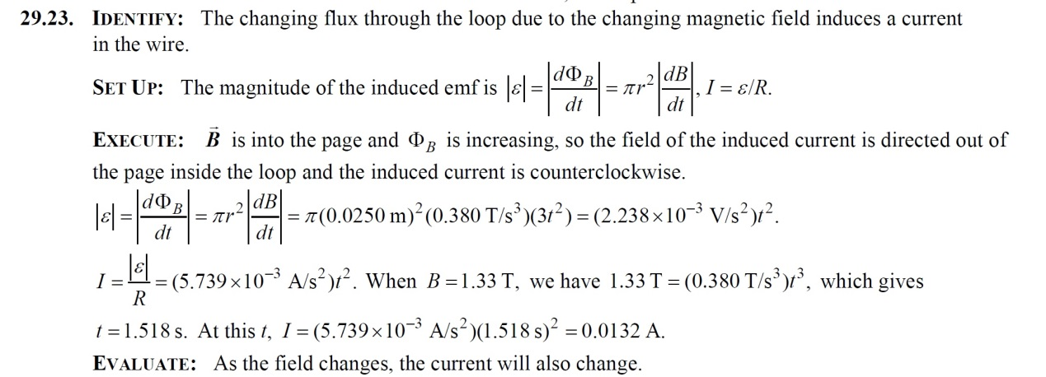

29.37. Identify:   Apply Faraday’s law in the form 

Set Up:   The magnetic field of a large straight solenoid is  inside the solenoid and zero outside.  where *A* isthe cross-sectional area of the long straight solenoid.

Execute:   



Evaluate:   An emf is induced in the second winding even though the magnetic field of the solenoid is zero at the location of the second winding. The changing magnetic field induces an electric field outside the solenoid and that induced electric field produces the emf

32.8. Identify:     Apply Eqs. (32.17) and (32.19).

Set Up:   The speed of the wave is 

Execute:   (a) 

(b) 

(c)   If  then  so that  will be in the   and 

Evaluate:   The directions of  and  and of the propagation of the wave are all mutually perpendicular. The argument of the cosine is  since the wave is traveling in the  Waves for visible light have very high frequencies.

