解答三

22.32

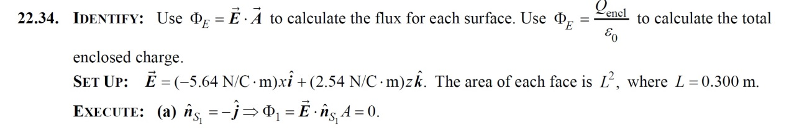

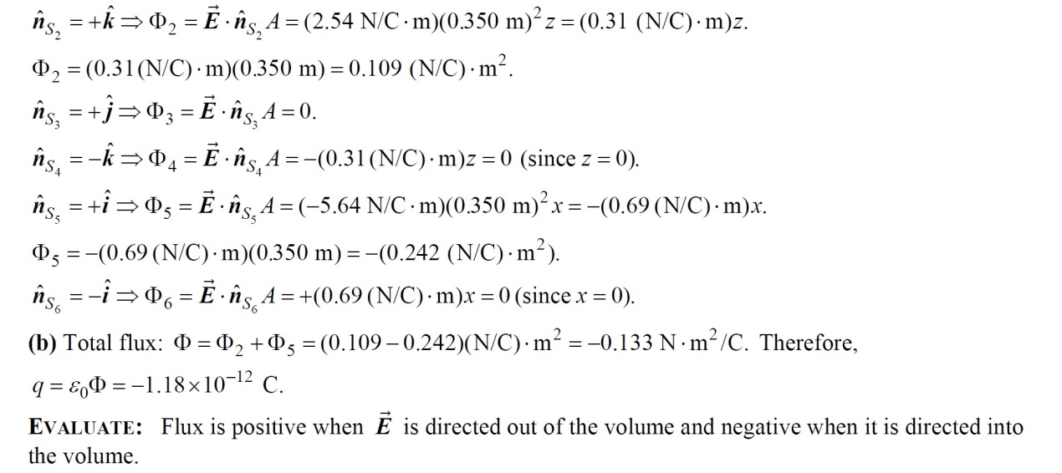

22.37

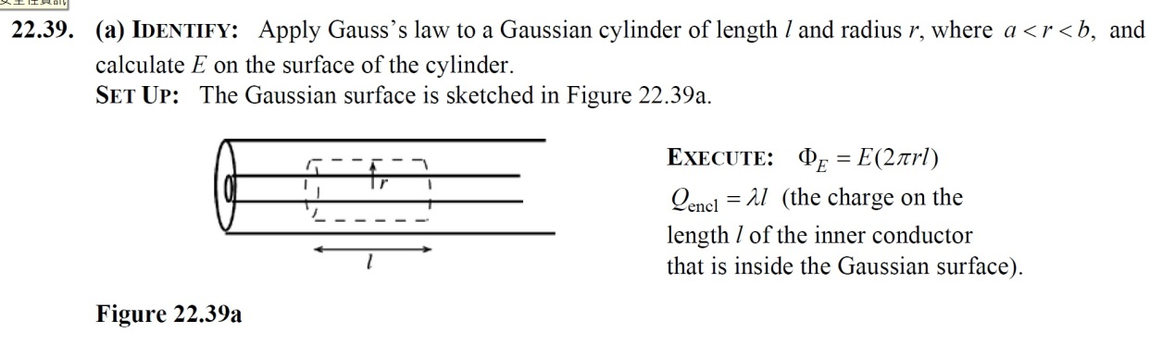

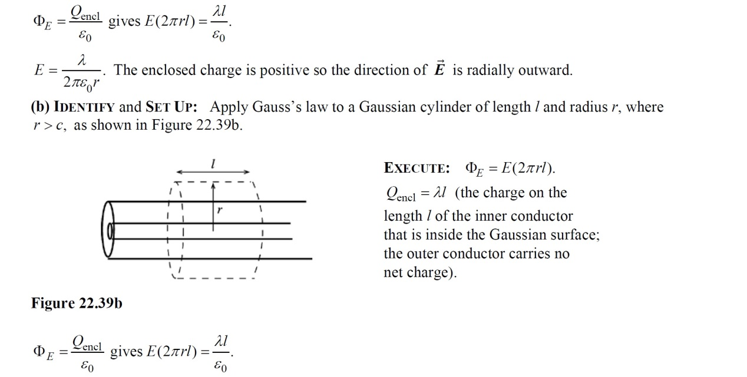

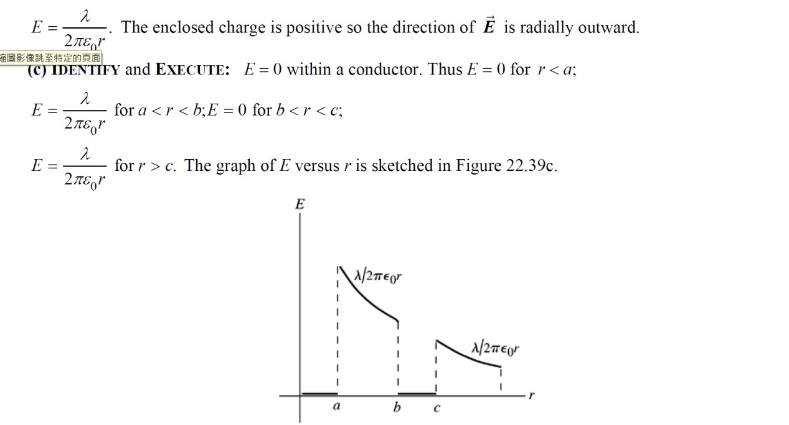

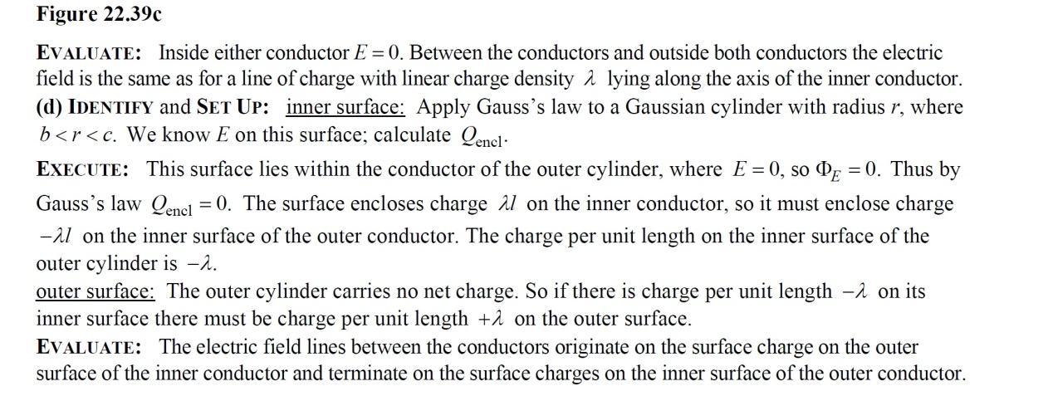

22.38

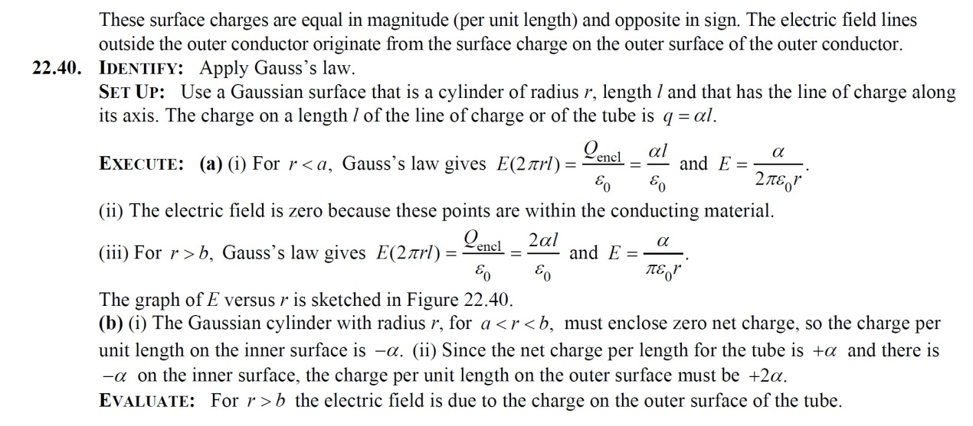

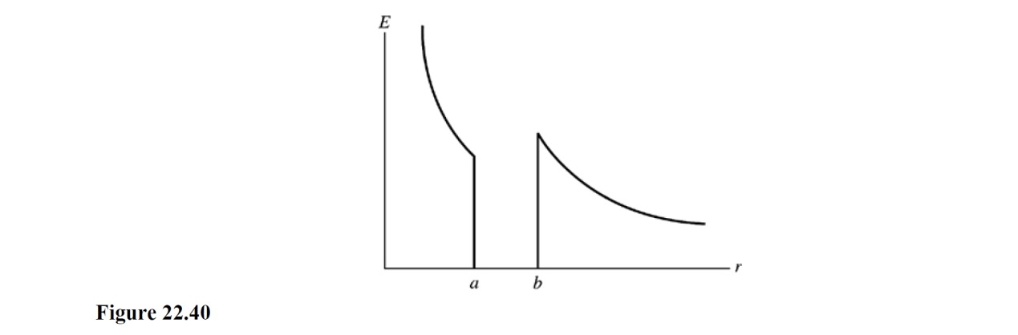

22.39 Identify**:**   Apply Gauss’s law.

Set Up:   Use a Gaussian surface that is a cylinder of radius *r* and length *l*, and that is coaxial with the cylindrical charge distributions. The volume of the Gaussian cylinder is  and the area of its curved surface is  The charge on a length *l* of the charge distribution is  where 

Execute:   (a) For   and Gauss’s law gives  and  radially outward.

(b) For   and Gauss’s law gives  and  radially outward.

(c) At  the electric field for BOTH regions is  so they are consistent.

(d) The graph of *E* versus *r* is sketched in Figure 22.42.

Evaluate:   For  the field is the same as for a line of charge along the axis of the cylinder.

|  |
| --- |
| C:\Documents and Settings\Yvette\My Documents\youn.ism.ch.22\FIG22-040.tif |
| Figure 22.42 |